What to do today
IMPORTANT Parent or Carer – Read this page with your child and check that you are happy with what they have to do and any weblinks or use of internet.

1. Write descriptive phrases and draft a poem
- Look carefully at Tiger Images 1-3. Make notes about what you notice.
- Watch this Deadly 60 Video Clip about tigers. Make more notes about what you notice.
https://www.youtube.com/watch?v=RBuSTyh3vec
- Turn some of your notes into Descriptive Phrases. Try to use precise vocabulary, alliteration, metaphors and similes.
- Try organising some of your phrases into a poem about tigers.

2. Read a poem
- Read The Tyger by William Blake. It’s an old poem, but you probably can work out some of what it means.
- Listen to the poem being read: https://www.youtube.com/watch?v=QMwNvzRKX64
- Which is your favourite line in the poem? What patterns can you spot in the poem?

3. Explore the poem
- Read the Verse Summaries. Match them to the poem’s verses.
- Find meanings for the words in Vocabulary List. You could use a dictionary or https://www.wordsmyth.net/

Well done. Read your descriptive phrases/poem and The Tyger to a grown-up. Tell them your favourite lines and find out theirs. You can check your answers to Verse Summaries at the end of this pack.

Try the Fun-Time Extra
Practise reading the poem. You could make a recording of yourself and share it with someone else.

Tiger Image 1

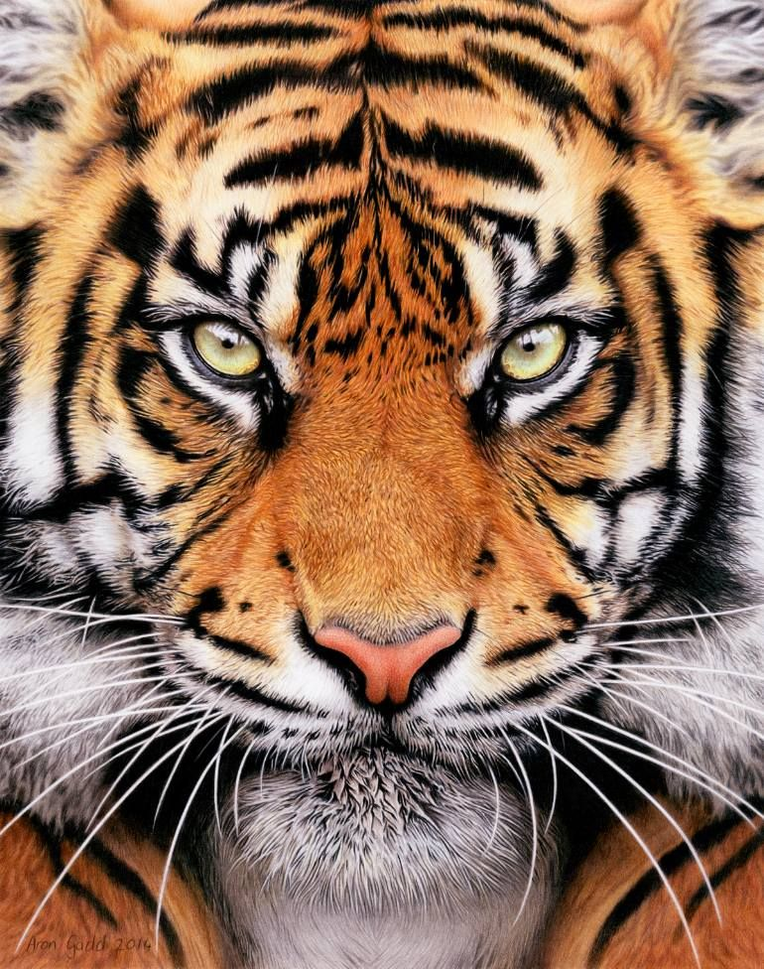

Tiger Image 2

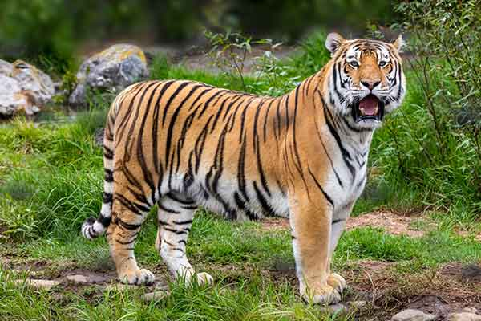
Tiger Image 3
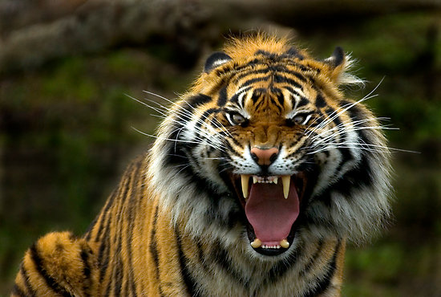
Descriptive Phrases

Write some descriptive phrases about tigers. Use really precise vocabulary, alliteration, metaphor and similes.

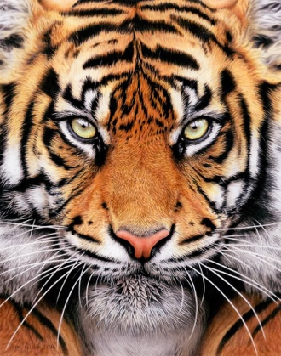
The Tyger by William Blake

Tyger Tyger, burning bright,
In the forests of the night;
What immortal hand or eye,
Could frame thy fearful symmetry?

In what distant deeps or skies.
Burnt the fire of thine eyes?
On what wings dare he aspire?
What the hand, dare seize the fire?

And what shoulder, & what art,
Could twist the sinews of thy heart?
And when thy heart began to beat,
What dread hand? & what dread feet?

What the hammer? what the chain,
In what furnace was thy brain?
What the anvil? what dread grasp,
Dare its deadly terrors clasp!

When the stars threw down their spears
And water'd heaven with their tears:
Did he smile his work to see?
Did he who made the Lamb make thee?

Tyger Tyger burning bright,
In the forests of the night:
What immortal hand or eye,
Dare frame thy fearful symmetry?

Verse Summaries

A | Where did the fire of your eyes come from? What sort of hand would be able to take hold of that fire to put it in your eyes?
B | When you were made did your creator smile? Did your creator make you and lambs as well?
C | What tools would be needed to make your brain? How could anyone dare to hold it?
D | Oh tiger! You look like something burning bright in night-time forests. What sort of being could ever have come up with your looks – your symmetry and your fearfulness?
E | How could shoulders be strong enough and skilful enough to create your heart? What hands and feet would it take to make that?
F | Oh tiger! You look like something burning bright in night-time forests. What sort of being would have dared come up with your looks – your symmetry and your fearfulness?

Vocabulary List

Immortal
Symmetry
Aspire
Sinews
Anvil
Dread

Verse Summary Answers
Tyger Tyger, burning bright,  In the forests of the night;  What immortal hand or eye,  Could frame thy fearful symmetry? | Oh tiger! You look like something burning bright in night-time forests. What sort of being could ever have come up with your looks – your symmetry and your fearfulness?
In what distant deeps or skies.  Burnt the fire of thine eyes?  On what wings dare he aspire?  What the hand, dare seize the fire? | Where did the fire of your eyes come from? What sort of hand would be able to take hold of that fire to put it in your eyes?
And what shoulder, & what art,  Could twist the sinews of thy heart?  And when thy heart began to beat,  What dread hand? & what dread feet? | How could shoulders be strong enough and skilful enough to create your heart? What hands and feet would it take to make that?
What the hammer? what the chain,  In what furnace was thy brain?  What the anvil? what dread grasp,  Dare its deadly terrors clasp! | What tools would be needed to make your brain? How could anyone dare to hold it?
When the stars threw down their spears  And water'd heaven with their tears:  Did he smile his work to see?  Did he who made the Lamb make thee? | When you were made did your creator smile? Did your creator make you and lambs as well?
Tyger Tyger burning bright,  In the forests of the night:  What immortal hand or eye,  Dare frame thy fearful symmetry? | Oh tiger! You look like something burning bright in night-time forests. What sort of being would have dared come up with your looks – your symmetry and your fearfulness?

