What to do today
IMPORTANT Parent or Carer – Read this page with your child and check that you are happy with what they have to do and any weblinks or use of internet.

1. Read a story
- Read Androcles and the Lion.
- Underline any vocabulary that you’re not sure about and look it up in a dictionary or on https://kids.wordsmyth.net/we/
- What would you say are the three main scenes in this story? Write a single sentence summary of each of them.

2. Compare the two stories
- Read Six Comparison Tasks and think about your answers.
- Write your answers to each of the tasks in clear sentences.

3. Now for some writing
- Think about the theme of both of these stories: Keeping Promises.
- Think of your own story on the same theme. Who could make a promise? What will they promise? To who? Will they keep it or break it? What will happen? Plan your story on the Story-Planner.
- Write your own story.

Well done. Show your writing to a grown-up. Read it to them and explain how it is similar to the stories of Androcles and Jabu.

Try the Fun-Time Extras
- Make a set of illustrations to go with your story.
- Record a reading of your story and share it with someone else.
- Make a papier-mâché lion mask and use it to act out the stories.
http://storytellingcraftsandkids.blogspot.com/2010/09/androcles-and-lionan-aesop-fable-retold.html

Androcles and the Lion
It happened in the old days in Rome that a slave named Androcles escaped from his master and fled into the forest, and he wandered there for a long time until he was weary and almost spent with hunger and despair. Just then he heard a lion near him moaning and groaning and at times roaring terribly. Tired as he was Androcles rose up and rushed away, as he thought, from the lion; but as he made his way through the bushes he stumbled over the root of a tree and fell down lamed, and when he tried to get up there he saw the lion coming towards him, limping on three feet and holding his forepaw in front of him.
Poor Androcles was in despair; he had not strength to rise and run away, and there was the lion coming upon him. But when the great beast came up to him instead of attacking him it kept on moaning and groaning and looking at Androcles, who saw that the lion was holding out his right paw, which was covered with blood and much swollen. Looking more closely at it Androcles saw a great big thorn pressed into the paw, which was the cause of all the lion's trouble.
Plucking up courage he seized hold of the thorn and drew it out of the lion's paw, who roared with pain when the thorn came out, but soon after found such relief from it that he fawned upon Androcles and showed, in every way that he knew, to whom he owed the relief. Instead of eating him up he brought him a young deer that he had slain, and Androcles managed to make a meal from it. | 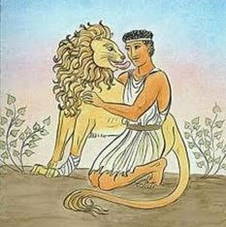
For some time, the lion continued to bring the game he had killed to Androcles, who became quite fond of the huge beast.
But one day a number of soldiers came marching through the forest and found Androcles, and as he could not explain what he was doing they took him prisoner and brought him back to the town from which he had fled.
Here his master soon found him and brought him before the authorities, and he was condemned to death because he had fled from his master. Now it used to be the custom to throw murderers and other criminals to the lions in a huge circus, so that while the criminals were punished the public could enjoy the spectacle of a combat between them and the wild beasts.
So Androcles was condemned to be thrown to the lions, and on the appointed day he was led forth into the Arena and left there alone with only a spear to protect him from the lion. The Emperor was in the royal box that day and gave the signal for the lion to come out and attack Androcles. But when it came out of its cage and got near Androcles, what do you think it did? Instead of jumping upon him it fawned upon him and stroked him with its paw and made no attempt to do him any harm.
It was of course the lion which Androcles had met in the forest. The Emperor, surprised at seeing such a strange behaviour in so cruel a beast, summoned Androcles to him and asked him how it happened that this particular lion had lost all its cruelty of disposition. So Androcles told the Emperor all that had happened to him and how the lion was showing its gratitude for his having relieved it of the thorn. Thereupon the Emperor pardoned Androcles and ordered his master to set him free, while the lion was taken back into the forest and let loose to enjoy liberty once more.
By Joseph Jacobs
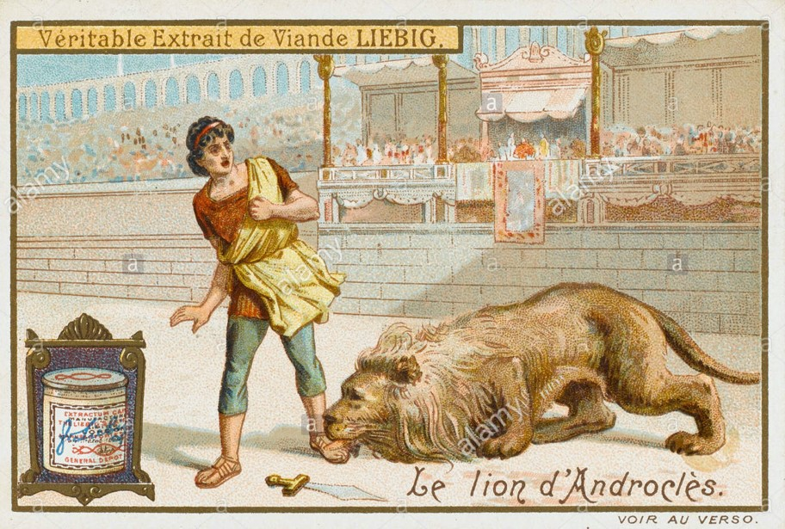

Six Comparison Tasks (Androcles and the Lion/Jabu and the Lion)
1. Describe in detail something that is the same in both stories. | 2. Describe in detail something that is different from one book to the other. | 3. Which main character, Androcles or Jabu do you identify with most? Which do you feel most sympathetic towards? Give reasons for your choice.
4. Which of the two lions do you prefer? Why? Which of the two lions do you think is most realistic why? | 5. Say which story has the best plot and explain why you think that. | 6. Think of a particular friend or relative. Which of the two stories would you suggest they read? Why do you think that would the better story for them?

Story-Planner

Keeping Promises

Write your own story here.

