What to do today
IMPORTANT Parent or Carer – Read this page with your child and check that you are happy with what they have to do and any weblinks or use of internet.

1. Investigate some vocabulary
- Find out the meanings of the words on Vocabulary.
- You could use a dictionary or this website:
https://kids.wordsmyth.net/we/
- Write meanings for the words using your own words.
- What story could include all these words? What do you think might happen in it?

2. Read the start of a story
- Read Jabu and the Lion Part 1.
- What do we learn about the character of Jabu? Write three sentences to describe him.

3. Imagine the rest of the story
- Think about how this story could develop and end. Why is the lion roaring? What will Jabu do? What will happen?
- Use notes and drawings to show your ideas on Story Development/Ending.
- Write your version of your predicted development and ending. Try to include some of the new vocabulary in your writing.

Well done. Show your writing about to a grown-up. Explain how the story began and why you chose that development and ending.

Try the Fun-Time Extras
Try testing other people with the new vocabulary that you have learnt. How many of the meanings do they know? Teach them the meanings that they don’t know.
Make illustrations to accompany your version of the story.

Jabu and The Lion Part 1
Once upon a time there was a young cowherd named Jabu. His daily task was to guard his father’s cattle, as they grazed lazily in the fields under the hot sun. And then, when the sun began to sink in the western sky, he would see that they were safely corralled for the night. It was a responsible job caring for his father’s herd of twenty-five cows – most of his friends cared for far fewer cattle – but he took great pride in this important task that had been entrusted to him. Patiently Jabu watched over the cattle, making sure they were safe and that none of them wandered away. Dangerous animals could always be lurking in the shadows, waiting to pounce on any unsuspecting stray animal.

Jabu’s father had planted corn in an adjoining field to provide food for the family during the year. But the cows loved to eat the corn and Jabu had to be extremely vigilant, otherwise the cows would trample it and spoil the harvest. Jabu took this job very seriously indeed and his father was very proud that he had the most reliable son in the whole neighbourhood.  One day Jabu was sitting on a small hill, watching the cattle languishing in the hot midday sun, as they chewed the cud contentedly. He had gathered long strips of thin grass to plait into bangles for his sisters. Suddenly his friend Sipho came racing into the clearing, panting visibly, as he excitedly relayed his message, “Jabu! Jabu! Have you heard the news? Bhubesi, the lion, is hunting in the vicinity. He has already attacked and killed one of Thabu’s (Tah’boh) father’s cows.” | 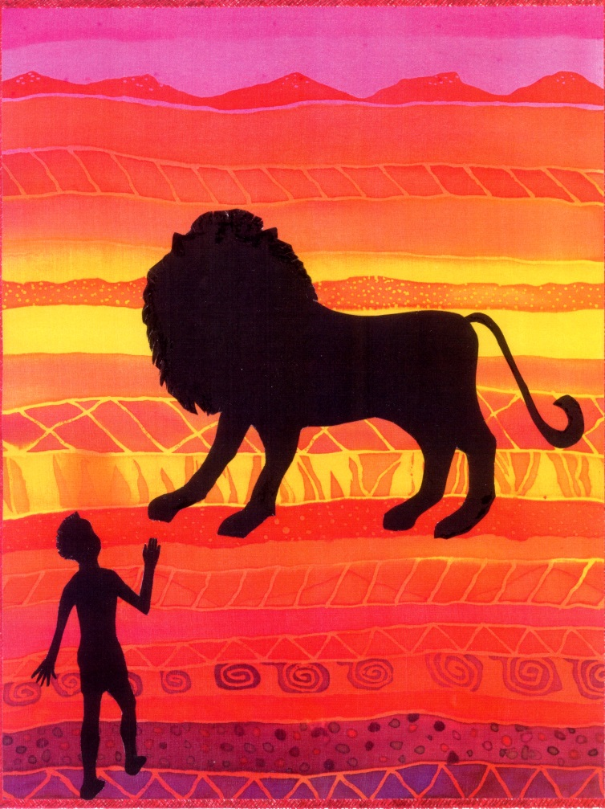

Jabu was not as surprised as Sipho imagined he would be. “I thought as much,” he explained. “This morning, as I was driving the herd to pasture, I noticed lion paw prints embedded in the soft earth near the river. I also smelled the distinctive scent of lion and saw the remains of a carcass nearby.”
Sipho was far too excited to listen, and danced impatiently around Jabu. “Come quickly!” he urged. “We can help the hunters lay traps to catch Bhubesi, the King of the Beasts.”
Jabu smiled at his excitable friend and explained, “I’m sorry, but I can’t come with you, my friend. I can’t corral the cattle now – it’s much too early in the day. They will need to quench their thirst in the river later in the afternoon, before being settled safely into the corral for the night.”

Sipho smiled at Jabu, “I am sorry you cannot come with me now – perhaps we can meet around the camp fire later tonight and I can tell you all about it. Good-bye.”
Sipho waved as he raced back towards the village, eager to be involved in traps to ensnare the lion.

Jabu frowned as he puzzled over Sipho’s words. How could the lion have caught one of Thabu’s cows? Wasn’t everyone aware that lions hunt at night? Could it be that Thabu’s son had forgotten to herd all the cattle into the corral last night? It was common knowledge in the village that he was often careless with his herding. The sun was beginning to set in the western sky and dusk was setting in. As Jabu whistled loudly, the cattle raised their heads and gazed in his direction. He waved his staff in the air, and the cattle began plodding languidly along the familiar, well-worn path towards the river, their hooves echoing tunefully as they stumbled over the parched, stony earth.

Jabu dangled his feet in the cool river as the cattle slurped, gulping noisily as their tongues lapped the refreshing life-giving liquid. Jabu was deep in thought, meditating contentedly as he moulded the soft clay into a model of a calf for his little brother. Then suddenly, out of the blue, came an earth-shattering “Rrrroar!” Jabu leapt to his feet, as the whole herd of cows simultaneously raised their heads and stared with horrified eyes in the direction of the thunderous roar. Jabu was terrified and so were the cattle. Nevertheless, he was a brave cowherd, and he walked cautiously towards the frightened animals. He waved his staff, being careful not to cause a stampede, and gently rounded the cattle up into a tight, safe ‘knot’. The corral was much too far away to attempt to lead them back: they would have to wait here, and hope that the lion would retreat.

Jabu listened, “Rrroar!...oarrr…oarrr!” went the lion.

Vocabulary

cowherd
responsible
adjoining
vigilant
cud
carcass
ensnare
languidly
parched
corral

Story Development/Ending

Jabu and the Lion – continued
Write your version of how you think the story will develop and end.

