What to do today
IMPORTANT Parent or Carer – Read this page with your child and check that you are happy with what they have to do and any weblinks or use of internet.

1. Investigate vocabulary
- Read Vocabulary for Villains. Underline unusual vocabulary.
- Choose six words that you think are most interesting or which you are least sure about. Find out their meaning. You could use a book dictionary or this website:
https://kids.wordsmyth.net/we/
- Write sentences that use these words.

2. Read a draft poem
- Read the Draft Poem that has been written about insulting a Teddy Bear.
- Spot the changes that the writer made when they re-read the poem. How have they improved the poem? Which lines in the poem do you like best? Why?

3. Write your own insult poem
- Decide what you will insult. Make it a toy or an object not a person!
- Use the Planner to write down ideas for insults. You can use some of the ideas in the teddy bear poem or from Day 4’s poems. You can also use some of your new vocabulary.
- Choose your favourite ideas and put them in a good order to create a really good poem.
- Read your poem through and make changes to improve it.

Try these Fun-Time Extras
Make a set of illustrations for your poem.
Write some more verses for I’m Telling You. You need two boasts and two insults for every verse that you write!

Vocabulary for Villains

Fiendish, fearsome, filthy,  Revolting, rancid, vicious,  Detestable, disgusting,  Malevolent, malicious.  Ghastly, grisly, gruesome,  Menacing, atrocious,  Grim, grotesque, repulsive,  Loathsome, foul, ferocious,  Hellish, diabolical,  Hateful, hideous, mean,  Odious, malodorous,  Venomous, unclean. | Wicked, evil, ugly, vile,  Callous, cruel, spiteful,  Horrific, harsh, horrendous  Pitiless, and frightful.  I've given you the adjectives,  Now it's your turn to be clever,  Go ahead, enjoy it,  Write the vilest poem ever.  Eric Finney  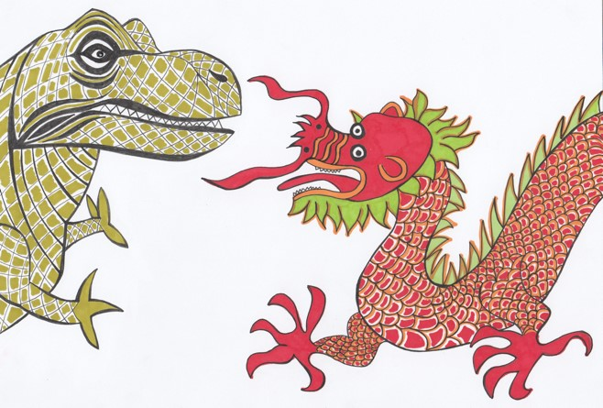

DRAFT POEM - Insulting a teddy bear

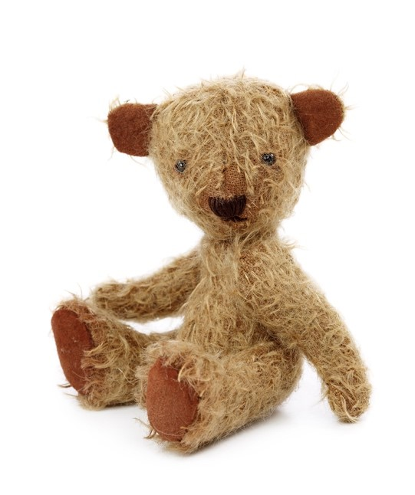

You!

You!
You would lose your ears if they weren't stuck stitched to your head.
You!
You bore me with your [endless] chatter about honey and bees.
You!
You are as lazy as a cat, stretched out in the summer's sun.
You!
You sit there like a [saggy] sack of potatoes, sat slumped in the corner.
You!
You never help me tidy my room.
You!
You are as useless as a dried up felt tip.

[additions on rereading] amendments on rereading

Planner

Insulting...
You are as lazy as a cat, stretched out in the summer's sun.
Prepositions: with, of, by, from, on, under, below, between, inside, next to, over, by, in, against

Insult Poem
Write your own insult poem here.

I'm Telling You

I'm as wise as an owl.
I'm as cunning as a cat.
You're as slimy as a snail.
You're as dirty as a rat.

I'm as brave as a lion.
I'm as strong as an ox.
You're as weak as a kitten.
You're as sneaky as a fox.

I'm as bright as a button.
I'm as hard as nails.
You're as useless as a yacht
Without any sails.

Sean Forbes

