What to do today
IMPORTANT Parent or Carer – Read this page with your child and check that you are happy with what they have to do and any weblinks or use of internet.

1. Listen to a story
- Listen to the last part of Sinbad’s Fifth Voyage
https://www.youtube.com/watch?v=F-3PjZu_5WY
Start the story from 11.15, watch until the end.
- Use Story Summary to re-tell the story in four scenes. Write 2/3 clear and interesting sentences for each scene and, if you want, illustrate the last two.

2. Read another version of the story
- Read Traditional Version – Part 1. This is a different version than the one that Wilf told. Write differences and similarities spotted on the Comparison Table. Which version do you prefer? Why?
- Read Traditional Version Part 2 and complete the Comparison Table for this. Challenge yourself to do Part 3 as well.

3. Now for some writing
- Choose one of the Sinbad Illustrations.
- Write down this part of the story. What has happened before the illustration? What will happen after it.
- Try to include conjunctions and prepositions in your writing.

Well done. Show your writing and the illustration to a grown-up. Can they spot any conjunctions or prepositions that you have used?

Try these Fun-Time Extras
Can you learn to tell the story of Sinbad and the Coconuts?
Can you tell all three parts of the whole of the fifth voyage story, one after another? You can use your Story Summaries to help you.

Story Summary

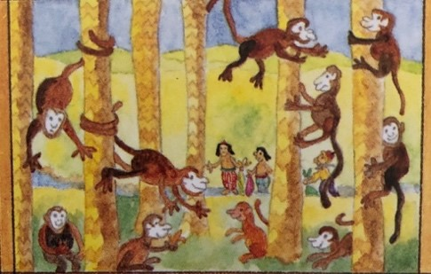 | _____________________________________  _____________________________________  _____________________________________  _____________________________________  _____________________________________  _____________________________________
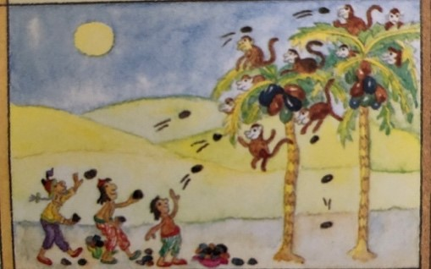 | _____________________________________  _____________________________________  _____________________________________  _____________________________________  _____________________________________  _____________________________________
Draw picture | _____________________________________  _____________________________________  _____________________________________  _____________________________________  _____________________________________  _____________________________________
Draw picture | _____________________________________  _____________________________________  _____________________________________  _____________________________________  _____________________________________  _____________________________________

Traditional Version – Part 1
And our journey prospered, until one day we reached a small island floating in the sea. I did not have any particular interest in this deserted place, and I remained below deck.

Some of the merchants were curious to investigate an unusual rock on the shore. It lay half buried in the sand, the top half forming a great white dome. When they ran their hands over its smooth surface, it felt to them like an egg. They bashed it with stones until it cracked open and water gushed out. Inside they found a giant chick which soon made a fine dinner.

The smell of the roast meat met my nostrils as I lay in my bunk, and I heard the merry merchants as they made a party of it. I got to my feet and waded ashore, keen to join the feast. When I saw the broken eggshells and the giant roast chick I fell down on my knees and cried: “In the name of Allah the merciful and the great, we are doomed. Do you not realise what you have done? You have killed the young of a roque - a monstrous bird who will soon return and reap vengeance for this folly.”

We splashed through the surf, reboarded our ship, and set out for the open sea. We had not got far before we saw the silhouette of a giant bird that held a great boulder in its talons. He dropped this load so that it landed by the side of our ship.

The waters opened to reveal the bottom of the sea and down we slid into the great trough before being tossed up again onto the foaming summit of a mountainous wave. Our ship was not sunk until a second, larger bird dropped a stone that cut through the deck and now we were ruined.

I swam for my life among the surging surf and grabbed hold of a piece of wreckage. A while later, by permission of The Most High, I was washed ashore, half drowned, on the beach of another island.

Adapted from https://www.storynory.com/the-fifth-voyage-of-sinbad/

Traditional Version – Part 2

I found myself in a kind of paradise, home to sweet smelling flowers, delicious low hanging fruit, and birds singing the praises of the one who is eternal. A mossy bank was my pillow for the night, by the side of a stream. In the morning when I awoke I saw, sitting not far from me, an old man dressed in a skirt of palm leaves. He made signs, as if begging me to pick him up on my shoulders and carry him across the water. I thought to myself: “I may profit in Heaven if I help this old man,” and I did as he asked, and let him climb onto my shoulders.

I waded across the water and knelt down to let him clamber back onto the ground. But he did not leave my shoulders. Instead he wrapped his leathery legs around my neck, half strangling me. I was finding it hard to breath, and for a moment the world went black to me and I lost consciousness. I came round a few moments later, and felt the old man, still on my shoulders, now kicking my sides. The pain forced me to rise again to my feet. Then he pointed for me to take him among the fruit trees, so that he could reach up and grab whatever he wanted to take and eat. If ever I refused to do his bidding, he beat or strangled me into submission.

It happened one day that we came to a part of the island where the ground was covered by gourds. These were large fruits with hard outer skins. An idea came to me to relieve my pain. I broke open a number of these gourds and scooped out the flesh of the fruit to make them into cups. Then I gathered some grapes that grew nearby and placed them inside the gourds, and pulverised them with a rock. After leaving these vessels in the sun for a few days, they fermented and turned into strong wine.

I handed a gourd of wine up to him. He too drank from it and began to get merry. Soon he demanded another, and another, and I obliged until eventually the wine got the better of him and he fell asleep. For the first time in weeks, I felt that the grip of his legs around my neck had loosened. Taking my chance, I tossed the devil off my shoulders and onto the ground.

Adapted from https://www.storynory.com/the-fifth-voyage-of-sinbad/

Traditional Version – Part 3

The captain transported me freely to the next Island where the capital is known as the City of the Apes. Here, even the strong walls of the city do not protect the people from an uncomfortable fate. Every evening when it grows dark, apes come down from the trees and invade the city. To avoid them, the people have no choice but to leave their houses and sleep in boats.

It was my good fortune to fall in with some business minded folk who showed me how they made the best of this ill luck. Every day they collected pebbles on the beach, and then stepped a little way into the forest and pelted the apes who lived in the trees. The apes responded by throwing back coconuts. This battle of stone and coconut took place every day, but the trade was fair, because the people picked up the nets and took them to trade in the market. I joined in this amusing but dangerous sport, and Allah permitted me to make a fair profit, day after day, until I had massed a good sum of money.

When I was once again well off, I hired a passage on a passing ship. While travelling on my way back I traded my gold for pearls and made an even greater profit.

By the time I reached the welcome port of Basrah, I had amassed a fifth fortune to add to my others.

Adapted from https://www.storynory.com/the-fifth-voyage-of-sinbad/
Comparison Table
Write what you notice about the traditional version and Wilf’s. One example has been done for you.
Similarities | Differences
There’s a giant bird in each story. | Wilf doesn’t say that the bird is called a roque.  In the traditional version, the sailors eat a chick rather than the egg.

Sinbad Illustrations
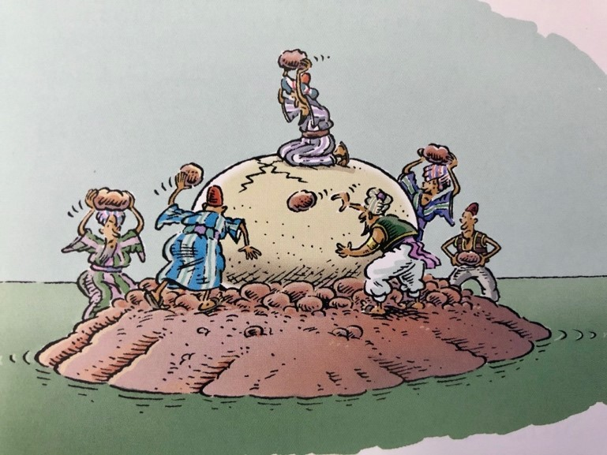
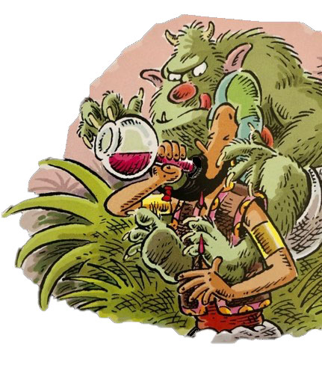
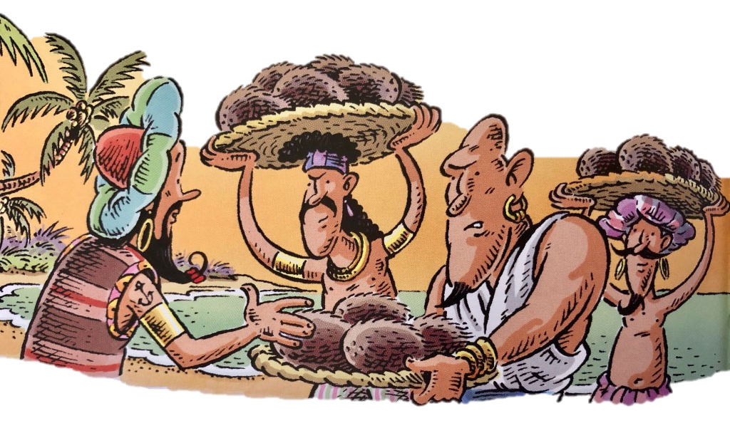
from The Adventures of Sinbad the Sailor illustrated by Paddy Mounter

Sinbad Writing
Choose one of the illustrations and write that part of the story here.
Try to include prepositions and conjunctions in your writing.

