What to do today
IMPORTANT Parent or Carer – Read this page with your child and check that you are happy with what they have to do and any weblinks or use of internet.

1. Listen to a story
- Read Sinbad Introduction 1 and 2. Have you heard about this set of stories? What do you think might happen?
- Listen to the first part of the story of Sinbad’s Fifth Voyage.
https://www.youtube.com/watch?v=F-3PjZu_5WY
Stop the video at 6:20
What did you like about the story? Was there anything about it that you disliked? Did it remind you of anything else that you have read or seen?

2. Retell the story
- Use Story Summary to retell the story in four parts.
- Write 2/3 clear sentences for each box. The first has been done for you. Draw pictures to match the last two summaries.

3. Remind yourself about clauses and conjunctions
- Use the PowerPoint up to Slide 6 on clauses and conjunctions or, if this is not possible, use the Revision Card to remind yourself of this topic.
- Complete Multi-Clause Sentences.

Well done. Show your writing about to a grown-up. Can you tell them the story of Sinbad so far and show them the sentences that you have written?

Try the Fun-Time Extra
Use your Story Summary to practise telling the story. Perhaps make a recording of yourself telling the story and share it with someone else.

Sinbad Introduction 1

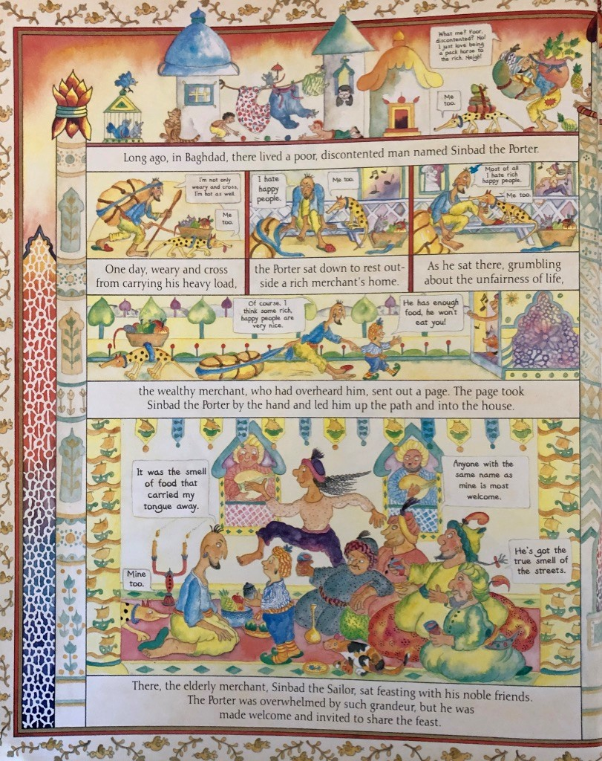

Sinbad Introduction 2

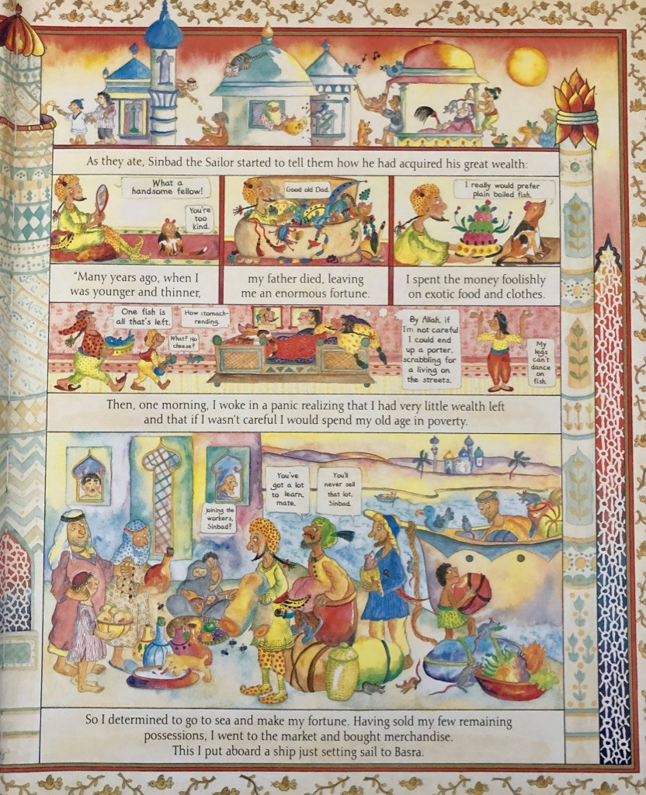

from Marcia William’s Sinbad the Sailor
Story Summary

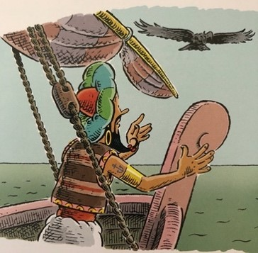 | Sinbad and his crew had journeyed so long that they had stopped counting the days. Now, worryingly, they were growing short on provisions. Desperate, Sinbad surveyed the sea, willing land to appear.
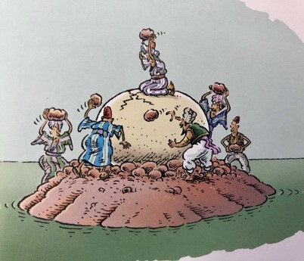 | _____________________________________  _____________________________________  _____________________________________  _____________________________________  _____________________________________  _____________________________________
Draw picture | _____________________________________  _____________________________________  _____________________________________  _____________________________________  _____________________________________  _____________________________________
Draw picture | _____________________________________  _____________________________________  _____________________________________  _____________________________________  _____________________________________  _____________________________________

Revision Card – Conjunctions

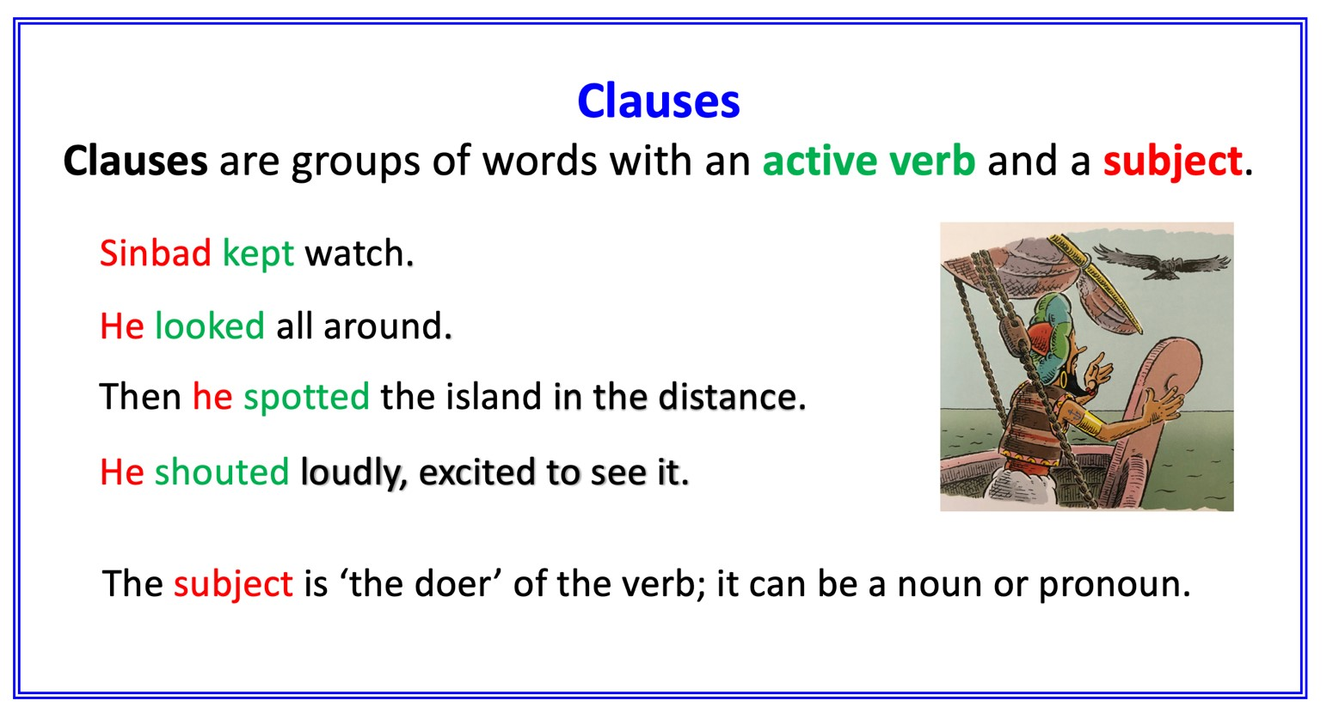
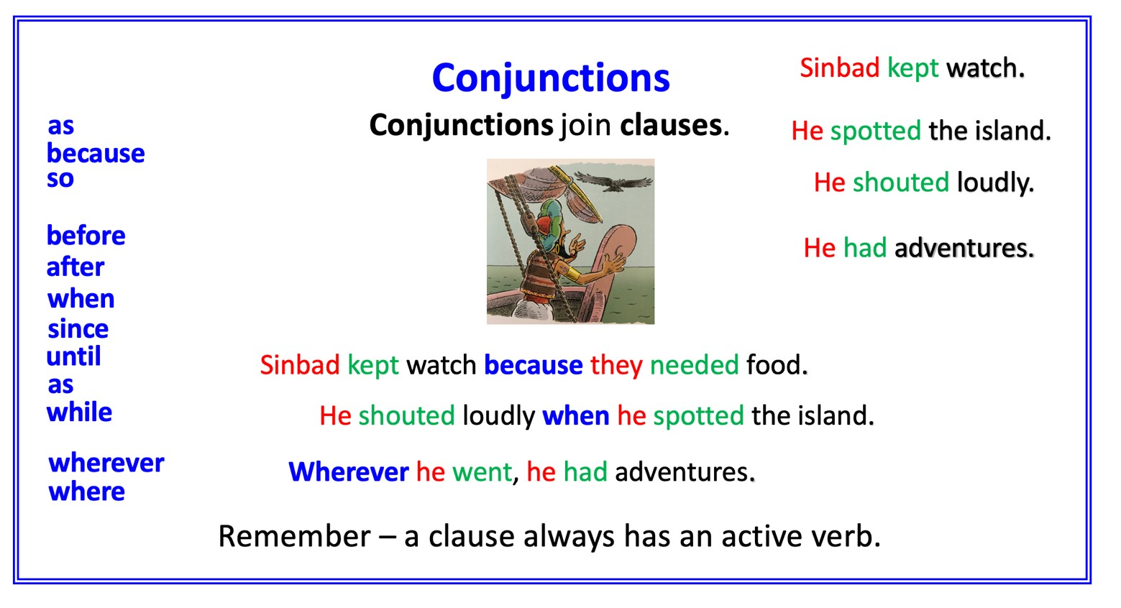

Multi-Clause Sentences

Underline the conjunctions that have been used in these sentences

- As I was already a rich man, I was able to buy the ship.

- The men loaded my goods onto the ship and other merchants paid me to use the space that was left over.

- Our journey prospered until one day we reached a small island floating in the sea.

- I did not have any particular interest in this deserted place so I remained below deck.

- When they ran their hands over its smooth surface, it felt to them like an egg.

Choose the best conjunction to complete the sentence.

- He saw a beautiful new ship at the port __ he decided to buy it.

- ____ it set sail, the ship was loaded with silks and spices.

- _____ they travelled, they traded and made more riches.

- Their provisions were running low ___ they had been travelling so long.

- Hope had almost disappeared ___ a small island was spotted.

Add a new clause to make a multi-clause sentence

- we saw the silhouette of a giant bird

- the bird held a great boulder in its talons

- the boulder landed hard on the boat

- the waters opened to reveal the bottom of the sea

- I swam for my life

Conjunction List

because | while | wherever | after | before | so
since | when | whenever | until | where | as

Multi-Clause Sentences ANSWERS

Underline the conjunctions that have been used in these sentences

- As I was already a rich man, I was able to buy the ship.

- The men loaded my goods onto the ship and other merchants paid me to use the space that was left over.

- Our journey prospered until one day we reached a small island floating in the sea.

- I did not have any particular interest in this deserted place so I remained below deck.

- When they ran their hands over its smooth surface, it felt to them like an egg.

Choose the best conjunction to complete the sentence.

- He saw a beautiful new ship at the port so he decided to buy it.

- When it set sail, the ship was loaded with silks and spices.

- As they travelled, they traded and made more riches.

- Their provisions were running low because they had been travelling so long.

- Hope had almost disappeared when a small island was spotted.

Add a new clause to make a multi-clause sentence
Suggestions

- As we gazed upwards, we saw the silhouette of a giant bird

- Then we saw that the bird held a great boulder in its talons

- The boulder landed hard on the boat, which splintered into pieces.

- The waters opened, as we gazed in horrified silence, to reveal the bottom of the sea

- I swam for my life since that was my only chance of survival.

