What to do today
IMPORTANT Parent or Carer – Read this page with your child and check that you are happy with what they have to do and any weblinks or use of internet.

1. Watch a video message
- Watch another ‘Message to myself in six months’ time’
https://www.youtube.com/watch?v=ahr9_4l-Fok
- Deanna remembers seven things. Make Jottings of as many as you can remember, then watch the video again and jot down what you missed.
- Which of these things is most like something that you will remember?

2. Remind yourself about expanded noun phrases.
- Use the PowerPoint on Expanded Noun Phrases, or, if this is not possible, use the Revision Card to remind yourself about it.
- Complete Noun Phrase Builder.

3. Now for some writing
- Use the rows from the Noun Phrase Builder.
- Add a Preposition after the head noun and write a prepositional phrase that gives even more detail to your noun.
- Write your sentences out carefully and try writing some of your own, with expanded noun-phrases, to describe some part of lock-down.

Well done. Show your sentences to a grown-up. Show them the examples of the different word classes that you have used: nouns, determiners, adjectives, adverbs, prepositions.

Try the Fun-Time Extra
- For the next week, make a list at the end of each day of five things that you have most enjoyed and will most remember. Write descriptively so that you will vividly remember those things. Tell someone about your list or keep it just for you! Plan to read it in six months’ time.
Jottings

What seven things does Deanna say that she will remember?

Revision Card – Expanded Noun Phrases

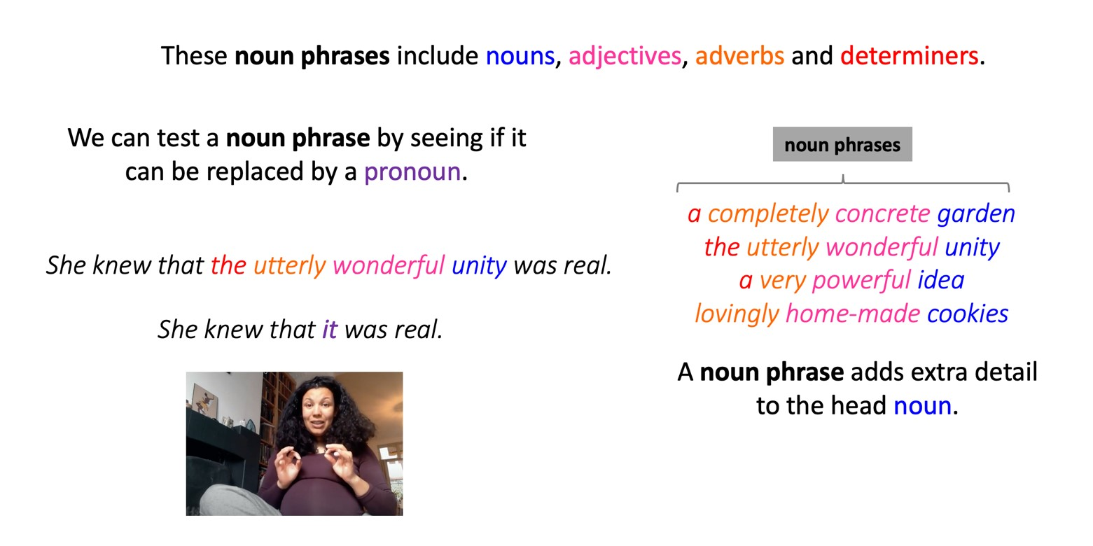
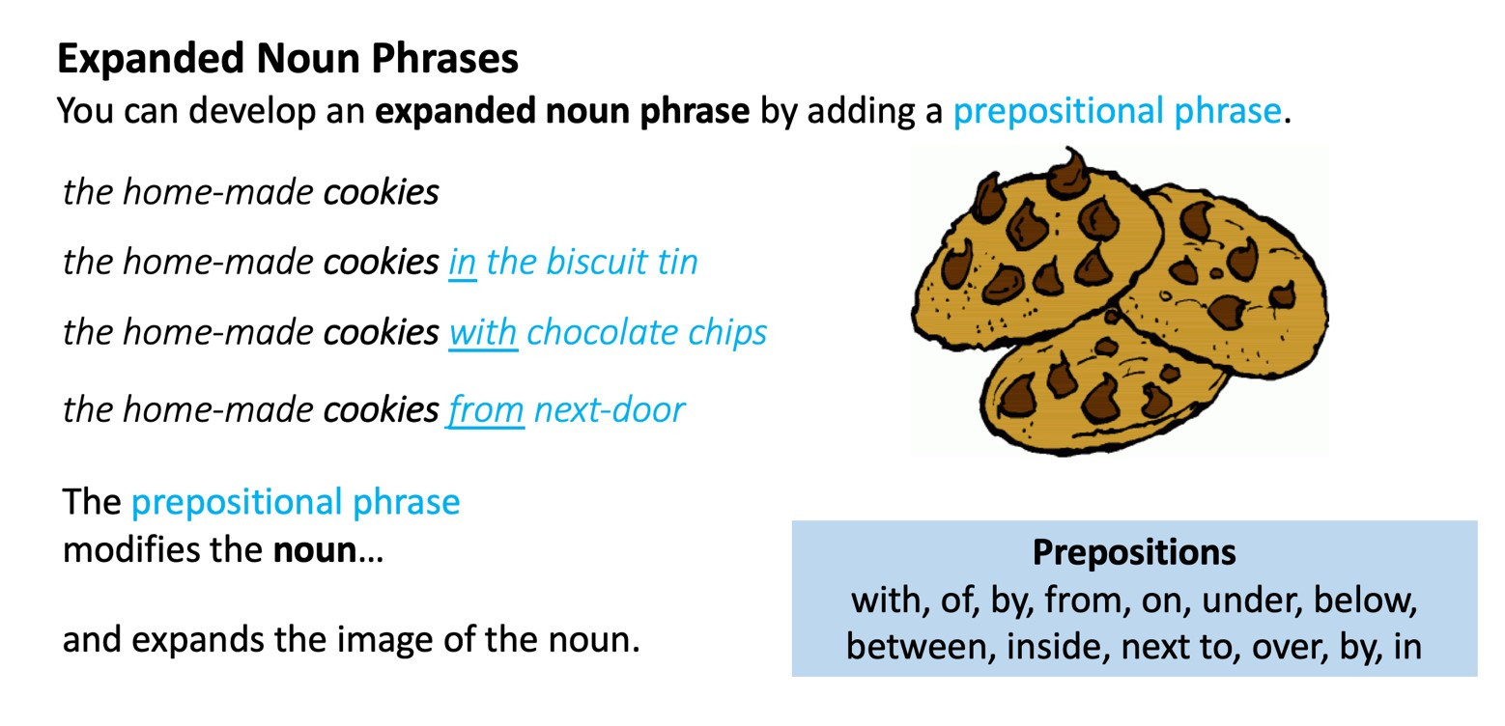

Noun Phrase Builder
Complete the table.
You don’t have to fill in each column every time!

determiner | adverb | adjective | adjective | head noun
the | amazingly | chewy | delicious | cookies
 |  |  |  | playing
 |  |  |  | laughing
 |  |  |  | dance
 |  |  |  | game
 |  |  |  | smile

Preposition
with
of
by
from
on
under
below
between
inside
next to
over
by
in/to
against

Your Sentences

Use the Noun Phrase Builder rows and add prepositional phrases to make descriptive sentences.

