What to do today
IMPORTANT Parent or Carer – Read this page with your child and check that you are happy with what they have to do and any weblinks or use of internet.

1. Watch a short video message
- Watch ‘Message to myself in six-months time’
https://www.youtube.com/watch?v=B4lraxptJjs *
- Read Listening Questions. Which of these can you answer already? Watch the video message again. Which can you answer now? Write sentence answers.

2. Remind yourself about informal and formal language
- Use the PowerPoint on Formal and Informal Language. If this is not possible, remind yourself using the Revision Card.
- Complete Apostrophes in Contractions.

3. Note initial ideas
- Think about what you might say to yourself in six-month’s time.
- Try to think of 6-10 ideas and record them on Idea Notes. You’ll pick the best ones to work with on Day 2.

Well done. Talk about your ideas with a grown-up. You can check your answers to Listening Questions and Apostrophes in Contractions at the end of this pack.

Try the Fun-Time Extra
Use the Transcript and try to re-write Laura Smyth’s message so that it is very formal. Try at least one paragraph. You could try all three. Read your writing aloud. How does it sound?

*This video is opens with the line, ‘Pity about the weight gain…’ so if you want to avoid this, start at 13 seconds in. If you email us, we can send you a version of this day with the questions changed.

Listening Questions

What did Laura say sorry for?

What two things did she say in her defence?

What was her hope for her future self about this?

What phrase does Laura repeat?

Why does she repeat this?

What four things does Laura ask about specifically?

What advice does Laura give herself?

Who does she mention in particular?

Revision Card – Formal and Informal

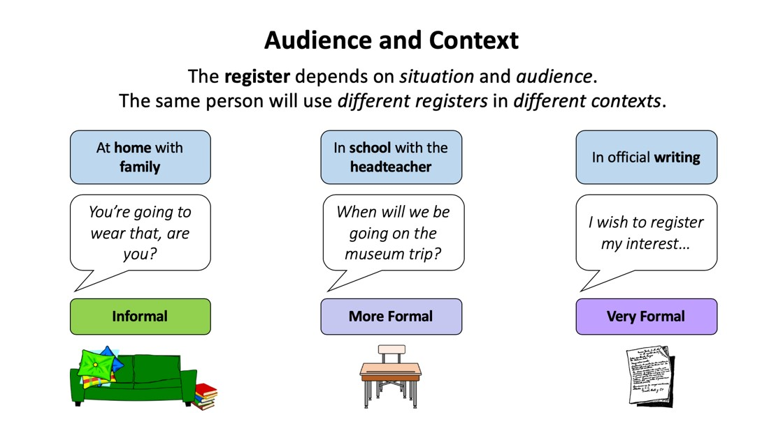
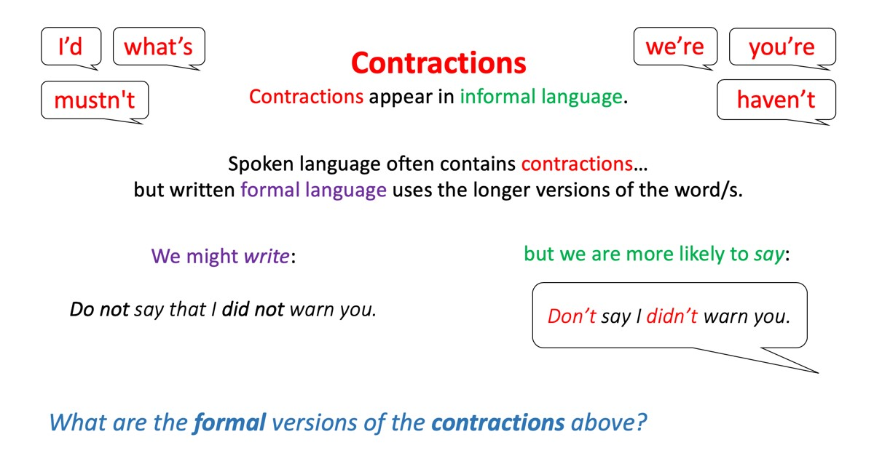

Apostrophes in Contractions

1. Contract these pairs of words.

she | will | She’ll
you | had
must | not
I | would
does | not
I | have
can | not

2. Place the contractive apostrophe in these words.

weve | dont | hell
itll | shouldnt | theyre
wouldve | youre | Ill
theyd | couldnt | mustve

3. Is the apostrophe in the right place in these words? Write T for True or F for False next to each one. Correct those that are wrong.

could’nt | we’ll | you’re
the’yd | thatl’l | you’dv’e
mustn’t | its’ | jack o’ lantern
o’clock | we’d’ve | you’ll
sh’ed | Hallowe’en | did’nt

Ideas

What would you say to yourself in six months’ time? You could use some of Laura’s ideas:

- What might you jokingly say sorry for?
- What advice might you give?
- What might you ask about in particular?
- Who might you ask about?

Try to note down 6-9 ideas.

Laura Smyth Transcript

Hello me in six months’ time.

Firstly, sorry about all the weight gain but, in my defence, I was house-bound and not wearing work-trousers so hope you’re on top of that.

How are you? I mean that. Because we actually mean it at the minute. When we’re asking. I don’t know if you remember. When we’re checking in with each other we really actually care about the answer.

How are you? How’s your health? How’s your kids? How’s your family? How’s your head? Are you keeping it together? Keep looking out for each other, OK. Don’t take each other for granted.

How’s Mum? Listen, we are really missing her. Don’t take her for granted, OK? We are really missing her. And not just the childcare, OK?

Listening Questions - ANSWERS

What did Laura say sorry for?
She says sorry for all the weight gain.
What two things did she say in her defence?
In her defence, she says that she was house-bound and not wearing work-trousers.
What was her hope for her future self about this?
She hopes that her future-self is ‘on top of that.’
What phrase does Laura repeat?
She repeats: ‘How are you?’
Why does she repeat this?
She repeats it because she says that people really mean it when they ask it at the moment.
What four things does Laura ask about specifically?
She asks about health, kids, family and head.
What advice does Laura give herself?
She advises herself to keep looking out for others.
Who does she mention in particular?
She mentions her mum in particular.
Apostrophes in Contractions - ANSWERS

1. Contract these pairs of words.

she | will | she’ll
You | had | you’d
must | not | mustn’t
I | would | I’d
does | not | doesn’t
I | have | I’ve
can | not | can’t

2. Place the contractive apostrophe in these words.

we’ve | don’t | he’ll
it’ll | shouldn’t | they’re
would’ve | you’re | I’ll
they’d | couldn’t | must’ve

3. Is the apostrophe in the right place in these words? Write T for True or F for False next to each one. Correct those that are wrong.

could’nt | F | we’ll | T | you’re | T
the’yd | F | thatl’l | F | you’dv’e | F
mustn’t | T | its’ | F | jack o’ lantern | T
o’clock | T | we’d’ve | T | you’ll | T
sh’ed | F | Hallowe’en | T | did’nt | F

