What to do today
IMPORTANT Parent or Carer – Read this page with your child and check that you are happy with what they have to do and any weblinks or use of internet.

1. Listen to a story
Listen to Voices in the Park. https://youtu.be/58kla7Ghxas
- What did you like about the story? Which was your favourite character? Why do you think the author wrote this book?

2. Read the different voices
- Read Voice A, B, C and D. (They are in a different order to the book).
- Read Voices Questions and write your answers as clear sentences.

3. Now for some writing
- Imagine what the two dogs might have noticed most about the trip to the park. Write notes about your ideas on Victoria and Albert.
- Choose one of the dogs and write about the trip to the park in their voice.

Well done. You can check your answers to the Voices Questions at the end of the pack. Show your writing to a grown-up. Show them how you have made the dog spot and notice different things to the other voices in the story.

Try the Fun-Time Extra
Try writing about something that happens in your house in at least two different voices.
Voice A

Dad had been really fed up, so I was pleased when he said we could take Albert to the park. Albert’s always in such a hurry to be let off his lead. He went straight up to this lovely dog and sniffed its bum (he always does that). Of course, the other dog didn’t mind, but its owner was really angry, the silly twit.

I got talking to this boy. I thought he was a bit of a wimp at first, but he’s okay. We played on the see-saw and he didn’t say much, but later on he was a bit more friendly.

We both burst out laughing when we saw Albert having a swim. Then we all played on the bandstand, and I felt really, really happy.

Charlie picked a flower and gave it to me Then his mum called him and he had to go. He looked sad. When I got home I put the flower in some water, and made Dad a nice cup of tea.

Voice B

I needed to get out of the house, so me and Smudge took the dog to the park.

He loves it there. I wish I had half the energy he’s got. I settled on a bench and looked through the paper for a job. I know it’s a waste of time really, but you’ve got to have a bit of hope, haven’t you?

Then it was time to go. Smudge cheered me up. She chatted happily to me all the way home.
Voice C

It was time to take Victoria, our pedigree Labrador, and Charles, our son, for a walk. When we arrived at the park, I let Victoria off her lead. Immediately some scruffy mongrel appeared and started bothering her. I shooed it off, but the horrible thing chased her all over the park.

I ordered it to go away, but it took no notice of me whatsoever. “Sit,” I said to Charles. “Here.”

I was just planning what we should have to eat that evening when I saw Charles had disappeared. Oh dear! Where had he gone?

You get some frightful types in the park these days! I called his name for what seemed like an age.

Then I saw him talking to a very rough-looking child. “Charles, come here. At once!” I said. “And come here please, Victoria.”

We walked home in silence.

Voice D

I was at home on my own again. It’s so boring. Then mummy said that it was time for our walk. There was a very friendly dog in the park and Victoria was having a great time. I wished I was.

“D’you wanna come on the slide?” a voice asked. It was a girl, unfortunately, but I went anyway. She was brilliant on the slide, she went really fast. I was amazed.

The two dogs raced round like old friends.

The girl took off her coat and swung on the climbing frame, so I did the same.

I’m good at climbing trees, so I showed her how to do it. She told me her name was Smudge – a funny name, I know, but she’s quite nice. Then Mummy caught us talking together and I had to go home. Maybe Smudge will be there next time?

Voices Questions

Read the extracts: Voice A, Voice B, Voice C, Voice D.

- Draw a line to show which character is which voice.
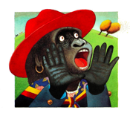 |  | Voice A
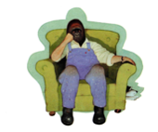 |  | Voice B
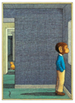 |  | Voice C
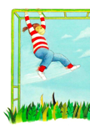 |  | Voice D

- How can you tell that Charles’ mother doesn’t like the dog Albert?
- Find a quote that shows how Charles’ mother treats him.
- Why didn’t Smudge’s father notice the dogs playing?
- How do you think Smudge’s father would describe Smudge?
- How can you tell that Charles likes Smudge? (Give two reasons)
- What is Charles proud to show Smudge?
- What did Smudge think of Charles’ mother?
- What did Smudge think of Charles at first?
- What things does Smudge report that Charles doesn’t mention?

Victoria and Albert

Victoria | 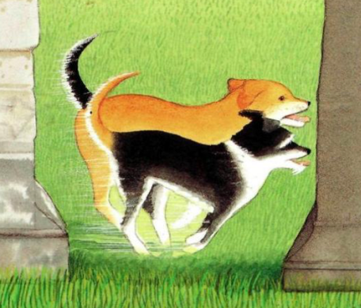 | Albert

A Dog’s Story

Voices Questions ANSWERS

Voice A – Smudge, Voice B – Smudge’s dad, Voice C – Charles’ mum; Voice D - Charles

- How can you tell that Charles’ mother doesn’t like the dog Albert?
She describes him as ‘a scruffy mongrel’ and says that he is ‘bothering Victoria’.
- Find a quote that shows how Charles’ mother treats him.
“Sit,” I said to Charles. “Here.” OR We walked home in silence.
- Why didn’t Smudge’s father notice the dogs playing?
He was reading the paper, looking for jobs.
- How do you think Smudge’s father would describe her?
Smudge’s Dad would describe her as cheerful and helpful – she chatted to him and makes him a cup of tea.
- How can you tell that Charles likes Smudge? (Give two reasons)
He describes her as ‘Quite nice’ and also implies that he hopes she will be in the park next time he comes.
- What is Charles proud to show Smudge?
Charles is proud to show her that he’s good at climbing trees
- What did Smudge think of Charles’ mother?
Smudge thought that Charles’ mother was a silly twit because she didn’t like the dogs sniffing each other’s bums!
- What did Smudge think of Charles at first?
Smudge thought that Charles was a bit of a wimp at first.
- What things does Smudge report that Charles doesn’t mention?
Smudge says that they played on the see-saw, watched Albert having a swim and played on the bandstand. She also says that Charles picked a flower and gave it to her.

