What to do today
IMPORTANT Parent or Carer – Read this page with your child and check that you are happy with what they have to do and any weblinks or use of internet.

1. Listen to both stories
- Listen to each of the stories again:
The Night Shimmy https://youtu.be/h7ypmw-0JU0 and Silly Billy https://youtu.be/vHiW5ndFNQQ
- What do you notice when you hear these stories for a second time?

2. Compare the two stories
- Think about what is the similar and what is different between the two stories.
- Complete Comparison Questions, writing in clear sentences.

3. Describe your own magical toy or object
- Eric has the parrot, Billy has worry-dolls. What magical toy or object would you have to protect you from bad dreams and worries?
- Describe your toy or object carefully and then draw an illustration to show how it protects against worries and bad dreams.

Well done. Show your drawing and description to a grown-up. What do they do to help them with bad dreams and worries?

Try the Fun-Time Extra
Imagine that Billy and Eric met each other. How would they tell each other their story? Write what they would say to one another.

Comparison Questions

How are the starts of each story similar? How are they different?

How are the ends of each story similar? How are they different?

In what ways are Billy and Eric similar? Write three things that are similar.
In what ways are they different? Write three things.

How are Grandma and Marcia similar? How are they different?

Which story do you prefer? Why?

Your magical toy or object

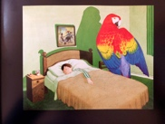 | 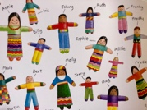

Think of the magical toy or object that you would have to take away bad dreams and worries. Write a description of it, then draw an illustration showing how it takes away worries and bad dreams.

