What to do today
IMPORTANT Parent or Carer – Read this page with your child and check that you are happy with what they have to do and any weblinks or use of internet.

1. Make predictions
- Look at the Front Cover. What do you think this story could be about? What could the Night Shimmy be? What might they do?
- Read the First Page. Write down four things that you know about Eric? What can you guess about him? Does he remind you of anyone? What might he do with the Night Shimmy?

2. Listen to the story
- Listen to the Night Shimmy by Gwen Strauss being read by Ruth Merttens: https://youtu.be/h7ypmw-0JU0
- What do you like about the story? Is there anything that you dislike about it? What did it remind you of? Anything that you have read or seen or anyone that you know? What questions would you like to ask the author?

3. Investigate artwork
- Look closely at Images 1-4.
- Read the Artwork Questions. Think about your answers and then write them in clear sentences.

Well done. Show the Images to a grown-up. Ask them what they notice and tell them what you spotted. Explain the story of The Night Shimmy to them.

Try the Fun-Time Extras
Design your own-super hero friend like The Night Shimmy. What would they look like?
Imagine what Eric and Marcia are talking about in Image 4. Write their conversation, using speech-marks.

Front Cover
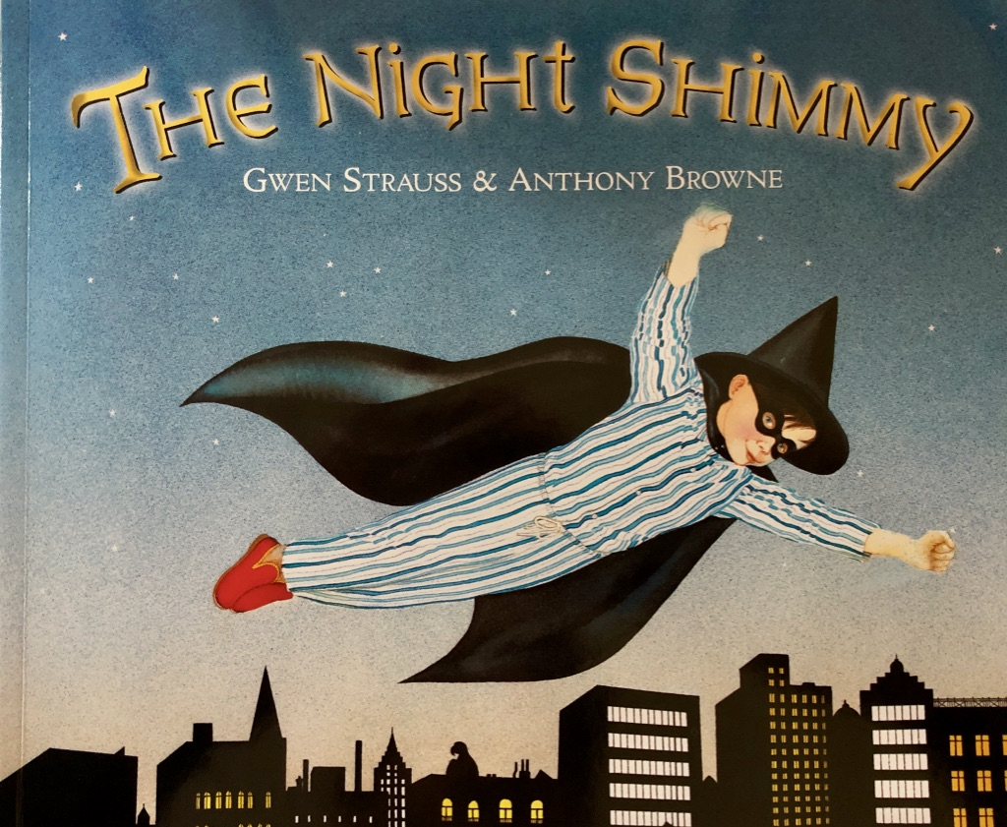

First Page

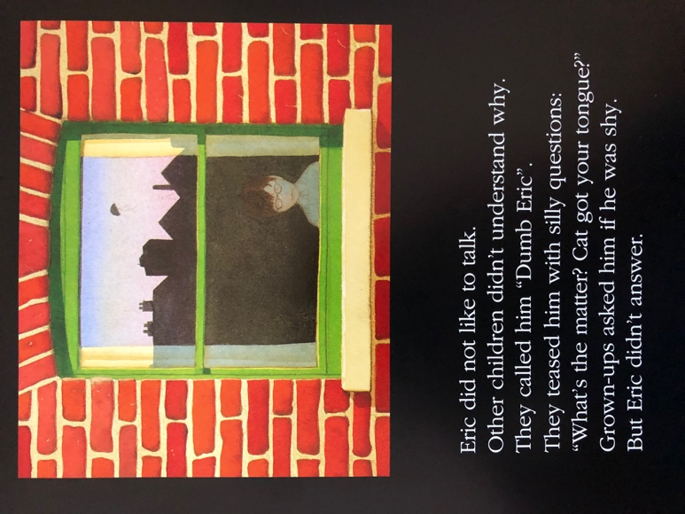

Eric did not like to talk.
Other children didn’t understand why.
They called him “Dumb Eric”
They teased him with silly questions:
“What’s the matter? Cat got your tongue?”
Grown-ups asked him if he was shy.
But Eric didn’t answer.

Image 1
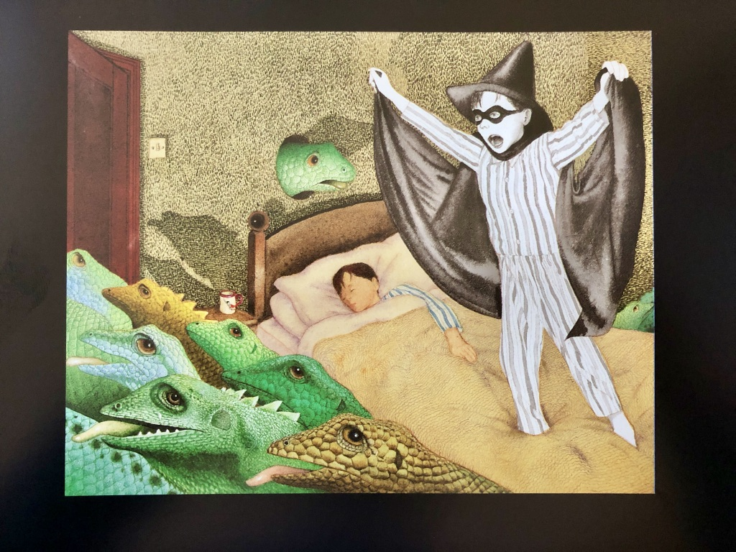

Image 2
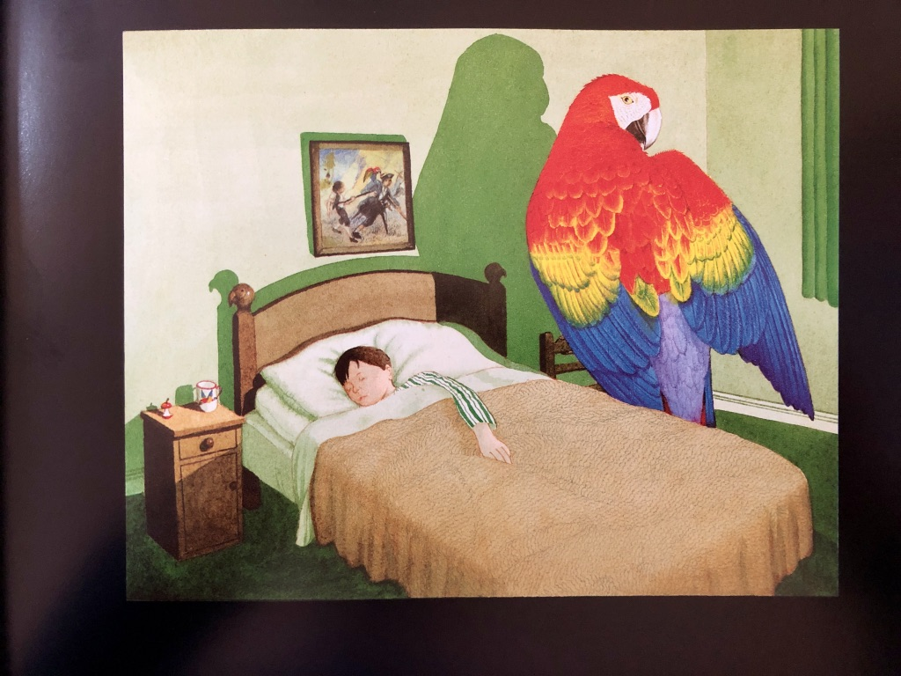

Image 3
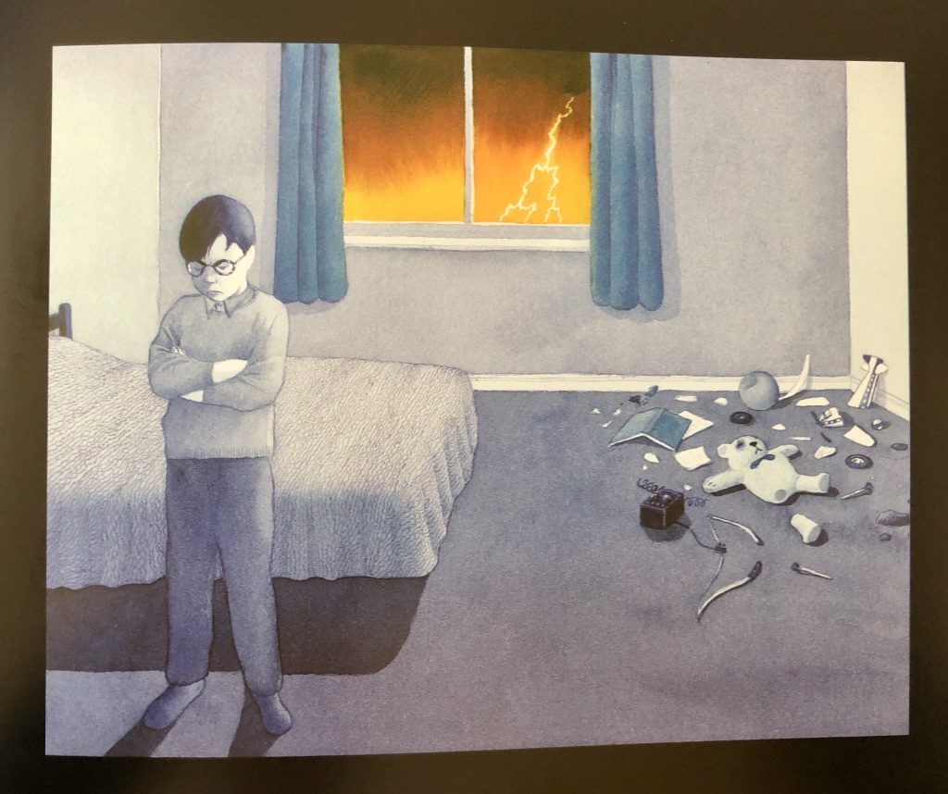

Image 4
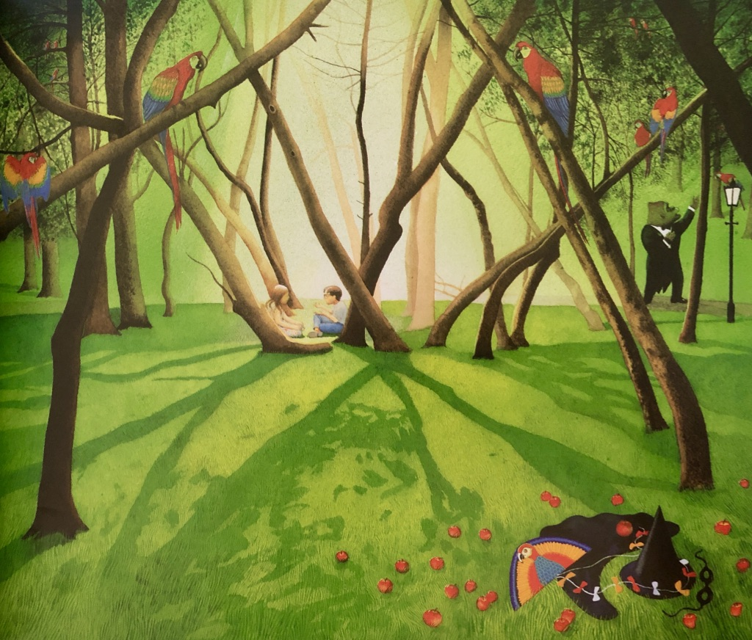

Artwork Questions

Look at Image 1
What is your first reaction to this image? Why do you think you had that reaction?
What do you think is happening in this picture?
Why do you think the Night Shimmy is in black and white?

Look at Image 2
What adjectives could you use to describe this picture?
Why is there a giant parrot in Eric’s bedroom?
What do you notice about the mug, the top of Eric’s bed and the picture on his wall?

Look at Image 3
Why do you think everything is grey and blue apart from the sky through the window?
What emotions do you notice in the artwork?
What do you think Eric might be thinking?

Look at Image 4
What can you notice in this picture that someone else might not spot?
Why do you think that all the other pictures have a black frame around them and this one doesn’t?
What do you think Eric and Marcia might be saying?

