What to do today
IMPORTANT Parent or Carer – Read this page with your child and check that you are happy with what they have to do and any weblinks or use of internet.

1. Read a draft poem
- Read the Draft Poem that has been written about insulting a Teddy Bear.
- Spot the changes that the writer made when they re-read the poem. How have they improved the poem? Which lines in the poem do you like best? Why?

2. Write your own insult poem
- Decide what you will insult. Make it a toy or an object not a person!
- Use the Planner to write down ideas for insults. You can use some of the ideas in the teddy bear poem or from Day 4’s poems.
- Choose your favourite ideas and put them in a good order for a poem.
- Read your poem through and make changes to improve it.

3. Practise performing your poem.
- Read Top Tips for Reading a Poem Aloud.
- Practise reading your poem, until you are able to read it really confidently.
- Share your performance with somebody else.

Try these Fun-Time Extras
- Make a set of illustrations for your poem.
- Write some more verses for I’m Telling You. You need two boasts and two insults for every verse that you write!

DRAFT POEM - Insulting a teddy bear
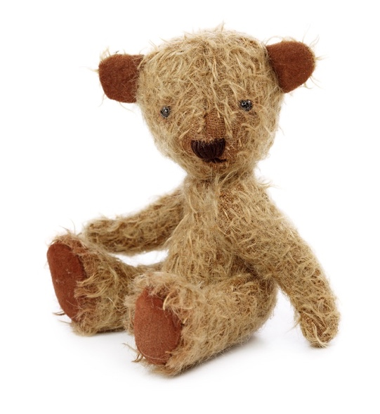
You!

You!
You would lose your ears if they weren't stuck stitched to
your head.
You!
You bore me with your [endless] chatter about honey and
bees.
You!
You are as lazy as a cat, stretched out in the summer's sun.

You!
You sit there like a [saggy] sack of potatoes, sat slumped in
the corner.
You!
You never help me tidy my room.

You!
You are as useless as a dried up felt tip.

[additions on re-reading] amendments on re-reading

Planner

Insulting...
You are as lazy as a cat, stretched out in the summer's sun.
Prepositions: with, of, by, from, on, under, below, between, inside, next to, over, by, in, against

Insult Poem
Write your own insult poem here.

Top tips for reading a poem aloud

- Work on the tricky words. Find out what they mean and how they are said. Practise saying them.
- Look for the full stops. Make sentences flow to the full stop, even when there’s a new line.
- Slow down. Speak slowly when you’re reading a poem, so that others can hear the words.
- Project your voice. Imagine someone on the other side of the room and speak to them.
- Practise. Read and read and read your poem, so that you get better each time.

I'm Telling You

I'm as wise as an owl.
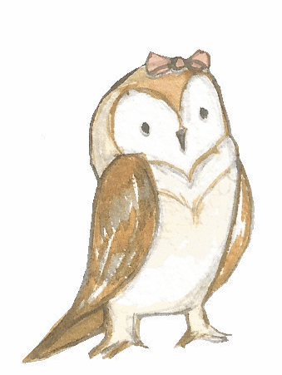
I'm as cunning as a cat.
You're as slimy as a snail.
You're as dirty as a rat.

I'm as brave as a lion.
I'm as strong as an ox.
You're as weak as a kitten.
You're as sneaky as a fox.

I'm as bright as a button.
I'm as hard as nails.
You're as useless as a yacht
Without any sails.

Sean Forbes

