What to do today
IMPORTANT Parent or Carer – Read this page with your child and check that you are happy with what they have to do and any weblinks or use of internet.

1. Read an insult poem
- Read the poem, You. Read it in your head and then out loud. (Read it quietly out loud, you don’t want anyone to think you’re saying it about them!)
- What did you like about the poem? Did it remind you of anything else that you have read or seen? Which is your favourite line? Why is it called an insult poem?

2. Investigate vocabulary
- Read Vocabulary for Villains. Underline unusual vocabulary.
- Choose five words that you think are most interesting or which you are least sure about. Find out their meaning. You could use a book dictionary or this website:
https://kids.wordsmyth.net/we/
- Write sentences that use these words.

3. Learn a poem by heart
- Read I’m Telling You.
- Practise learning this poem off by heart. You could use Top Tips for Learning a Poem by Heart to help you.

Well done. Try performing the poem to somebody else. Which bits can you remember well and which are more tricky?

Try the Fun-Time Extra
- Choose your favourite of these three poems. Copy it out in your best handwriting and add illustrations.

You!

You!
Your head is like a hollow drum.
You!
Your eyes are like fans for blowing fire.
You!
Your nostril is like a mouse's hole.
You!
Your mouth is like a lump of mud.
You!
Your hands are like drum-sticks.
You!
Your belly is like a pot of bad water.
You!
Your legs are like wooden posts.
You!
Your backside is like a mountain-top.

Traditional (Africa)

Vocabulary for Villains
Fiendish, fearsome, filthy,  Revolting, rancid, vicious,  Detestable, disgusting,  Malevolent, malicious.  Ghastly, grisly, gruesome,  Menacing, atrocious,  Grim, grotesque, repulsive,  Loathsome, foul, ferocious,  Hellish, diabolical,  Hateful, hideous, mean,  Odious, malodorous,  Venomous, unclean. | Wicked, evil, ugly, vile,  Callous, cruel, spiteful,  Horrific, harsh, horrendous  Pitiless, and frightful.  I've given you the adjectives,  Now it's your turn to be clever,  Go ahead, enjoy it,  Write the vilest poem ever.  Eric Finney  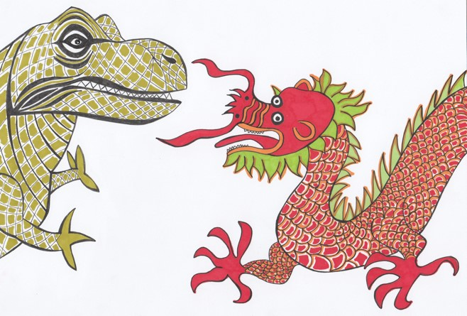

I'm Telling You

I'm as wise as an owl.
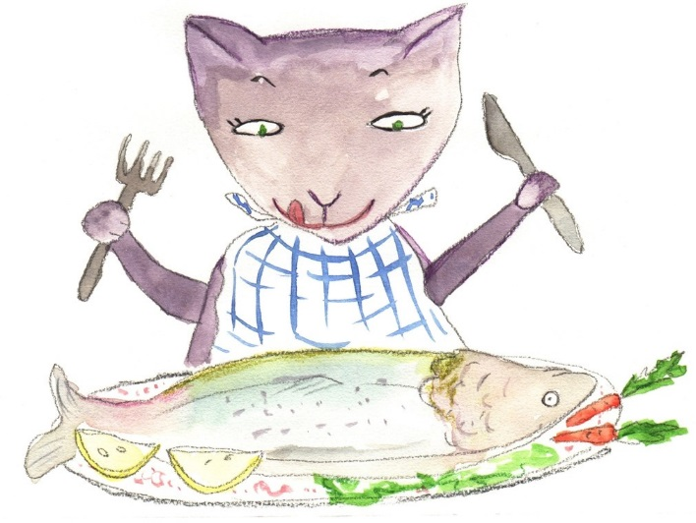
I'm as cunning as a cat.
You're as slimy as a snail.
You're as dirty as a rat.

I'm as brave as a lion.
I'm as strong as an ox.
You're as weak as a kitten.
You're as sneaky as a fox.

I'm as bright as a button.
I'm as hard as nails.
You're as useless as a yacht
Without any sails.

Sean Forbes

Top tips for learning a poem by heart

- Read the poem aloud several times slowly.
- Copy the poem out a couple of times.
- Be strategic. Poems with a pattern, metre and rhyme are much easier to learn by heart than free verse.
- Learn and internalise the “story” in the poem.
- Understand the poem by knowing every word’s meaning.
- With a card, cover everything but the first line of the poem. Read it. Look away, see the line in the air, and say it. Look back. Repeat until you’ve “got it.”
- Uncover the second line. Learn it as you did the first line, but also add second line to first, until you’ve got the two.
- Then it’s on to three. Always repeat the first line on down, till the whole poem sings.
