What to do today
IMPORTANT Parent or Carer – Read this page with your child and check that you are happy with what they have to do and any weblinks or use of internet.

1. Listen to a story
- Listen to the last part of Sinbad’s Fifth Voyage
https://www.youtube.com/watch?v=F-3PjZu_5WY
Start the story from 11.15, watch until the end.
- Use Sinbad and the Coconuts to re-tell the story in four scenes. Decide the most important scenes and show them with words and pictures.

2. Read another version of the story
- Read Usborne – Sinbad.
- This is a different version than the one that Wilf told. Write the differences and similarities that you spot on the Comparison Table. Which version do you prefer? Why?

3. Now for some writing
- Choose one of the Sinbad Illustrations.
- Write down this part of the story. What has happened before the illustration? What will happen after it?
- Use conjunctions in your story to join clauses and prepositions to add description to your writing.

Well done. Show your writing to a grown-up. Show them the illustration that you were writing about. Can they spot any conjunctions or prepositions that you have used in your sentences?

Try these Fun-Time Extras
- Can you learn to tell the story of Sinbad and the Coconuts? Can you tell all three parts of the whole of the fifth voyage story, one after another? You can use your four-scene stories to help you.

Sinbad and the Coconuts

Usborne - Sinbad
Sinbad has returned home after his adventures which included escaping from a roc – a giant bird.
The problem was Sinbad found life at home dull after his adventures. One morning he saw a beautiful new ship at the port and decided to buy it.

He loaded the ship with silks and spices, hired an eager crew and set sail.
They came to an island with another roc’s egg. Some sailors were curious and went to see it. They threw stones at the egg to see how tough it was.

Fifty stones later, it cracked.

“Fools!” cried Sinbad. “The mother roc will want revenge!”

As they sailed away, a dark shape hid the sun. It was a roc! She dropped a massive boulder on the ship and all but Sinbad perished in the sea.

Yet again, Sinbad was saved. This time, he was swept to a leafy island. As he paused for water by a stream, he saw a sad troll.

Sinbad helped the troll across the stream. But then the troll refused to get down from Sinbad’s shoulders. It just tightened its grip around his neck.

For days, Sinbad was the troll’s prisoner. He carried it everywhere until he was exhausted. Then he remembered he had a flask of wine.

The troll saw Sinbad take a sip and snatched the flask. It glugged down the wine and was soon swaying from side to side. A few burps later, it toppled to the ground.

Sinbad ran away and met some people carrying baskets. “Can you help me get to Baghdad?” he asked hurriedly.

“If you help us collect more coconuts,” replied a bald man.

“How?” wondered Sinbad, following the group into a forest of palms. Monkeys chattered in every tree.

“Watch!” said the man. He picked up a stone and threw it at a monkey. The monkey was very annoyed and through a coconut back at the man.

Soon, all the monkeys were throwing coconuts. Sinbad easily collected enough to pay for his trip home.
From The Adventures of Sinbad the Sailor by Katie Daynes
Comparison Table
Write what you notice about the Usborne version and Wilf’s. One example has been done for you.
Similarities | Differences
There’s a giant bird in each story. | Wilf doesn’t say that the bird is called a roc.

Sinbad Illustrations
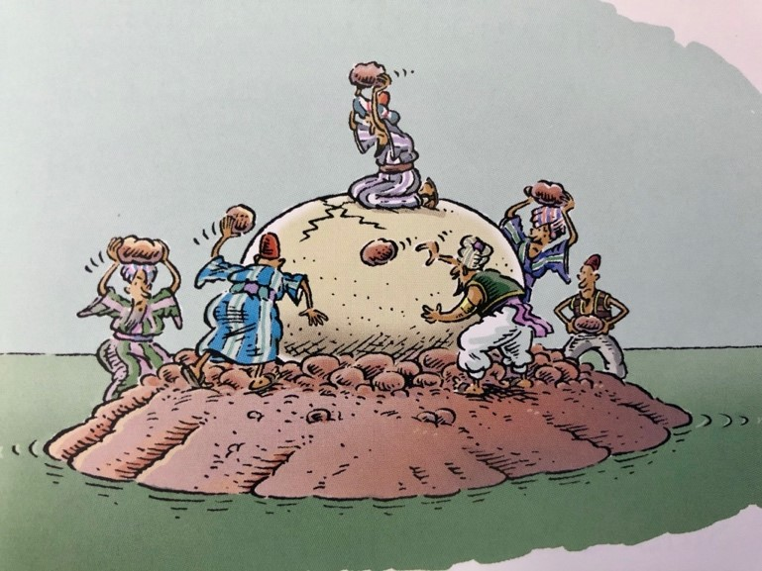
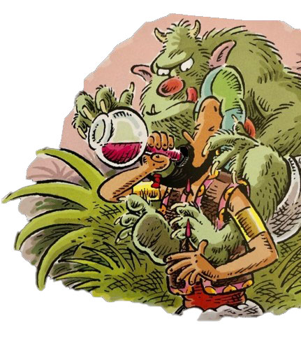
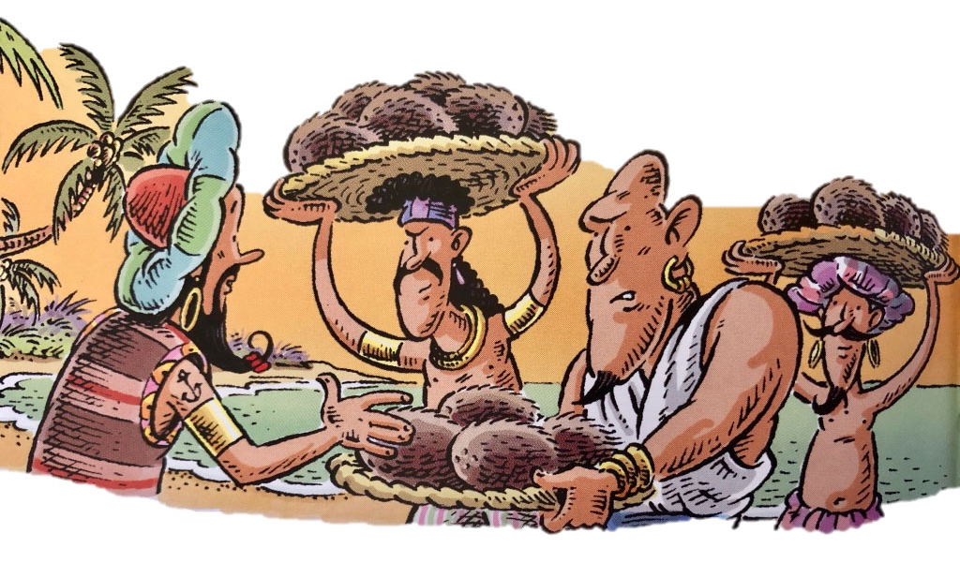
from The Adventures of Sinbad the Sailor illustrated by Paddy Mounter
Sinbad Writing
Choose one of the illustrations and write that part of the story here.
Include prepositions and conjunctions in your writing – see below.

Conjunctions

Use these to join clauses.
Sinbad was walking along when he saw an enormous tree.

because | while | wherever | after | before | so
since | when | whenever | until | where | as

Prepositions

Use these to add description.
… an enormous tree with fantastic fruit in its top branches.

with, of, by, from, on, under, below, between, beside, inside, next to, over, by, in

