What to do today
IMPORTANT Parent or Carer – Read this page with your child and check that you are happy with what they have to do and any weblinks or use of internet.

1. Listen to a story
- Look carefully at Sinbad Illustration. What do you notice? What could be happening here? Who might the man be? What might be in the pot?
- Listen to the second part of Sinbad’s Fifth Voyage
https://www.youtube.com/watch?v=F-3PjZu_5WY
Start the story at 6:00 and stop it at 11:14
- What did you find out about the Sinbad Illustration?

2. Retell the story
- Use Sinbad and the Old Man to retell the story in four parts.
- Decide the four most important scenes and use words and pictures to show them.

3. Remind yourself about Prepositions
- Use the PowerPoint on Prepositions (slide 7 to end) or, if this is not possible, use the Revision Card to remind yourself about prepositions.
- Complete Expanding Noun Phrases by re-writing the noun phrase and adding a prepositional phrase. Write neatly.
- If you want, look below for Suggestions on Expanding Noun Phrases.
- If you can, take on the challenge!

Well done. Show your writing to a grown-up. Show them the prepositions that you have used to link phrases to clauses.

Try the Fun-Time Extras
- Use your four-scene story to help you practise telling the story of Sinbad and the Old Man. Watch how Wilf tells the story. Can you tell it as expressively?
Sinbad Illustration
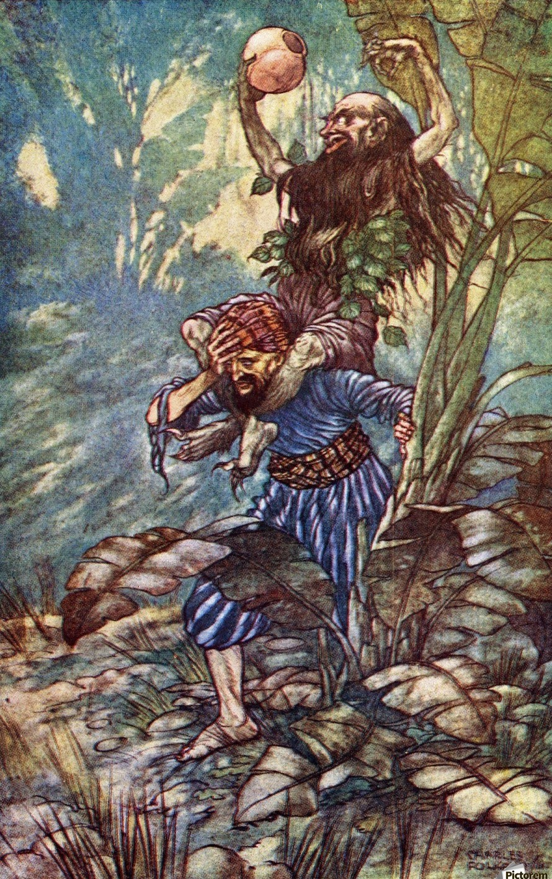

Sinbad and the old man

Revision Card – Prepositions

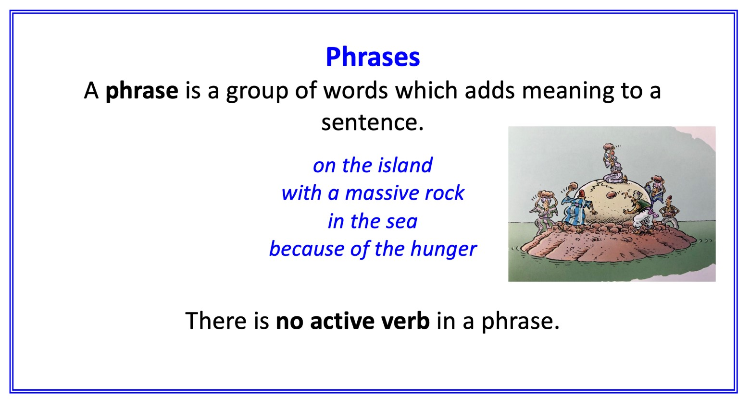
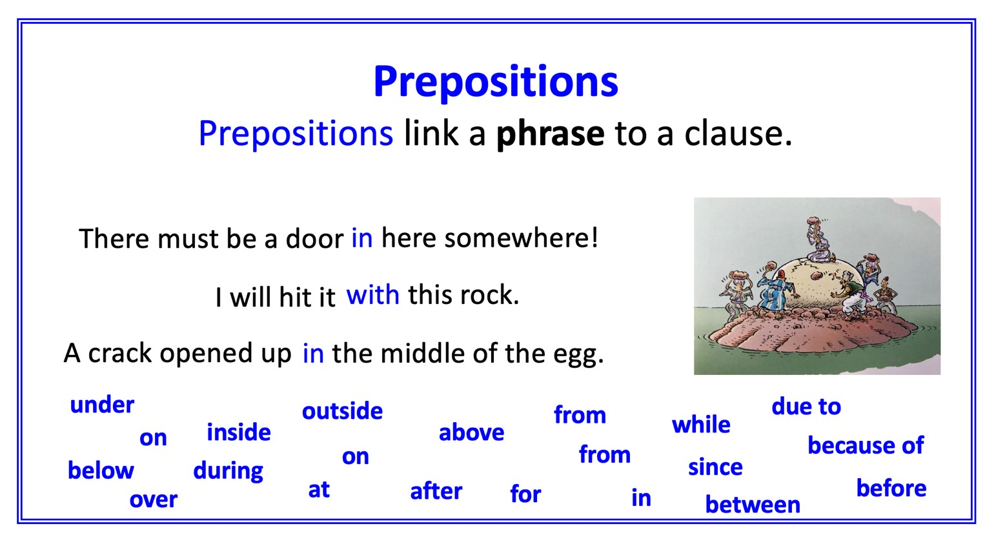

Expanding Noun Phrases

- Choose prepositions and add phrases to these noun phrases.
- Write each one out neatly.
(The first has been done for you.)
Challenge if you want! Try to use a different preposition in each one!

a wild and raging sea with waves as high as houses
a beautifully calm island
a sad old man
the devious trick
his powerful legs
his endless commands
a clever idea
a calabash full of wine
an enormous gulp
the lucky escape

Prepositions
with, of, by, from, on, under, below, between, beside, inside, next to, over, by, in

Expanding Noun Phrases - Suggestions

a wild and raging sea with waves as high as houses
a beautifully calm island in a sea of turquoise stillness
a sad old man below the great trees
the devious trick by a cunning giant
his powerful legs over Sinbad’s shoulders
his endless commands between dawn and dusk
a clever idea by a lucky chance
a calabash full of wine beside a warm rock
an enormous gulp of delicious sweet liquid
the lucky escape from the horrible old bully

Prepositions
with, of, by, from, on, under, below, between, beside, inside, next to, over, by, in

