What to do today
IMPORTANT Parent or Carer – Read this page with your child and check that you are happy with what they have to do and any weblinks or use of internet.

1. Listen to a story
- Read Sinbad Introduction 1 and 2. Have you heard of this set of stories? What do you think might happen?
- Listen to the first part of the story of Sinbad’s Fifth Voyage.
https://www.youtube.com/watch?v=F-3PjZu_5WY
Stop the video at 6:20
What did you like about the story? Was there anything about it that you disliked?

2. Retell the story
- Use Sinbad and the Giant Bird to retell the story in four parts.
- Decide the four most important scenes and use words and pictures to show them.

3. Remind yourself about clauses and conjunctions
- Use the PowerPoint on clauses and conjunctions (Slides 1 to 7), or remind yourself using the Revision Card on this subject.
- Complete Multi-Clause Sentences.

Well done. Show your writing to a grown-up. Can you tell them the story of Sinbad so far and show them the sentences that you have written?

Try the Fun-Time Extra
- Use your four-part story words and pictures to practise telling the story. You could make a recording of yourself telling the story and share it with someone else.

Sinbad Introduction 1

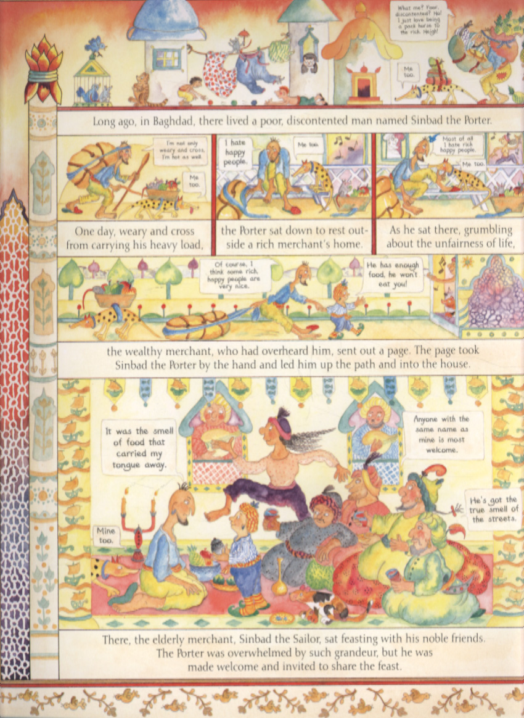

Sinbad Introduction 2

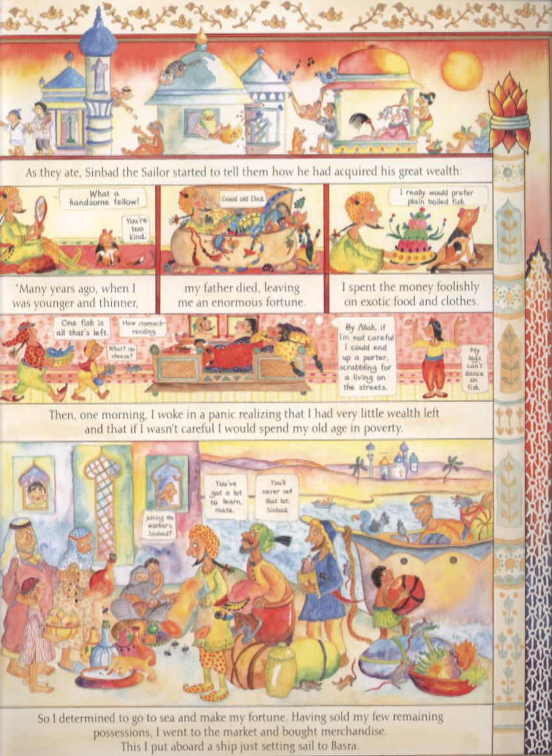

from Marcia William’s Sinbad the Sailor
Sinbad and the Giant Bird

Revision Card – Conjunctions

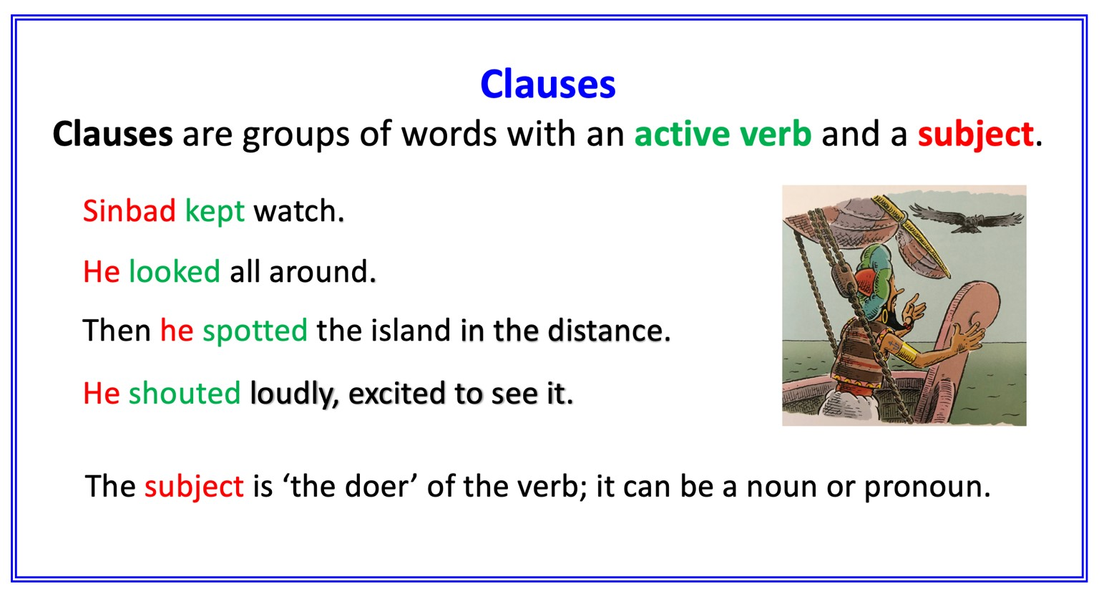
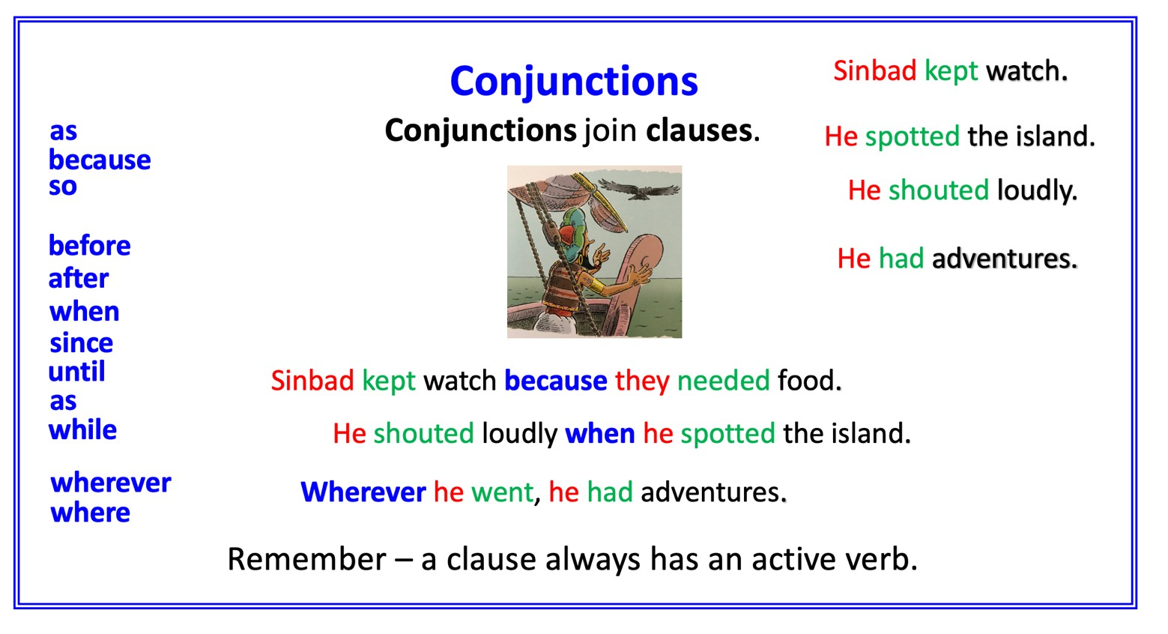

Multi-Clause Sentences

Make multi-clause sentences, choosing one of these tasks. Use the first clauses below.

Choose a conjunction and make up another clause. Write out your new sentence.  CHALLENGE: Choose a conjunction and make up another clause. Then extend the sentence again with another conjunction. Write your 3-clause sentence out. Does it make sense? | Don’t forget!  The clause you add can start the sentence.

Conjunctions
because | while | wherever | after | before | so
since | when | whenever | until | where | as

First clauses
Sinbad found life at home was dull
He saw a beautiful new ship at the port
He decided to buy the ship
The ship was loaded with silks and spices
They arrived at an island
They saw a huge egg
They decided to eat from the egg
They were no longer hungry
The giant bird heard them
She began to attack them

