What to do today
IMPORTANT Parent or Carer – Read this page with your child and check that you are happy with what they have to do and any weblinks or use of internet.

1. Learn a poem
- Read Snow. What patterns can you spot in this poem?
- Fill in the boxes on the Memory Frame with quick pictures that will help you to remember each line of the poem.
- Use your pictures to practise saying the poem without looking at the words.

2. Investigate a poem
- Read Summer Days. What do you like about the poem? Which is your favourite line?
- Fill in the Word Table to show the pattern of words used in Summer Days.

3. Write your own poem
- Decide a title for your poem. It could be one of these, or you could choose your own idea:
A day at the beach
Summer meadow
Seasons of the tree
- Fill in the Blank Word Table to make lines for your poem.
- Choose your favourite lines and put them in an order you like to make your poem. Write it out carefully.

Try the Fun-Time Extras
- Share your poem with somebody else.
- Make an illustration for your poem.
- Teach somebody to learn Snow off by heart.

Snow

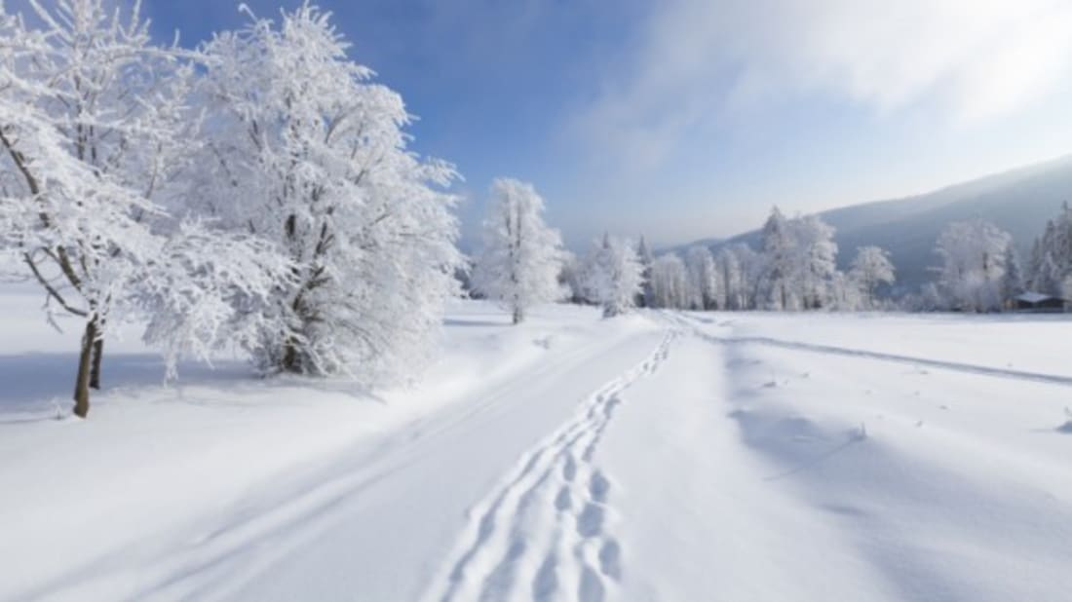

White snow,
bright snow,
silent in the night snow.
Crystal petal
snowflakes settle.
Sparkle in the light snow.

Deep snow,
heaped snow,
leap about and sweep snow.
Snowmen, snowballs,
snowdrifts, snowfalls.
Hands and feet aglow snow.

Cold snow,
old snow,
melting as you hold snow.
Icy, slushy
dirty mushy
Time for you to go snow.

Jane Clark
Snow Memory Frame

White snow.
bright snow,
silent in the night snow.
Crystal petal
snowflakes settle.
Sparkle in the light snow.
Deep snow,
heaped snow,
leap about and sweep snow.
Snowmen, snowballs,
snowdrifts, snowfalls.
Hands and feet aglow snow.
Cold snow,
old snow,
melting as you hold snow.
Icy, slushy,
dirty, mushy...
Time for you to go snow.
Snow by Jane Clarke P55, Off By Heart – Poems for YOU to remember

Summer Days

Blue waves lap gently
Soft sand sprinkles lightly
Bright sun sizzles powerfully
Light breeze dances delicately
Colourful flowers stand proudly
Delicious ice cream melts rapidly
Sticky sunscreen applied abundantly
Vibrant clothes worn joyfully

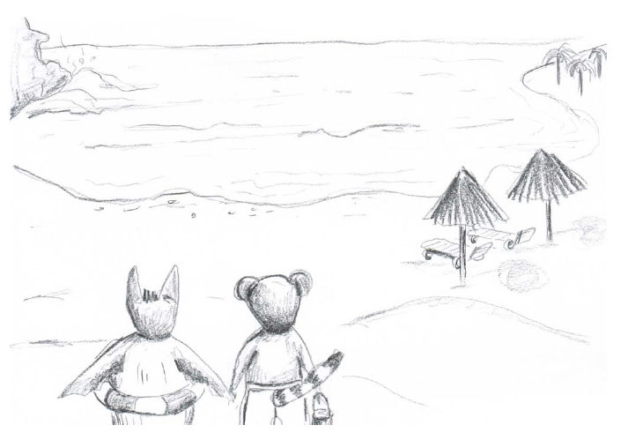

Word Table

Adjective  modifies (tells you more about) nouns | Noun  a person, place, thing or feeling | Verb  a doing or action word | Adverb  modifies (tells you more about) verbs and sometimes adjectives
blue | waves | lap | gently
soft | sand | sprinkles | lightly

Word Table

Adjective  modifies (tells you more about) nouns | Noun  a person, place, thing or feeling | Verb  a doing or action word | Adverb  modifies (tells you more about) verbs and sometimes adjectives

Your Poem

Write your poem here.

