What to do today
IMPORTANT Parent or Carer – Read this page with your child and check that you are happy with what they have to do and any weblinks or use of internet.

1. Look carefully at an illustration
- Look at the picture of the Procession.
- What is happening in the story in this picture? What has happened just before? What could happen next? (You could use your Story Summary from Day 1 to remind you).
- Listen to the music that goes with this part of the story:
https://www.youtube.com/watch?v=HM0lMX5BJAg
- Close your eyes as you listen to the music and try to picture the characters, how they are moving, what they might be feeling and what they could be saying.

2. Imagine a new ending for the story
- Complete New Ending. Imagine what will happen when the procession arrives at the zoo.

3. Now for some writing
- Write your new ending to the story. Include some direct speech. Use the Revision Card to remind you about using a new line for a new speaker.

Well done. Read your new ending to a grown-up. Show them the direct speech that you have used and how you have punctuated it.

Try the Fun-Time Extra
Watch some of this version of the musical performance. You can see the instruments being played. What do you notice? Did the instruments look as you expected them to?
https://www.youtube.com/watch?v=MfM7Y9Pcdzw

Procession

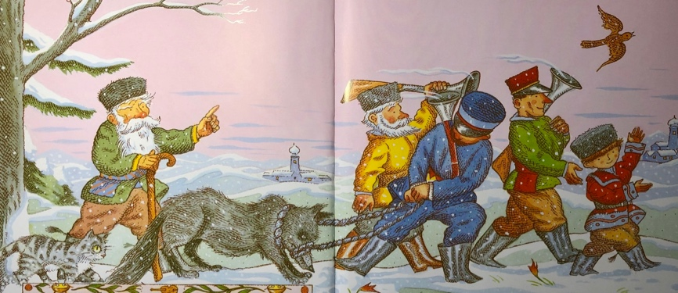

New Ending

Imagine what will happen when the procession arrives at the zoo.

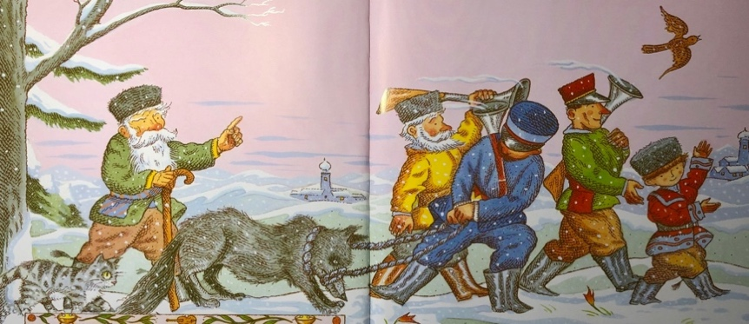

What will Peter say?

What will the zoo-keeper say?

What will Grandfather say?

What might the other characters say? (The cat, bird or hunters).

What could the duck say from inside the wolf’s stomach?

Revision Card – New Line for New Speaker

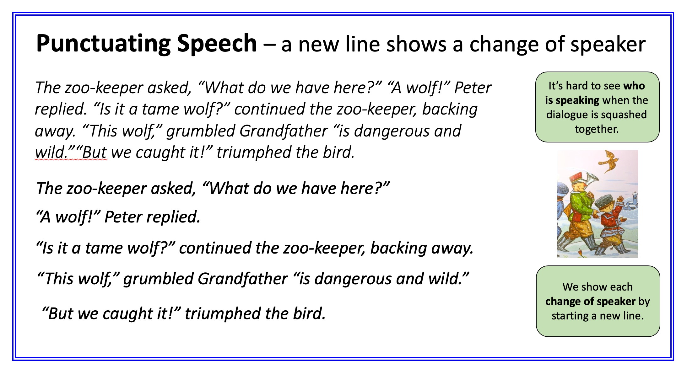

New Ending

Write what happens when the procession arrives at the zoo.

