What to do today
IMPORTANT Parent or Carer – Read this page with your child and check that you are happy with what they have to do and any weblinks or use of internet.

1. Make predictions
- Look at Front Cover. Write notes to say what you notice and what predictions you can make about the book. Who do you think could be the characters in this story? What could happen?
- Listen to the story being read
https://www.youtube.com/watch?v=ickziSniXkI . Did some of your predictions occur?

2. Remind yourself about speech marks and reporting clauses.
- Use the PowerPoint about speech marks and reporting clauses or, if this is not possible, use the Revision Card to remind yourself.
- Complete Peter and the Wolf Sentences. You can use some of the Said Synonyms for your reporting clauses.

3. Summarise the story
- Look closely at the Six Illustrations. What is happening in each? What has happened just before and what will happen just after?
- Write sentences on Story Summary about the illustrations.

Well done. Use your Story Summary to tell a grown-up the story of Peter and the Wolf.

Try the Fun-Time Extra

- Design a back-cover. Write a blurb to tell about the book
- The story is famously set to music. Listen to all or half of the musical performance here:
https://www.youtube.com/watch?v=Va8Uz6MoKLg

Front Cover

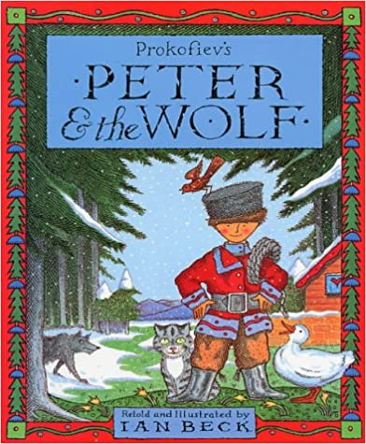

Revision Card – Direct Speech and Reporting Clauses

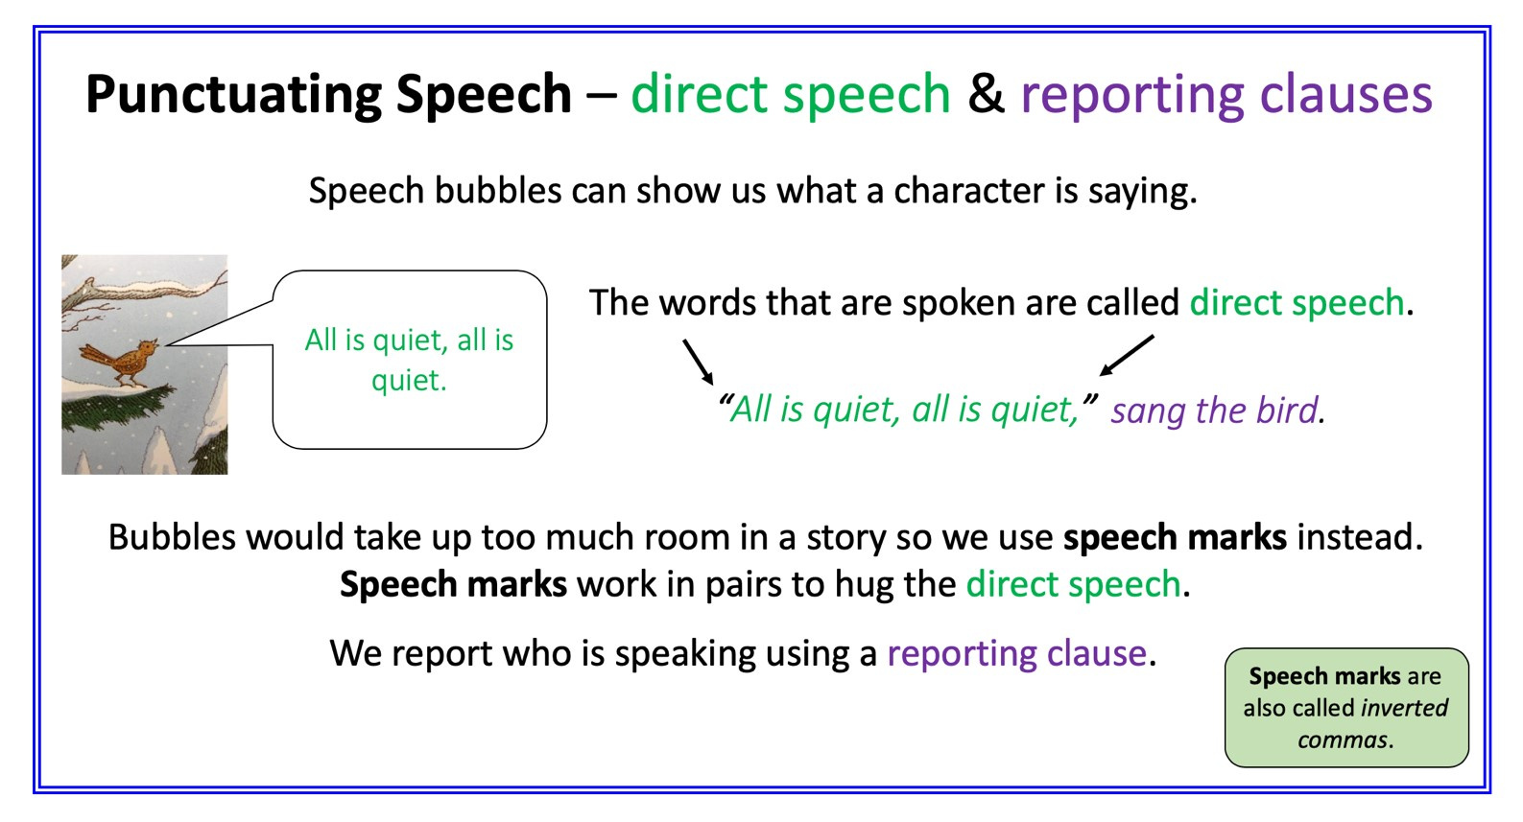
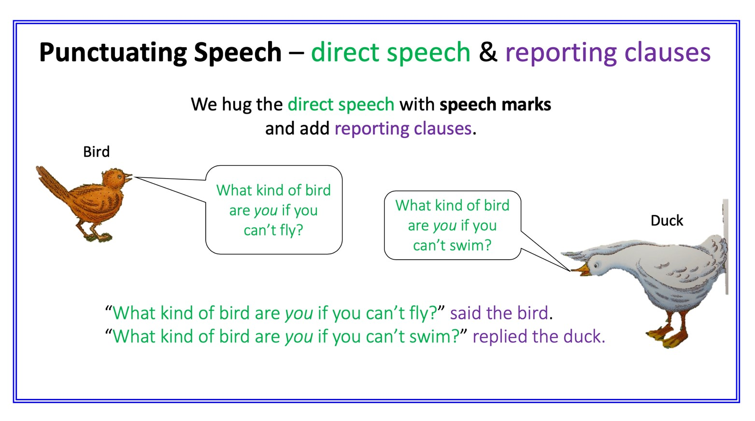

Peter and the Wolf Sentences

Add speech marks to these sentences. Add a reporting clause to 5-10.

- All is quiet, all is quiet, sang the bird.
- What kind of bird are you if you can’t fly? he asked.
- What kind of bird are you if you can’t swim? she answered, as she dived into the water.
- While the little bird is so busy arguing with that duck, I’ll just grab him thought the cat, stealthily creeping nearer.
- Look out!
- Is it worth climbing up so high?
- It’s a dangerous place, this. Suppose a wolf were to come out of the forest.
- Fly down and circle around the wolf’s head.
- Don’t shoot!
- My, what brave fellows we are, Peter and I. Look what we’ve caught

Speakers:

5. Peter 6. The cat 7. Grandfather 8. Peter 9. Peter 10. The bird
Said Synonyms

Anger
Shouted, bellowed, yelled, snapped, cautioned, rebuked.

Affection
Consoled, comforted, reassured, admired, soothed.

Excitement:
Shouted, yelled, babbled, gushed, exclaimed.

Fear:
Whispered, stuttered, stammered, gasped, urged, hissed, babbled, blurted.

Determination:
Declared, insisted, maintained, commanded.

Happiness:
Sighed, murmured, gushed, laughed.

Sadness:
Cried, mumbled, sobbed, sighed, lamented.

Amusement
Teased, joked, laughed, chuckled, chortled, sniggered, guffawed, giggled, roared.

Six Illustrations

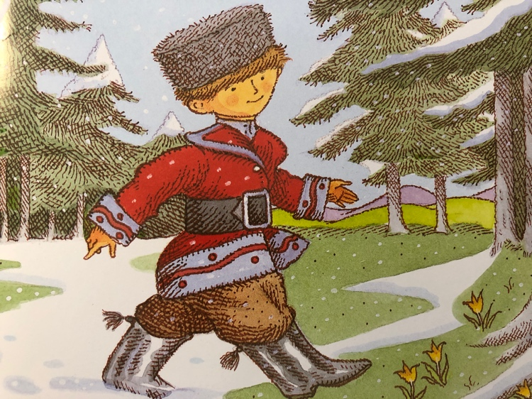 | 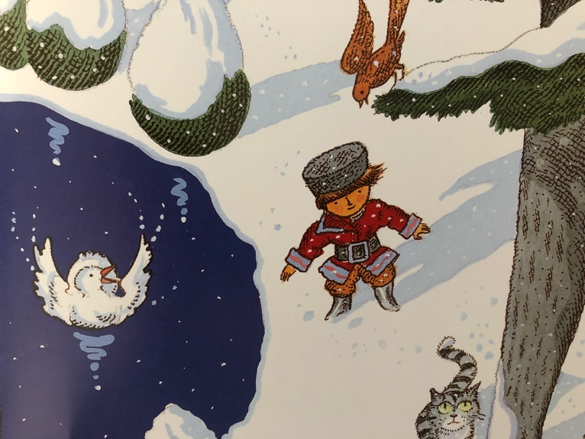
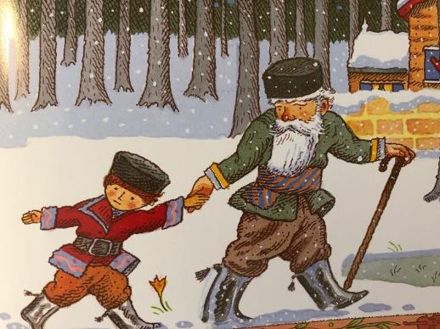 | 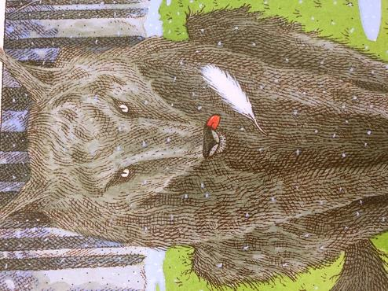
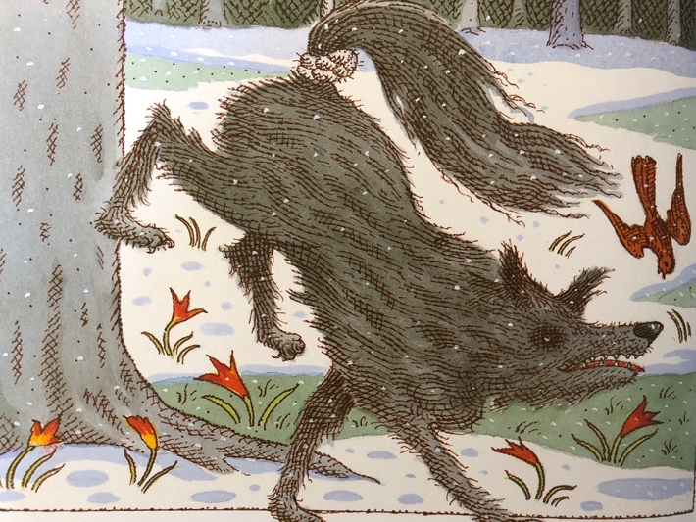 | 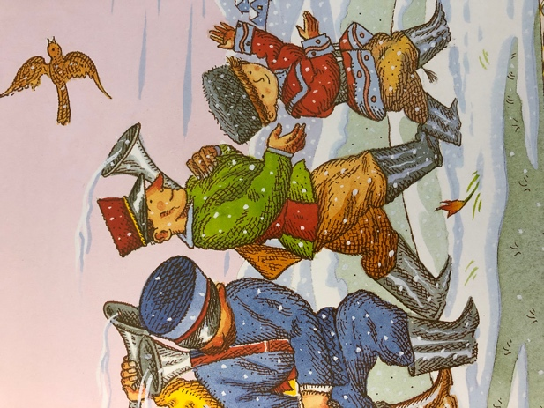

Story Summary

