What to do today
IMPORTANT Parent or Carer – Read this page with your child and check that you are happy with what they have to do and any weblinks or use of internet.

1. Make predictions
- Look at Front Cover. Write notes to say what you notice and what predictions you can make about the book. What might the title mean? What do you think the ‘Underground Railroad’ might be?

2. Listen to the story
- Listen to the reading of the story.
- https://www.youtube.com/watch?v=-41aaH6Vv6c
- What did you like about the story? Was there anything that you disliked? Did it remind you of anything you have read or seen? What questions or puzzles did it leave you with?

3. Order the events of the story
- Cut out the Map of Events.
- Re-arrange them so that they are in the right order.

4. Read the Author’s Note
- Read the Author’s Note.
- Answer Author’s Note – Questions.

Well done. Share your answers with a grown-up. You can check the order for the Questions and the Map of Events at the end of the pack.

Try the Fun-Time Extra
Design a back-cover for the book. Write a blurb to tell people about the book and add a design that will make them want to read it.

Front Cover

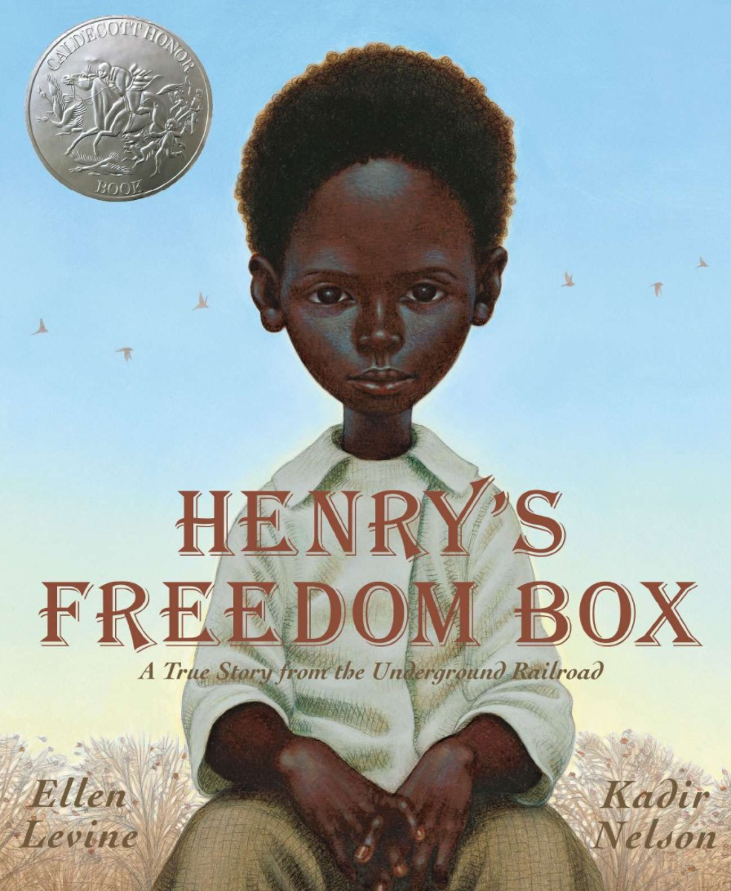
Map of Events

Cut these out and arrange them so they are in the right order.

Henry stayed silent and still for twenty-seven hours inside the box.

He travelled by train, steamboat and train again, journeying 350 miles.

Henry decided to escape. He asked his friend James and Dr Smith to help him.

He wrote an address on a large, wooden box. Henry climbed inside and James nailed down the lid.

Henry met Nancy who was also a slave. They got married and had three children.

Henry worked in a tobacco factory. The rules were very strict.

When he was older, Henry was given to his master's son. He had to leave his family and move to a new place.

Henry arrived in Philadelphia, delivered to the home of friends. The box was opened and Henry was free.

Henry was born as a slave. He grew up with his family, working in a big house.

Nancy and their children were sold and taken away. Henry was left alone.

Author’s Note

IN THE MID-1800s, THERE WERE ABOUT FOUR MILLION SLAVES LIVING IN THE UNITED STATES.

Slaves were owned, like tables, or cows, or wagons. Historians believe between 60,000 and 100,000 slaves escaped to freedom, traveling on what was called the Underground Railroad.

The Underground Railroad wasn't a real railroad. It was all the secret ways slaves made their way from the South to the North.

They hid in carts, rode on horseback, walked hundreds of miles through forests and swamps, and crossed flowing rivers in summer and icebound rivers in winter.

"Conductors" and "station masters" hid them and helped them throughout their journey.

When Henry Brown climbed into his Freedom Box, he hoped he'd be carried to a safe world. He brought along a small tool to make air holes, a little water, and a few biscuits. Henry arrived in Philadelphia, having travelled 350 miles from Richmond, Virginia, in 27 hours.

His story made newspaper headlines in America and Europe. Henry never found Nancy and his children. In 1850 he went to England, and there are some reports that he married again. We do know with absolute certainty that Henry "Box" Brown became one of the most famous runaway slaves on the Underground Railroad—the man who mailed himself to freedom.

From Henry’s Freedom Box by Ellen Levine

Author’s Note - Questions

- How many slaves were living in the United States in the mid-1800s?

- What was the Underground Railroad?

- What were some of the ways that slaves travelled?

- What did Henry Brown carry with him?

- How far had Henry travelled?

- Did Henry ever find Nancy or his children?

- Where did Henry Brown go in 1850?

Author’s Note - Answers

- How many slaves were living in the United States in the mid-1800s?

There were about four million slaves living in the United States.

- What was the Underground Railroad?

The Underground Railroad was the name given to all the secret ways that slaves escaped to the north from the south.

- What were some of the ways that slaves travelled?

Slaves hid in carts, rode horses, walked and waded rivers to travel.

- What did Henry Brown carry with him?

Henry carried a small tool for air holes, a little water and a few biscuits.

- How far had Henry travelled?

Henry had travelled 350 miles.

- Did Henry ever find Nancy or his children?

No, Henry never found Nancy or his children.

- Where did Henry Brown go in 1850?

In 1850, Henry came to England.

Map of Events - Answers

Henry was born as a slave. He grew up with his family, working in a big house.

When he was older, Henry was given to his master's son. He had to leave his family and move to a new place.

Henry worked in a tobacco factory. The rules were very strict.

Henry met Nancy who was also a slave. They got married and had three children.

Nancy and their children were sold and taken away. Henry was left alone.

Henry decided to escape. He asked his friend James and Dr Smith to help him.

Henry arrived in Philadelphia, delivered to the home of friends. The box was opened and Henry was free.

Henry stayed silent and still for twenty-seven hours inside the box.

He travelled by train, steamboat and train again, journeying 350 miles.

He wrote an address on a large, wooden box. Henry climbed inside and James nailed down the lid.

