What to do today
IMPORTANT Parent or Carer – Read this page with your child and check that you are happy with what they have to do and any weblinks or use of internet.

- Learn a verse of a poem
- Choose one verse of Triangle Poem. Read it out loud several times.
- Try learning the first line until you can say it without looking at the words. Challenge yourself to learn the next two lines as well.

- Remind yourself about prepositions
- Use the PowerPoint on Prepositions, Slides 5 to end or if this is not possible, use Revision Card to remind yourself about these.
- Complete Find the Preposition.
- Challenge yourself to complete Sentence Strips.

- Write your own triangle poem
- Choose a starting line from Triangle Poem Kit.
- Use conjunctions or prepositions to add clauses or phrases to this line.
- Use these longer new lines for the second and third line of your poem.

Try the Fun-Time Extras
- Carefully illustrate your poem.
- Send a copy of your poem to somebody else. Explain to them what you had to write it.

Triangle Poem
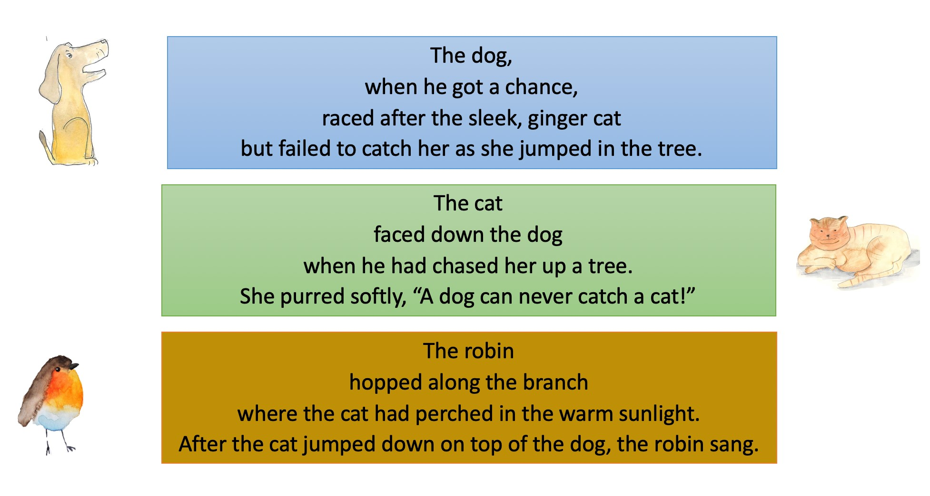
Revision Card - Prepositions

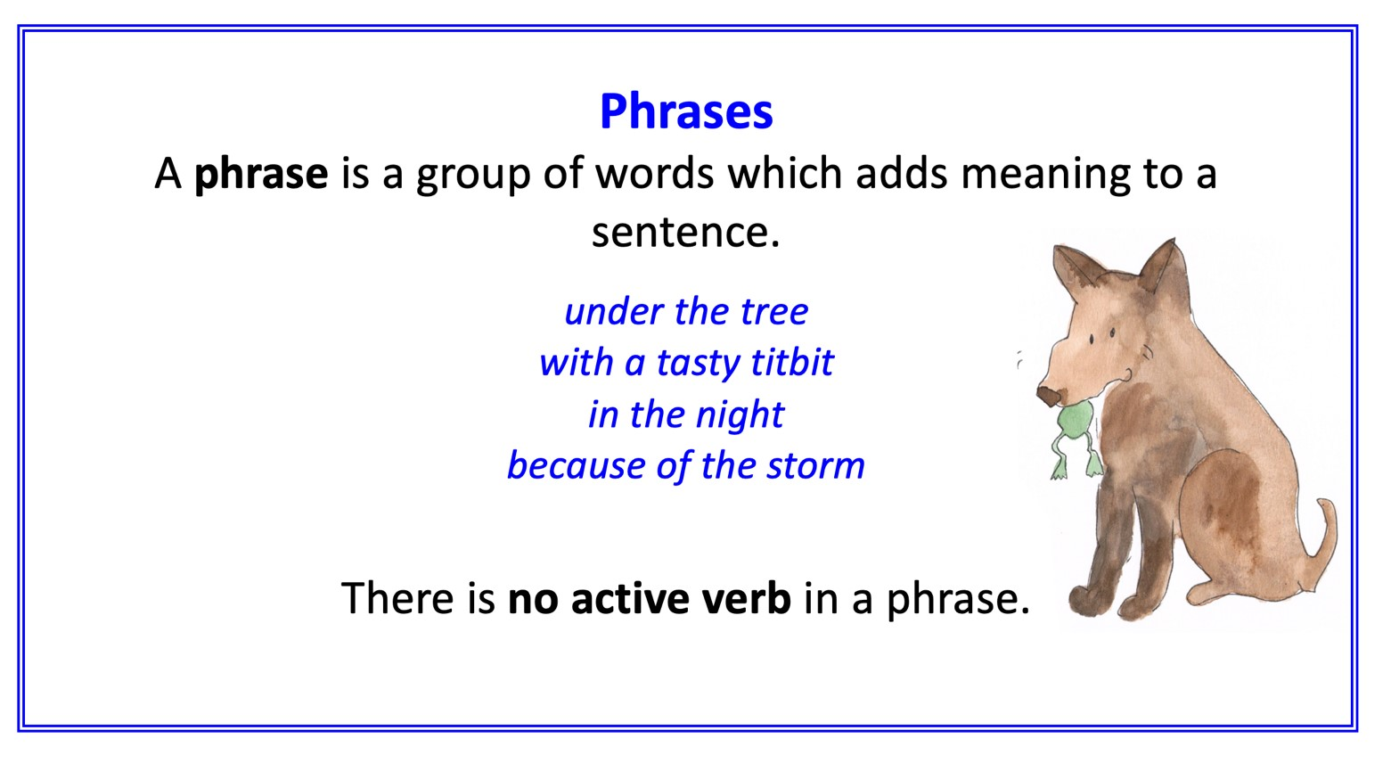
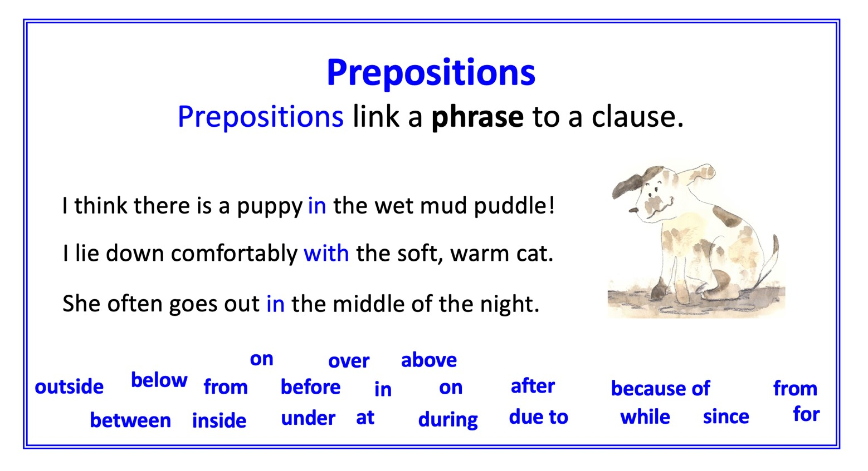

Find the preposition
Identify the preposition and underline it.
Now find the phrase that it introduces and highlight it.
Check that the main clause makes sense on its own without this phrase.

The cat ate her breakfast in the kitchen.
After breakfast, the cat washed her paws.
The cat purred beside the warm fire.
Before heading out, the puppy wagged her tail.
The puppy chased the ball under the bush.
The puppy barked with great excitement.
During the storm, I watched them play.
I fed the animals for some peace and quiet.
I took the puppy for a walk on the heath.

Sentence strips
Cut up the strip and pick one at a time.
Write a prepositional phrase to add at the beginning or the end of the sentence.
Does your phrase give more information about the time, place or cause?

The cat slept
The cat miaowed
The cat chased birds
The puppy drank
The puppy ran
The puppy slept
I played with the puppy
I chased the puppy
I stroked the cat

Triangle Poem Kit
Choose one of these sentences for your first line. Add clauses or phrases to extend this sentence to create Lines 2 and 3.
The snake slithered over the ground
The rat disappeared into the hole
The barn owl flapped its wings
Wolves howled loudly
A polar bear lay on the ice
The eagle swooped majestically
The bottle-nosed dolphin leapt and dived
A small, curious rabbit hopped through the grass
The hedgehog appeared that evening
The parrot chattered wildly
A small fox-cub wandered into the garden
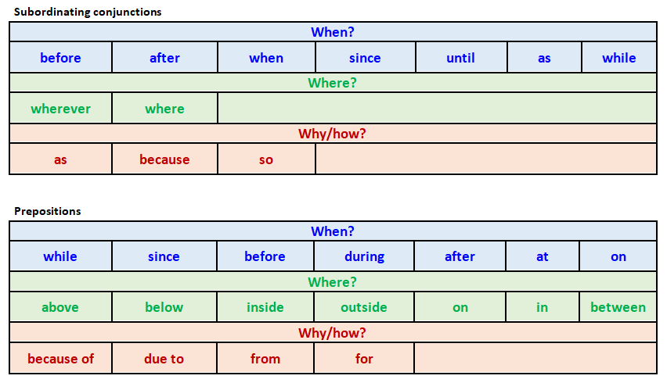
Triangle Poem
Write your new triangular poem here. Try to keep the triangular shape of the poem clear.

ANSWERS Find the preposition
Identify the preposition and underline it.
Now find the phrase that it introduces and highlight it.
Check that the main clause makes sense on its own without this phrase.

The cat ate her breakfast in the kitchen.
After breakfast, the cat washed her paws.
The cat purred beside the warm fire.
Before heading out, the puppy wagged her tail.
The puppy chased the ball under the bush.
The puppy barked with great excitement.
During the storm, I watched them play.
I fed the animals for some peace and quiet.
I took the puppy for a walk on the heath.

