What to do today
IMPORTANT Parent or Carer – Read this page with your child and check that you are happy with what they have to do and any weblinks or use of internet.

1. Read a poem
- Read Triangle Poem. Read it twice: once in your head and once out loud. Which is your favourite verse? Your favourite phrase?
- Why is this called Triangle Poem?*

2. Remind yourself about conjunctions
- Use the PowerPoint on Conjunctions Slides 1-4, or if this is not possible, use Revision Card to remind yourself of conjunctions.
- Complete Conjunctions and Clauses: Cats and Dogs.

Well done. Show your answers to a grown-up. You can check them at the end of this pack.

3. Practise your handwriting
- Choose your favourite verse from Triangle Poem and write it out as neatly as you can.
- Try to keep the shape of the verse as you write, so that it is a triangle-shaped poem.

Try the Fun-Time Extra

- Look at the pictures of Cats and Dogs. Write some sentences about them and include conjunctions in your sentences.
*Because the lines are shaped like a triangle
Triangle Poem

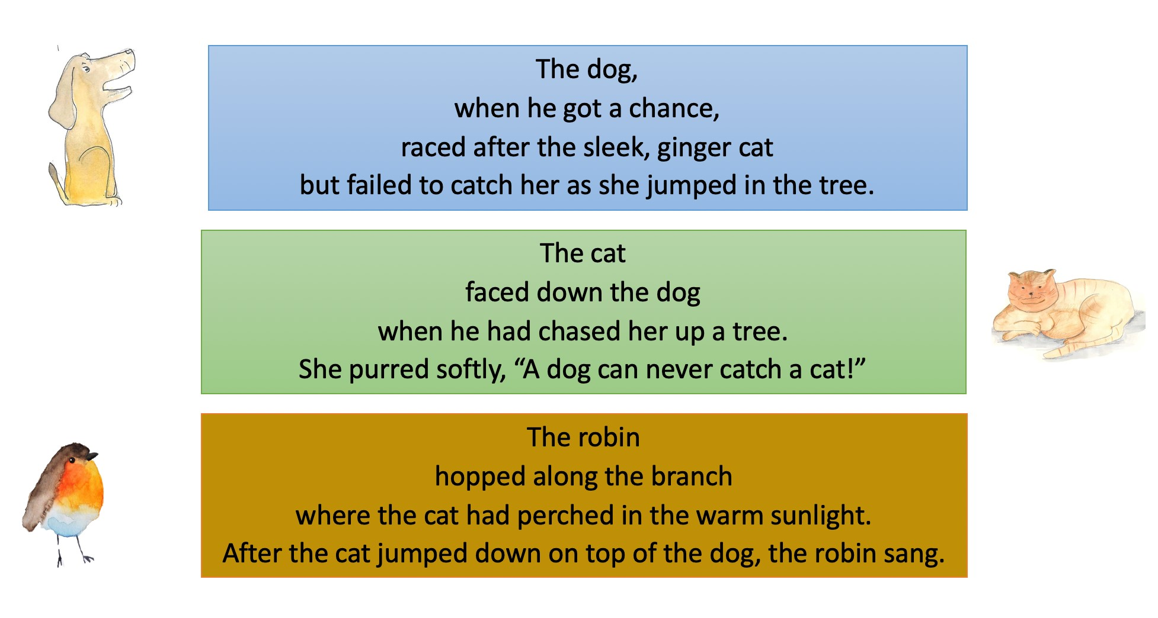
Conjunctions – Revision Card

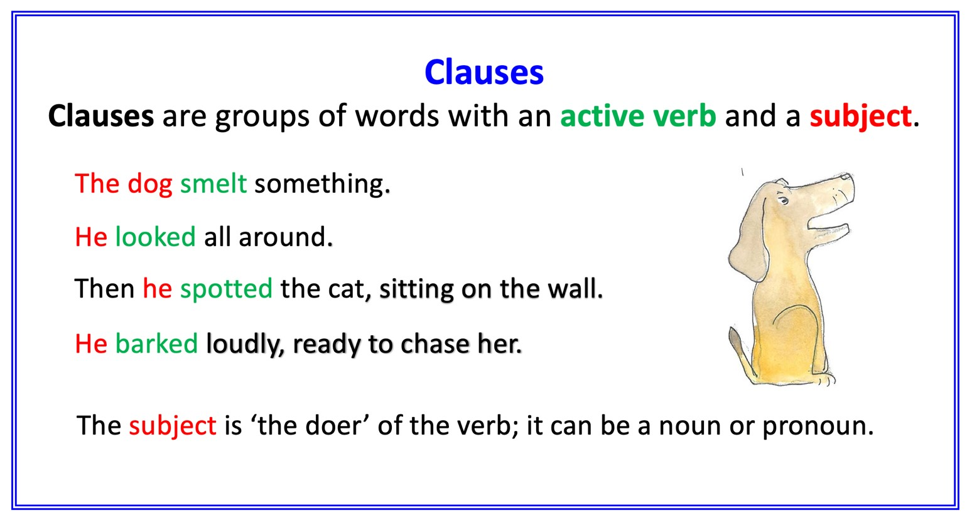

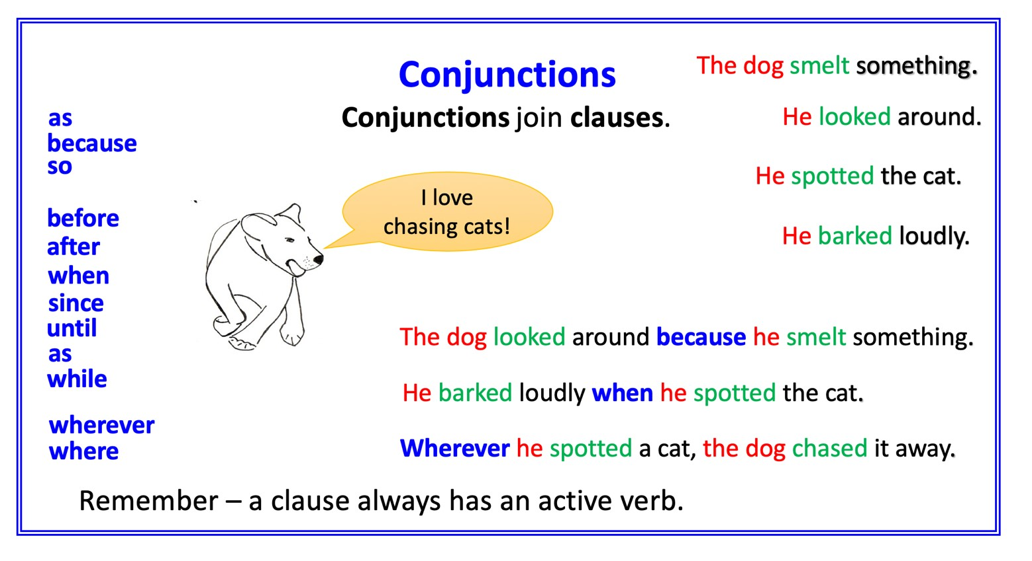

Conjunctions and Clauses: Cats and Dogs

Find and circle all of the subordinating conjunctions. Be careful with the last sentence.

- The cat hid in the tree when the dog barked.
- The dog barked loudly because the cat was in the tree.
- The dog waited where he couldn’t be seen.
- The cat began to purr after the dog went home.
- The cat hissed, so the dog growled back.
- Before the dog appeared, the cat was happily sleeping.

Choose a conjunction and add a clause to express time, cause or place. Sometimes add the clause at the start of the sentence!

- The dog chased the cat up the tree
- The cat hissed
- The dog bounded through the park
- The tree swayed
- Another dog joined in the chase
- The cat hid in the tree
- The cat peered out through the leaves
- The dog waited at the bottom of the tree
- The dog barked loudly

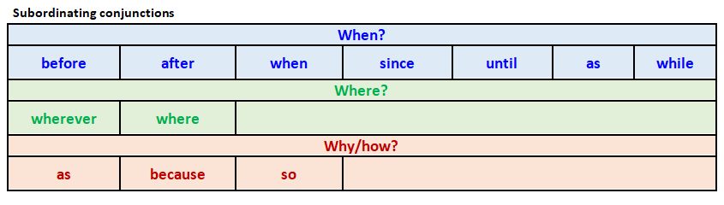

Triangle Poem
Choose your favourite verse and write it out neatly here. Try to keep the triangular shape of the poem.

Conjunctions and Clauses: Cats and Dogs - ANSWERS

Find and circle all of the subordinating conjunctions. Be careful with the last sentence.

- The cat hid in the tree when the dog barked.
- The dog barked loudly because the cat was in the tree.
- The dog waited where he couldn’t be seen.
- The cat began to purr after the dog went home.
- The cat hissed, so the dog growled back.
- Before the dog appeared the cat was happily sleeping.
Cats and Dogs - Pictures

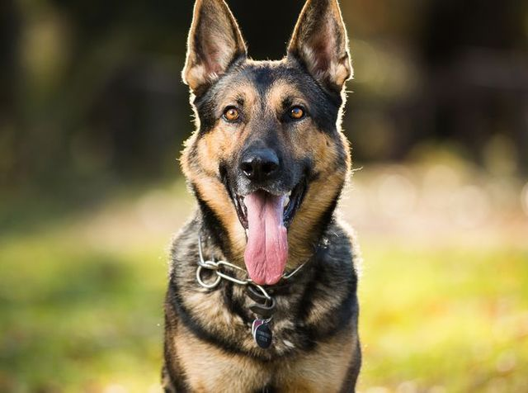
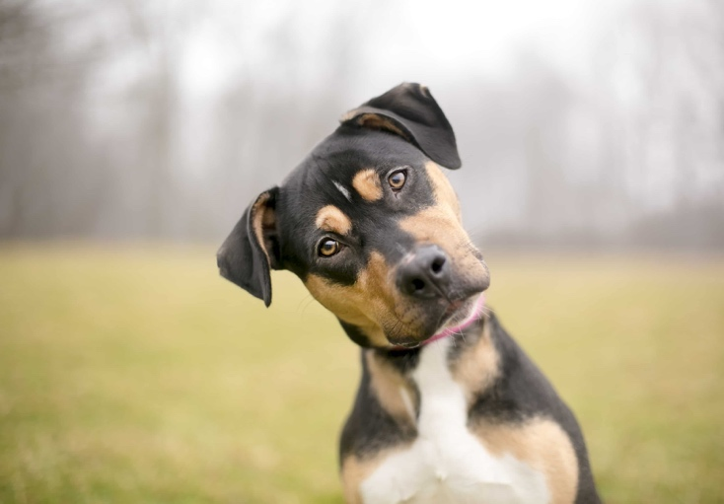 | 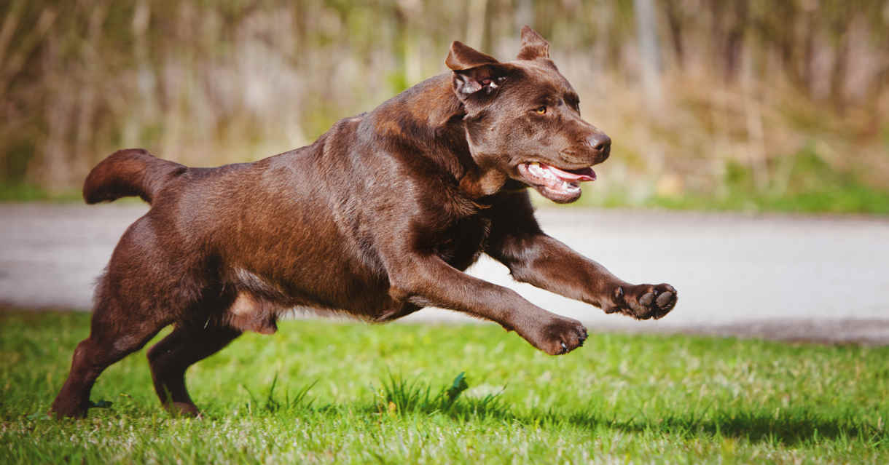
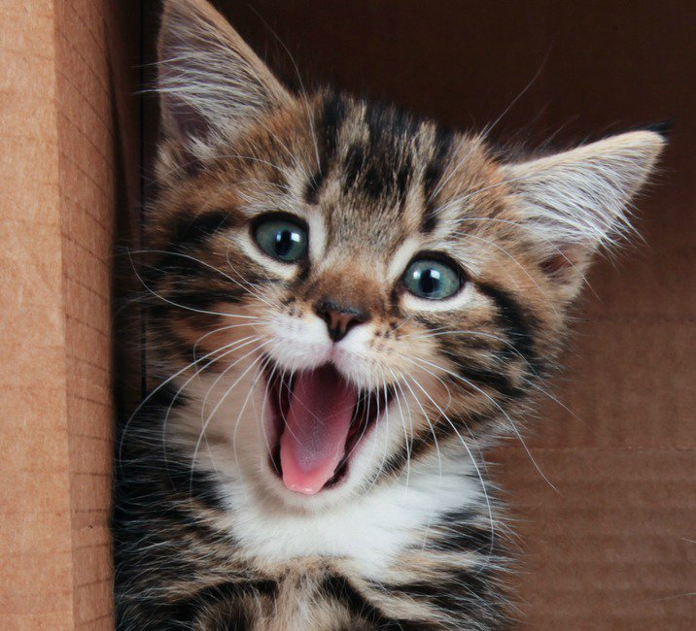 | 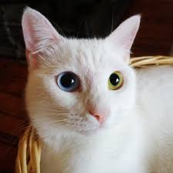
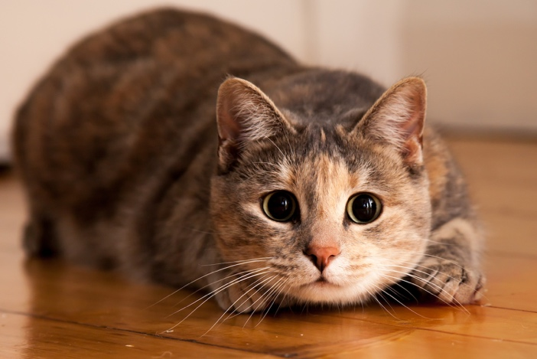 | 