What to do today
IMPORTANT Parent or Carer – Read this page with your child and check that you are happy with what they have to do and any weblinks or use of internet.

1. Listen to a song
- Read King of Rome – Opening.
- Where does the story start? When is it set? What can you say about Charlie Hudson? What do you think might happen?
- Listen to the song. Read the lyrics as you do.
https://www.youtube.com/watch?v=asbcMaegOT4

2. Remind yourself about direct speech
- Use the PowerPoint on direct speech or, if this is not possible, remind yourself using the Revision Card.
- Complete King of Rome - Sentences.

3. Make a version of the story
- Watch the video again. How could you tell the story in six parts?
- Use words and pictures on King of Rome. You could use speech-bubbles.

Well done. Show your story to a grown-up. Use the words and pictures to tell them the story. You can check your answers to King of Rome – Sentences at the end of this pack.

Try the Fun-Time Extras
- Watch this version of the song. Which of the two versions do you prefer? Why?
https://www.youtube.com/watch?v=6fL3E8FRxiw
- Find out some more about the true story of Charlie Hudson and the King of Rome. You could start with this website:
http://www.derbyphotos.co.uk/features/kingofrome/

King of Rome – Opening

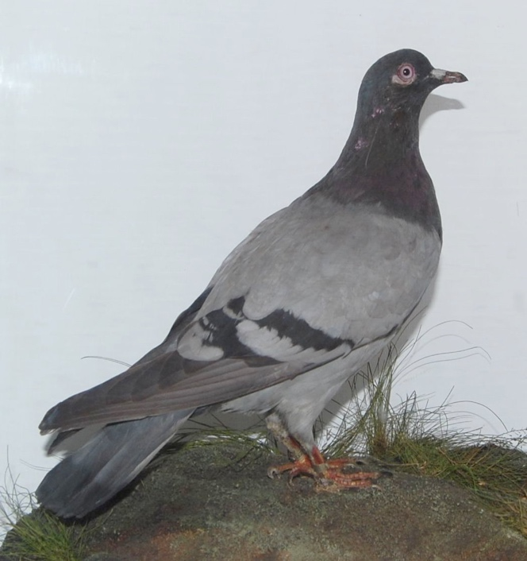
The King of Rome – in Derby museum.

In the West End of Derby lives a working man.
He says, "I can't fly but me pigeons can.”
“And when I set them free
It's just like part of me
Gets lifted up on shining wings."

Charlie Hudson's pigeon loft was down the yard
Of a rented house in Brook Street where life was hard.
But Charlie had a dream
And in 1913
Charlie bred a pigeon to make his dream come true.

by Dave Sudbury

King of Rome by Dave Sudbury - Lyrics

In the West End of Derby lives a working man
He says "I can't fly but me pigeons can
And when I set them free
It's just like part of me
Gets lifted up on shining wings"

Charlie Hudson's pigeon loft was down the yard
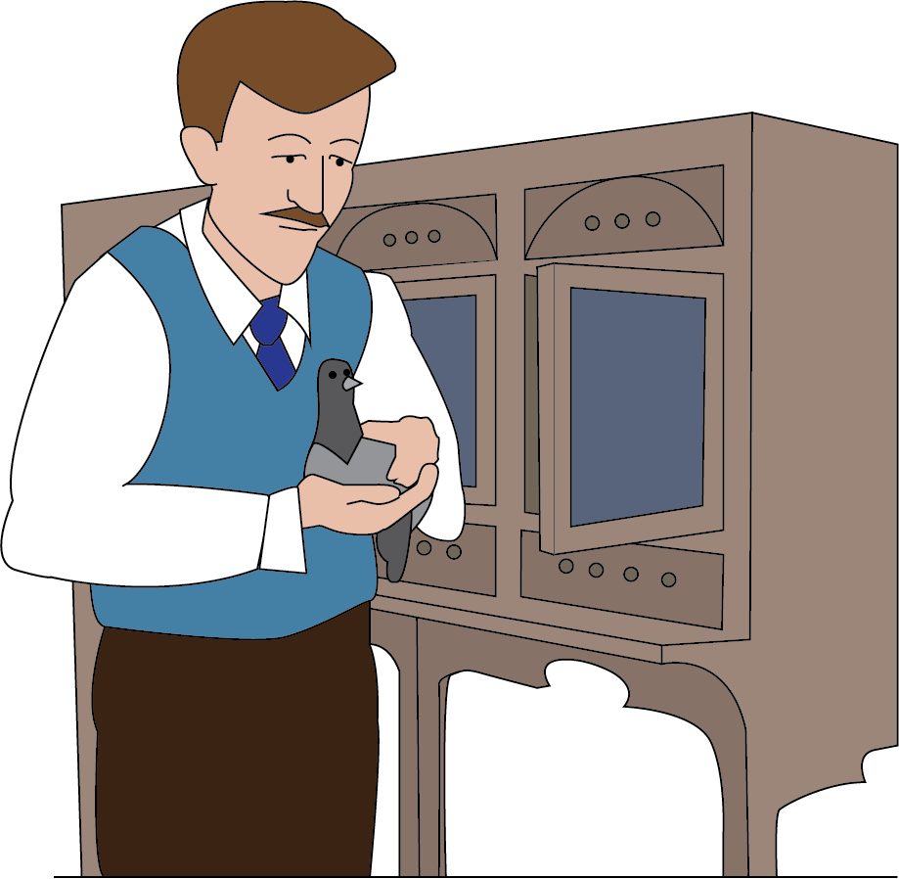
Of a rented house in Brook Street where life was hard
But Charlie had a dream
And in 1913
Charlie bred a pigeon to make his dream come true

There was gonna be a champions' race from Italy
We got out the maps, all that land and sea
“Charlie, you'll lose that bird"
But Charlie never heard
He put it in a basket and sent it off to Rome

On the day o' the big race a storm blew in
A thousand birds were swept away and never seen again
"Charlie we told you so
Surely by now you know
When you're living in the West End there ain't many dreams come true"

"Yeah, I know, but I had to try
A man can crawl around or he can learn to fly
And if you live 'round here
The ground seems awful near
Sometimes I need a lift from victory"

I was off with me mates for a pint or two
When I saw a wing flash up in the blue
"Charlie, it's the King of Rome
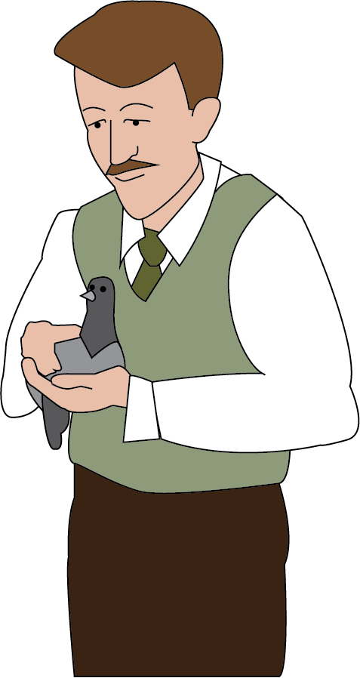
Come back to his West End home
Come outside quick, he's perched up on your roof"

"Come on down, your majesty
I knew you'd make it back to me
Come on down, you lovely one
You made me dream come true"

In the West End of Derby lives a working man
He says "I can't fly but me pigeons can
And when I set them free
It's just like part of me
Gets lifted up on shining wings"

Revision Card

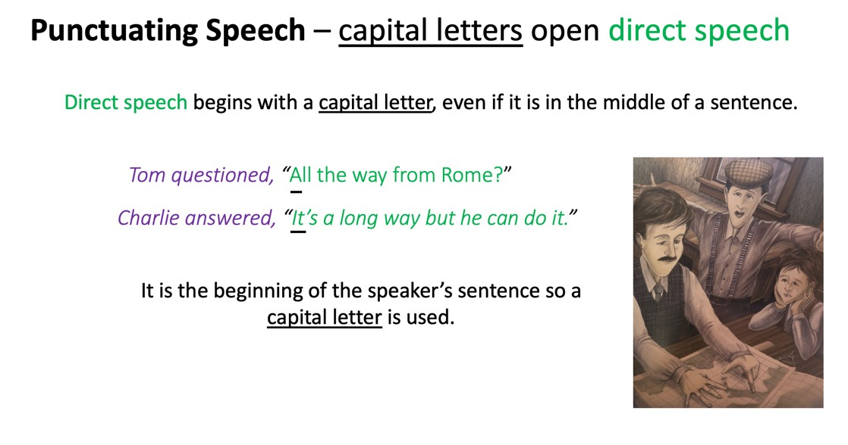 | 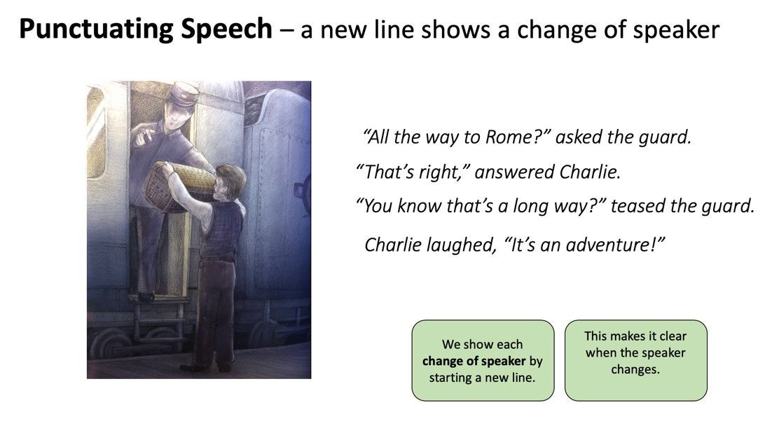
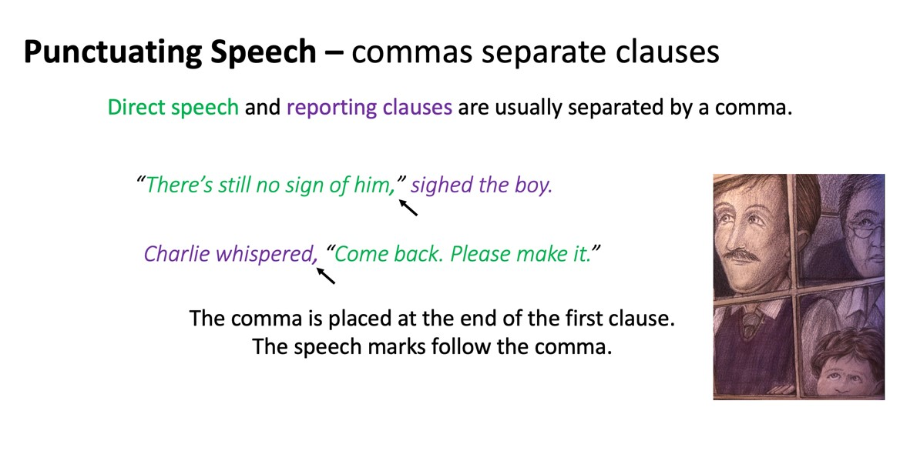 | 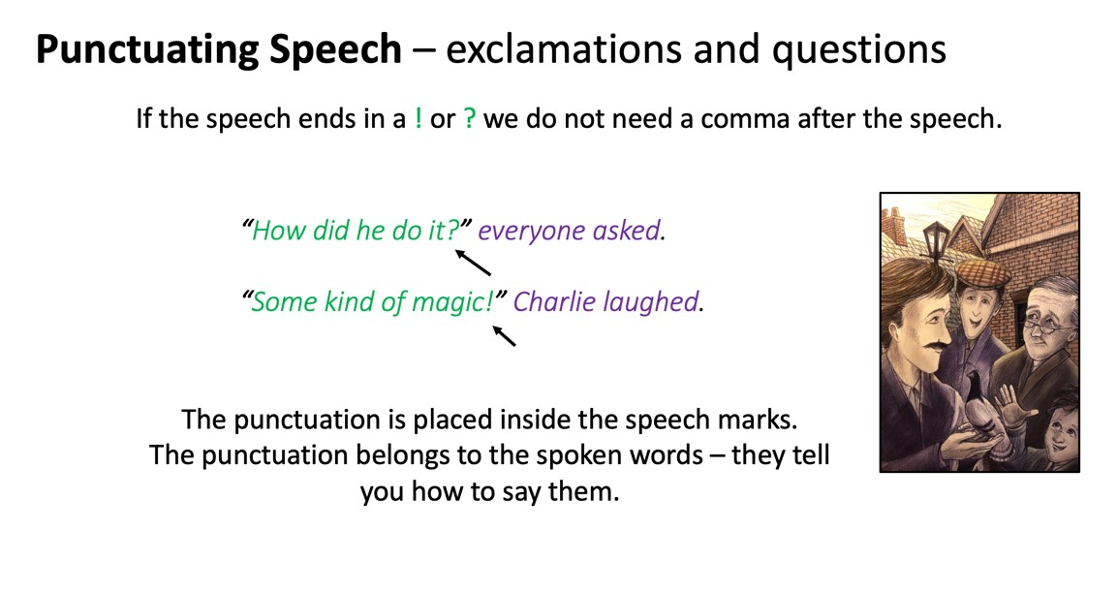

King of Rome - Sentences

Add speech marks to these sentences. Add a reporting clause to 5-10.

- Charlie always said, I can't fly but me pigeons can.
- When I set them free, he explained, it's just like part of me gets lifted up on shining wings.
- Charlie, you'll lose that bird, warned his friends when they heard about his plan.
- When the pigeon didn’t return, his friends chorused, Charlie, we told you so!
- Surely by now you know when you're living in the West End, there ain't many dreams come true.
- Yeah, I know but I had to try.
- A man can crawl around or he can learn to fly.
- And if you live 'round here the ground seems awful near.
- Charlie, it's the King of Rome. Come outside quick, he's perched up on your roof.
- Come on down, your majesty I knew you'd make it back to me.
- Come on down, you lovely one. You made my dream come true…

Speakers:

5. Friends 6. Charlie 7. Charlie 8. Charlie 9. Friends 10. Charlie 11. Charlie

King of Rome - Story

King of Rome - Sentences - ANSWERS

Add speech marks to these sentences. Add a reporting clause to 5-10.

- Charlie always said, “I can't fly but me pigeons can.”
- “When I set them free,” he explained, “it's just like part of me gets lifted up on shining wings.”
- “Charlie, you'll lose that bird,” warned his friends when they heard about his plan.
- When the pigeon didn’t return, his friends chorused, “Charlie, we told you so!”
- “Surely by now you know when you're living in the West End, there ain't many dreams come true.”

6-10 – Check you have speech marks around the speech, a comma after the first clause in the sentence and a reporting clause.

