What to do today
IMPORTANT! Parent or Carer – Read this page with your child and check that you are happy with what they have to do and with any weblinks or use of the Internet required.
Please be aware that some Greek myths are quite grown-up in content.

1. Story time
The longer, more detailed story of Icarus is provided below. You read the first half yesterday. Read the second half of the story, pausing to reflect at the points you are asked to on the Discussion Points page.

2. Now, watch a film of the story from the live-action Daedalus & Icarus.
Warning to parent or carer: watch this first to check that it is suitable for your child. It was a children’s programme, but is quite challenging emotionally. So, WATCH IT FIRST. Go to https://www.youtube.com/watch?v=FPKSGAnN7_E This goes up to where Icarus is flying. The end of the story is here:
https://www.youtube.com/watch?v=7yp_igX-sDs&t=79s
- Do the characters and settings look as you imagined they would when you were reading the stories?

3. Giving your opinion
Consider all the versions of the story of Daedalus and Icarus you have watched or read.
- Read the instructions on My thoughts about the stories.
- Complete the chart giving your opinions.
- Write a short explanation of which version you liked the most and why.

Now try this Fun-Time Extra
- If you could fly, where would you go and what would you do? Record your ideas on If I could fly.
- Watch further animations of Greek myths: https://www.youtube.com/results?sp=mAEB&search_query=geethanjali+kids
- Read Greek myths at https://greece.mrdonn.org/myths.html

Discussion Points

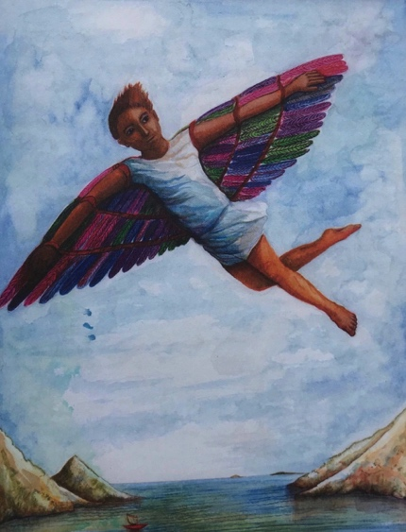

Carry on reading the story of Icarus from ‘That’s how we’ll escape – we’ll fly!’

When you get to the line, ‘...as the sun rose, looking out over the sea,’ pause.

Q. How do you think Daedalus and Icarus would have been feeling as they prepared to take off? Try to think of a variety of emotions they might have had. Do you think they would both have felt the same as each other or might each one have had different feelings of their own?

Continue but pause again at, ‘He was at one with the sky.’

Q. When it says that Icarus was glad to break free from the earth with all its troubles and weights, what does it mean by ‘weights’? List some of the things you think Icarus might be describing as ‘weights’.

Carry on reading to the end of the story.

Q. Read this statement: ‘Icarus was a fool and got all he deserved.’ How much do you agree with this statement? How much do you disagree with this statement? Overall do you feel what happened to Icarus was his own fault or Daedalus’s fault?

The Story of Icarus

Once upon a time there was a boy who tried to fly. He flew with his father, soaring over the shining, sun-dappled sea. His father, who had created the wings which enabled them to fly, was the most brilliant, the most cunning, the most inventive designer who ever lived. But in his past was a dark secret, and a labyrinth and a monster so terrible it could not be spoken of.
The boy’s name was Icarus. His father, Daedalus, had escaped from Athens after his nephew, Talos, had died under very peculiar and suspicious circumstances. Daedalus never spoke to Icarus about what had happened – about how it was that Talos had fallen, spiralling down from the roof of the highest tower in Athens. But he knew that he and his father had been on the run ever since, moving from city to city. Daedalus designed and made moving toys of intricate detail and extraordinary complexity, and sold them in the markets as they travelled. The greatest designer and inventor in Greece was reduced to pedalling toys like a common salesman!

Finally they found themselves in Crete, in the city of Knossos, where Minos the king had his palace. Soon the rumour spread around the capital that Daedalus was making amazing toys, and that these could be bought in the market. The richest and most important families in Knossos flocked to ensure that their children became the proud owners of a set of toy soldiers that marched up a hill, or a wooden bird that flapped its brightly feathered wings and opened its beak to catch a fish. In due course, the fame of these wonderful toys spread to the palace, and Daedalus was summoned by the king himself.  Minos was not a nice man. He had tried to cheat Poseidon, the god of the sea, and had ended up with a terrible and dark secret. | 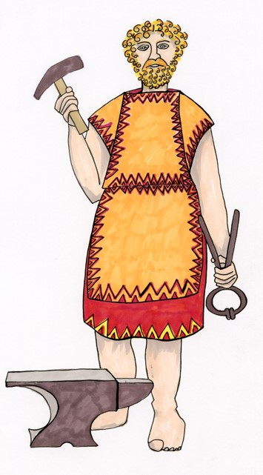
His wife had given birth to a monster – half gigantic bull and half man – named the Minotaur. This was a beast so huge and so horrible that no one could look on it without fainting. It devoured human flesh, and the king was terribly afraid that, if the Minotaur escaped, his country would live in fear forever, and his kingship would be destroyed. Minos wanted Daedalus to design and build a huge cage for the Minotaur – one that would keep it safe forever, a cage from which it could never, ever escape.

Daedalus took up the king’s challenge. He built a labyrinth beneath the palace; a labyrinth so complicated that anyone entering the maze would be caught in its web of passages, and would never be able to find their way out again. The Minotaur was released into the labyrinth and, every year, each of the countries ruled by Minos was forced to send seven young men and seven maidens to the labyrinth to feed the monster’s foul appetites. But, despite the fact that his terrible secret was at last safely imprisoned in the labyrinth, Minos was not a happy man. For Daedalus now knew of his secret. And Daedalus, alone amongst men, also knew the secret ways and paths of the labyrinth itself. Minos could not stand the thought of Daedalus having this knowledge and so, one night, as Daedalus and his son slept, he had them rounded up and thrown, without any warning, into the labyrinth itself. Icarus was terrified, but Daedalus calmed him. “Fear not,” he reminded him, “for I built this prison, and by that knowledge we shall escape.”

As the Minotaur’s roars got nearer and nearer, Daedalus and Icarus ran through the maze of passages, Daedalus counting the twists and turns. Just as the Minotaur was about to turn the last corner and devour them, Daedalus touched a rock and opened a secret doorway which led to the cliff wall at the edge of the sea. Pushing Icarus through first, he hurled himself out just as the door slammed shut, keeping the Minotaur in its labyrinth goal.

But now, Icarus and Daedalus were really scared. Wherever they went on the island, they would be captured and killed by the king’s soldiers. They spent the day miserably crouching in a small cave at the foot of the cliff on the edge of the shore. The sea gulls flew screeching in and out of their cave, bringing fish to the baby birds, who leant screaming over the sides of their nests, balanced precariously on ledges along the cliff face. Daedalus watched the swooping of the gulls as they skimmed the water’s surface before flying gracefully round and back to their young. He watched as feathers fell from their nests and fluttered gently downwards, and, as he watched, Daedalus, ever inventive, had an idea.
“We’ll fly!” he exclaimed suddenly to his startled son. “We’ll fly away. That’s how we’ll escape. We’ll fly!” Start again here

At dawn the next morning, Daedalus tracked down a bees’ nest and robbed it of its wax. He sent Icarus to gather driftwood from along the seashore, and he cut down long, straight, pliable branches from the willows growing along the edge of the river which cascaded into the sea. Gently he worked, designing the wings, sticking on the feathers with the wax, and adapting the beating mechanism, which he created out of meticulously carved pieces of wood, levers fashioned from driftwood, and notches carved in the swathes of willow. Finally they were ready – two pairs of strong, sturdy wings, covered in the broad, long feathers of flight. Daedalus and Icarus dragged themselves to the top of the cliff, and stood, as the sun rose, looking out over the sea.

“We shall fly,” Daedalus told his son. “We shall fly to freedom. Follow me. Fly neither too low, where the sea spray will dampen your wings and they will become heavy with water, nor too high, for the wax will be melted by the hot sun. Follow me.”
And so saying, Daedalus broke into a clumsy run toward the edge of the cliff and then, wings creaking as they beat, flapped slowly out over the glistening sea. Icarus followed, making his own terrified run, and then out, out, out over the water, shining in the sunlight below. As he

flapped his large, unwieldy wings, and felt the air rush beneath him and the wind in his hair and face, he dared to look down. He was flying, he was gliding, he was swooping on the
currents and floating on the breeze! He understood the power and the fearlessness of flight. He was a bird on the wing. He had left his feet behind and was no longer attached to the earth, with its troubles and weights, its heaviness and its depressions. He was at one with the sky!  He gazed up. Above him was only a blue, a deep, drowning blue. He tipped his wings and soared down and then up, a long slow incline, reaching new heights. And now the tiny, fluffy clouds were beneath him, and the | 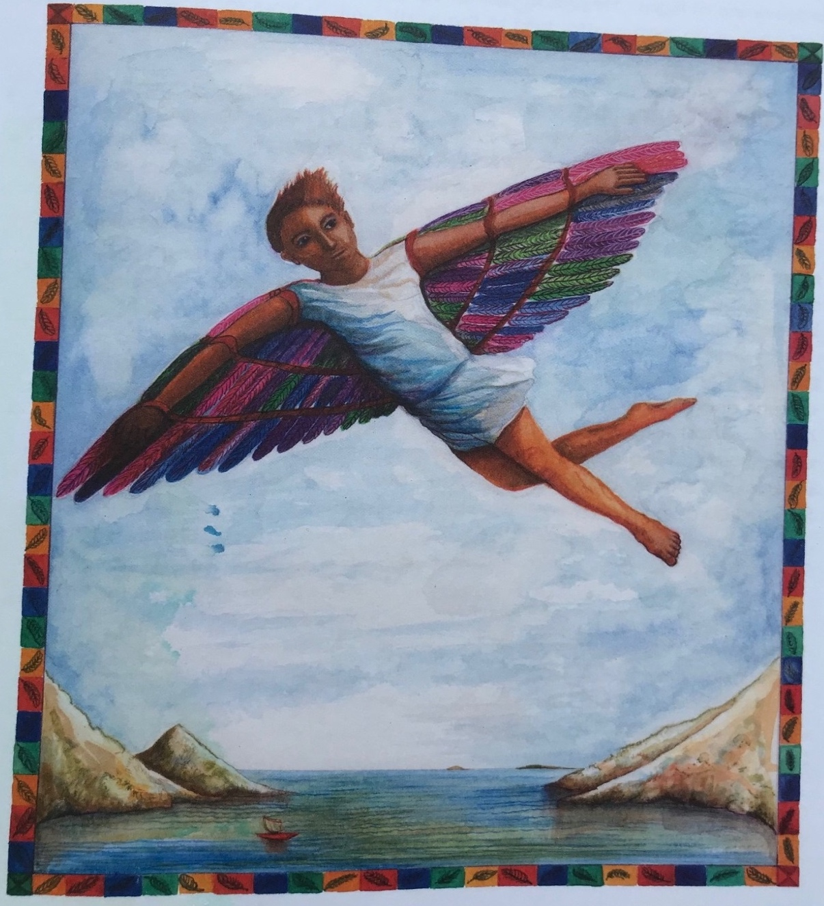
sea was but a glistening haze in the distance below. He soared again, down and then up, up, up. Now he was surrounded by blue. Far below he could hear the cries of the gulls as they swooped and quarreled over the water. Mingled with them he could hear his father’s warning shouts. But he cared not. Again, he soared, and again, and again, climbing higher and higher into the deep blueness above.

Daedalus saw feathers floating past him, in ones and twos, then in dozens and scores, floating down on the sea breeze. Then, as he gazed in horror, almost forgetting to beat his own wings, he saw Icarus, plummeting downwards, falling out of the blue sky and into the mirror of the sea below. Daedalus watched helplessly as his son’s body sank beneath the waves, then flapped his own weary way to safety.

Re-told by Ruth Merttens
My thoughts about the stories

Using the chart below, say one thing about each version of the story that you either very much liked or very much disliked. This must be a different thing for each version.
Story book
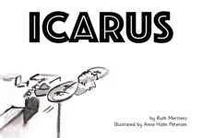
Text version
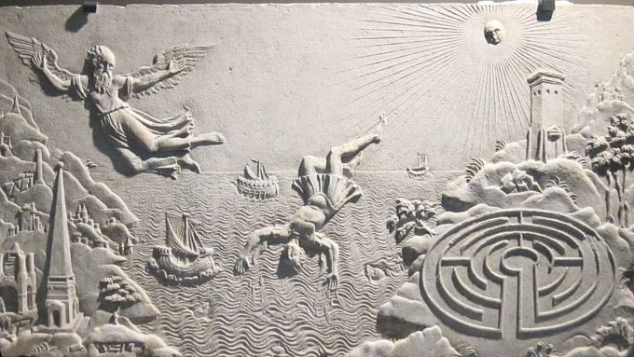
Animation
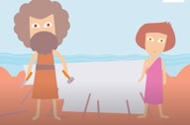
Video live action
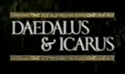
Longer detailed version
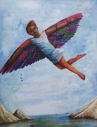

Select the version of the story that, overall, you considered the best. Explain in a paragraph why you liked it the most.
If I could fly

