What to do today
IMPORTANT! Parent or Carer – Read this page with your child and check that you are happy with what they have to do and with any weblinks or use of the Internet required.

1. Story time
Referring to the Discussion Points as you go, read the first half of the longer version of the story of Icarus below.
- Pause at the indicated places and think about the discussion points.
- Stop at ‘That’s how we’ll escape – we’ll fly!’

2. Reading instructions
Read Luring the Minotaur into the Labyrinth.
These are the instructions that Daedalus provided for King Minos.
- Read what to do. Use a felt pen to highlight the features of the text.
- Check your work using the Answers at the end of these resources.

3. Writing instructions
Look at Getting out of the labyrinth.
- Read what you have to do.
- Use How to find and operate the hidden door to write out Daedalus’s instructions.

Now try this Fun-Time Extra
- Follow the instructions on Making an Ancient Greek manuscript. Ask an adult to help you with this activity.
- Using your best handwriting, copy out your instructions onto pieces of Ancient Greek paper.

Discussion Points

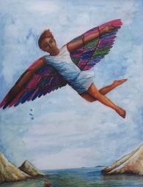

Start to read the story of Icarus.

When you get to the line, ‘...pedalling toys like a common salesman,’ pause.

Q. We learn that Daedalus and Icarus have had to leave their home city of Athens and have been ‘on the run’ ever since, moving from place to place. What does ‘on the run’ mean? How do you think Icarus would feel about having to do this? How would you feel if you had to leave your home behind and hide in all sorts of different places?

Continue but pause again at ‘...keeping the Minotaur in its labyrinthine gaol.’

Q. We learn about King Minos in the opening part of the story – what he does and what he is like. Circle all of the words and phrases in the list below that you think describe King Minos well. Can you think of any other words or phrases that would be good to describe him?

inventive humorous fearful resourceful dull arrogant cruel disorganised

Carry on reading but finish at, ‘That’s how we’ll escape – we’ll fly.’

Q. Look at the last paragraph you have read, that starts, ‘The gulls flew screeching...’. Look at all the powerful verbs used in this paragraph, such as screeching. Which is your favourite? Why do you think it is such an effective verb?

The Story of Icarus

Once upon a time there was a boy who tried to fly. He flew with his father, soaring over the shining, sun-dappled sea. His father, who had created the wings which enabled them to fly, was the most brilliant, the most cunning, the most inventive designer who ever lived. But in his past was a dark secret, and a labyrinth and a monster so terrible it could not be spoken of.
The boy’s name was Icarus. His father, Daedalus, had escaped from Athens after his nephew, Talos, had died under very peculiar and suspicious circumstances. Daedalus never spoke to Icarus about what had happened – about how it was that Talos had fallen, spiralling down from the roof of the highest tower in Athens. But he knew that he and his father had been on the run ever since, moving from city to city. Daedalus designed and made moving toys of intricate detail and extraordinary complexity, and sold them in the markets as they travelled. The greatest designer and inventor in Greece was reduced to pedalling toys like a common salesman!

Finally they found themselves in Crete, in the city of Knossos, where Minos the king had his palace. Soon the rumour spread around the capital that Daedalus was making amazing toys, and that these could be bought in the market. The richest and most important families in Knossos flocked to ensure that their children became the proud owners of a set of toy soldiers that marched up a hill, or a wooden bird that flapped its brightly feathered wings and opened its beak to catch a fish. In due course, the fame of these wonderful toys spread to the palace, and Daedalus was summoned by the king himself.  Minos was not a nice man. He had tried to cheat Poseidon, the god of the sea, and had ended up with a terrible and dark secret. | 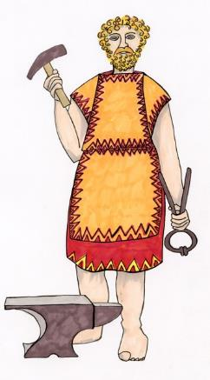
His wife had given birth to a monster – half gigantic bull and half man – named the Minotaur. This was a beast so huge and so horrible that no one could look on it without fainting. It devoured human flesh, and the king was terribly afraid that, if the Minotaur escaped, his country would live in fear forever, and his kingship would be destroyed. Minos wanted Daedalus to design and build a huge cage for the Minotaur – one that would keep it safe forever, a cage from which it could never, ever escape.

Daedalus took up the king’s challenge. He built a labyrinth beneath the palace; a labyrinth so complicated that anyone entering the maze would be caught in its web of passages, and would never be able to find their way out again. The Minotaur was released into the labyrinth and, every year, each of the countries ruled by Minos was forced to send seven young men

and seven maidens to the labyrinth to feed the monster’s foul appetites. But, despite the fact that his terrible secret was at last safely imprisoned in the labyrinth, Minos was not a happy
man. For Daedalus now knew of his secret. And Daedalus, alone amongst men, also knew the secret ways and paths of the labyrinth itself. Minos could not stand the thought of Daedalus having this knowledge and so, one night, as Daedalus and his son slept, he had them rounded up and thrown, without any warning, into the labyrinth itself. Icarus was terrified, but Daedalus calmed him. “Fear not,” he reminded him, “for I built this prison, and by that knowledge we shall escape.”

As the Minotaur’s roars got nearer and nearer, Daedalus and Icarus ran through the maze of passages, Daedalus counting the twists and turns. Just as the Minotaur was about to turn the last corner and devour them, Daedalus touched a rock and opened a secret doorway which led to the cliff wall at the edge of the sea. Pushing Icarus through first, he hurled himself out just as the door slammed shut, keeping the Minotaur in its labyrinth goal.

But now, Icarus and Daedalus were really scared. Wherever they went on the island, they would be captured and killed by the king’s soldiers. They spent the day miserably crouching in a small cave at the foot of the cliff on the edge of the shore. The sea gulls flew screeching in and out of their cave, bringing fish to the baby birds, who leant screaming over the sides of their nests, balanced precariously on ledges along the cliff face. Daedalus watched the swooping of the gulls as they skimmed the water’s surface before flying gracefully round and back to their young. He watched as feathers fell from their nests and fluttered gently downwards, and, as he watched, Daedalus, ever inventive, had an idea.
“We’ll fly!” he exclaimed suddenly to his startled son. “We’ll fly away. That’s how we’ll escape. We’ll fly!”

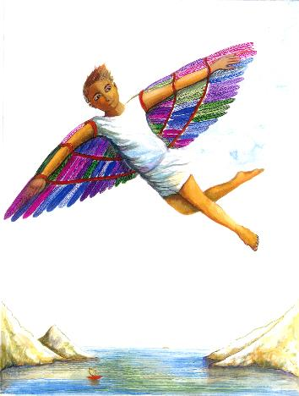
Luring the Minotaur into the Labyrinth

These instructions will enable you to capture the Minotaur and safely install him in his new labyrinth home.  - Open the entrance door to the labyrinth wide but tie a fine, strong cord to the handle so that the door can be pulled shut as soon as it is needed.  - Now bury this cord in the sand so that it is invisible to the Minotaur’s keen sight.  - Just within the labyrinth, place a deep dish of tasty food that | 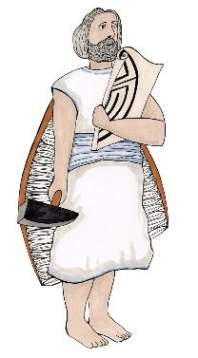

will draw the wary Minotaur into the maze with its delicious, tempting smells. As the Minotaur is a carnivore, a huge mixed grill of sausages, chops, burgers and steaks would do the job well.
- Make sure your soldiers are well hidden and ready to pull the door shut just as soon as the Minotaur is properly within the maze.
- Next, force one of your servants to run in front of the Minotaur to catch his attention and lead the ravening beast towards the labyrinth.
- When the servant reaches the building, get him to duck quickly out of sight.
- Let the smells from the meat now pull the Minotaur into the trap.
- Finally, slam the door shut with the ravening beast inside and bolt the door firmly.

Instructions usually begin with a sentence or two explaining what the instructions are for. Where is this section in the instructions above?

Thereafter, a set of instructions is written as a series of commands. Highlight a command sentence in Daedalus’s instructions.

In a command, verbs are in the imperative or ‘bossy’ form (Move, Make, Do not stop, etc.) Highlight three verbs in the imperative form in the text.

Some verbs are in the present tense rather than in the past tense (I reach the door). Highlight some verbs in the present tense.

Instructions follow a sequence or set order, and use sequencing words and phrases to indicate this (Then, Following this, Once you have…, Lastly, etc.). Highlight these.

Getting out of the labyrinth

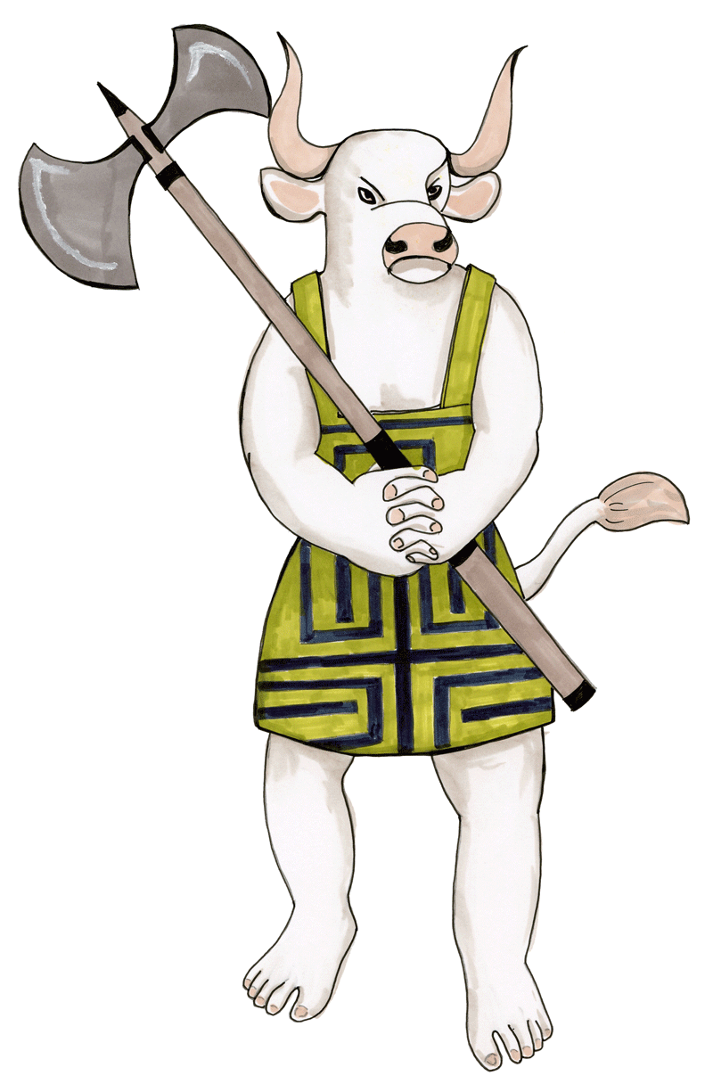

You are going to write Daedalus’s instructions for how to find and operate the hidden door in the labyrinth.

Use all the key features of instruction writing that you found in his instructions for capturing the Minotaur.

Think about the kinds of things Daedalus would say when telling someone how to find the door. Perhaps you would need to count a certain number of right turns and then a certain number of left turns? Maybe there are things that a person has to look for with their eyes, feel for with their hands or even listen for to tell them they are on the right path (special crystals in the walls, markings cut into the stone, the sound of the sea on the other side of the wall, coming through a cleverly-cut hole, almost like a loudspeaker.)

In the book it just says that Daedalus touched a special rock to open the door, but can you go into more detail in your instructions? Maybe you must turn something or fit a special key into the rock? Maybe you have to tap a kind of code into the rock before it will open.

Think up really imaginative instructions for how to find and open the door!

Record these on the special line paper and then follow the instructions for making them look like an Ancient Greek manuscript.

How to find and operate the hidden door

Making an Ancient Greek Manuscript

Use tea bags and wax to create an Ancient Greek manuscript to write your instructions out on. Ask an adult to help you with this activity.

1. Heat the oven to approximately 160⁰.
2. Put two tea bags in a large (bigger than A4) baking tray and add warm water so that you have a couple of centimetres depth.
3. Allow the tea mixture to infuse, darken and cool down.
4. Lay a sheet of white A4 paper in the tea and leave to soak for a few minutes.
5. Transfer the wet sheet to another baking tray and place in the oven to dry out.
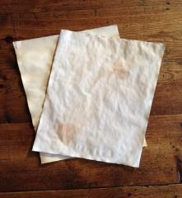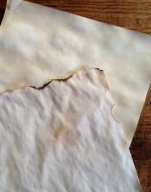

6. Check the paper occasionally, turning if need be to keep the sheet flat as it dries.
7. When dry, tear at the paper’s edge to make it look older. You can also ask a grown up to singe the edges with a flame to create a similar, aged effect.
8. Write out Daedalus’s instructions in your neatest handwriting. Watch out – pencil is not easy to read on tea paper. A black pen is much better.
9. Roll or fold up your instructions and get help from an adult to seal them with dripping wax from a lit candle. Who knows – you might even be able to use beeswax, like Daedalus did on his and Icarus’s wings!

Luring the Minotaur into the Labyrinth - Answers

These instructions will enable you to capture the Minotaur and safely install him in his new labyrinth home.

- Open the entrance door to the labyrinth wide but tie a fine, strong cord to the handle so that the door can be pulled shut as soon as it is needed.
- Now bury this cord in the sand so that it is invisible to the Minotaur’s keen sight.
- Just within the labyrinth, place a deep dish of tasty food that will draw the wary Minotaur into the maze with its delicious, tempting smells. As the Minotaur is a carnivore, a huge mixed grill of sausages, chops, burgers and steaks would do the job well.
- Make sure your soldiers are well hidden and ready to pull the door shut just as soon as the Minotaur is properly within the maze.
- Next, force one of your servants to run in front of the Minotaur to catch his attention and lead the ravening beast towards the labyrinth.
- When the servant reaches the building, get him to duck quickly out of sight.
- Let the smells from the meat now pull the Minotaur into the trap.
- Finally, slam the door shut with the ravening beast inside and bolt the door firmly.

Instructions usually begin with a sentence or two explaining what the instructions are for. Where is this section in the instructions above? Yellow highlights

Thereafter, a set of instructions is written as a series of commands. Highlight a command sentence in Daedalus’s instructions. Blue highlights

In a command, verbs are in the imperative or ‘bossy’ form (Move, Make, Do not stop, etc.) Highlight three verbs in the imperative form in the text. Underlined

Some verbs are in the present tense rather than in the past tense (I reach the door). Highlight some verbs in the present tense. Green highlights

Instructions follow a sequence or set order, and use sequencing words and phrases to indicate this (Then, Following this, Once you have…, Lastly, etc.). Highlight these. Grey highlights

