What to do today
IMPORTANT! Parent or Carer – Read this page with your child and check that you are happy with what they have to do and with any weblinks or use of the Internet required.

1. Story time
Re-read the Hamilton Story Icarus, by Ruth Merttens and Anne Holm Petersen.

2. Comparing two versions of the same story
Go to https://www.youtube.com/watch?v=RVkwWo_LNZs&t=184s.
- Watch the animated version of the story.
- Read Different Versions of Greek Myths and then use Differences to compare the two versions of Icarus that you have read and listened to.

3. Reading and writing diaries
Look at Daedalus’s Diary.
- Read the diary entry and the instructions that go with it.
- On the diary paper, write Icarus’s diary entry, detailing the boy’s experiences and saying how much he regrets not listening to his Dad.

Now try this Fun-Time Extra
- Use A time when I didn’t listen to write about a time you didn’t listen to your Mum and Dad and there was nearly a disaster and you wished you had. Ask Mum and Dad to help you remember a time if you can’t think of one! They’ll certainly be able to help...

Different Versions of Greek Myths

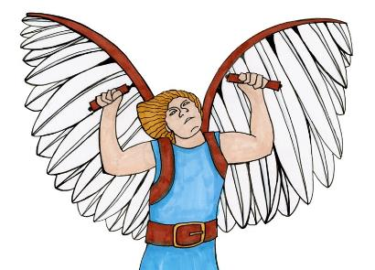

Greek myths have been told and retold many times over the centuries.
With each telling, some of the details of the story change so that, over time, you end up with lots of slightly different versions of the same story.

What differences did you notice between the Icarus story you read and the animation you watched?

On Differences, write full sentences about all the things you spotted that are different.

Call the book you read ‘the story’ and the version you watched online ‘the animation’.

but yet while whereas

Try using these conjunctions to help you write your comparing sentences

In the story Daedalus and Icarus are locked in a tower but in the animation, they have to go into the labyrinth.

Differences

Daedalus’s Diary

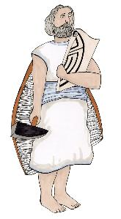
Dear Diary,

It has been an awful day! Although I am so glad to be
free of that dreadful King Minos and to finally be
away from the island of Crete, the labyrinth and the Minotaur, I just can’t bear to think about what might have happened to my dear, dear son, Icarus.

It all started so well, with the wings that I had designed working perfectly and letting us flap our way gently to freedom. I had spoken very seriously to Icarus about not letting himself get too close to either the sea or the sun. For a while at least, he did just as I had asked him. But then his adventurous spirit got the better of him and he started flying higher and higher, circling up towards the fiery rays of the midday sun. The wax on his wings melted and the feathers fell away, leaving him to tumble headlong into the sea.

If only I had been firmer with him. I should have made him fly right next to me so that I could keep an eye on him. He always was a headstrong and impetuous child – and now I have lost him. What shall I do?

But wait – Icarus is safe! He was picked up from the sea by a fishing boat and taken home to Athens.

On the lined paper, write Icarus’s diary entry, explaining what happened from his point of view and how he feels about having not listened to his father’s advice.

What does Icarus decide he will do the next morning?

Diary

A time when I didn’t listen

