What to do today
IMPORTANT! Parent or Carer – Read this page with your child and check that you are happy with what they have to do and with any weblinks or use of the Internet required.

1. Story time
Go to https://www.youtube.com/watch?v=vHiW5ndFNQQ .
Listen to Ruth reading Silly Billy by Anthony Browne.

2. Billy’s worries
Think about the things that Billy worries about in the story.
- On Billy’s Worries, list the six things we are told worry Billy.
- For each one, say what you think it is about the thing or situation that Billy might find scary.

3. A letter to Billy
Oh no! Billy has left his worry dolls at his Grandma’s house and is starting to get very anxious.
- Imagine you are one of the dolls shown in the book.
- Write a letter from that doll to Billy.
- Say something to calm Billy down. Advise Billy what he should do to stop being anxious about two of his worries.
- Sign your letter with your doll’s name.

Now try this Fun-Time Extra
- Go to https://www.youtube.com/watch?v=8oL0n5X2Rlc&t=19s
Follow the instructions and make some worry dolls of your own.
If you don’t have the right things at home to make worry dolls, draw some and stick your drawings onto card.
Tell them your worries and see if they can help!

Billy’s Worries

1.
2.
3.
4.
5.
6.

What bothers him about each thing or situation?

1.

2.

3.

4.

5.

6.

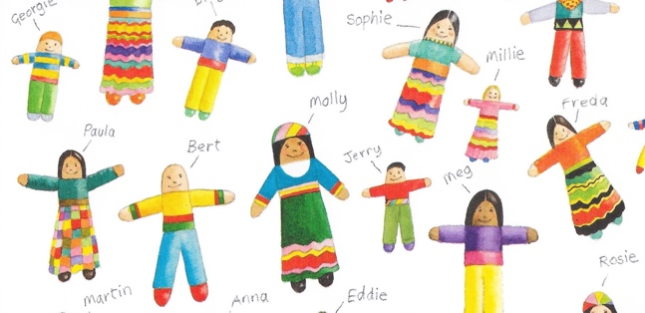

______________________

__________________________________________________________________________________________________________________________________________________________________________________________
__________________________________________________________________________________________________________________________________________________________________________________________
__________________________________________________________________________________________________________________________________________________________________________________________
________________________________________________________________________________________________________________________________________________________________________________________________________________________________________________________
____________________________

___________________________
Worry Dolls

