What to do today
IMPORTANT! Parent or Carer – Read this page with your child and check that you are happy with what they have to do and with any weblinks or use of the Internet required.

1. Story time
Listen again to The King of the Birds.
https://www.youtube.com/watch?v=C1ETMDoDd18&feature=youtu.be

2. Determiners
Read the information on Do I use a or an?
- Complete the Bird Sentences by writing in either a or an in the relevant spaces.
- Check with the Answers.

3. Writing a persuasive letter
After the competition, the Eagle’s mum and the Wren’s mum both wrote letters to the Parrot.
- Read the information on The Mums’ Letters.
- Using the letter paper, either write the letter from the Eagle’s Mum trying to persuade the parrot to change his mind or write the letter from the Wren’s mum asking the Parrot to confirm his decision.

Now try this Fun-Time Extra
- On another piece of letter paper, write the reply from the Parrot to the Mum whose letter you wrote.

Do I use a or an?

To decide whether to use a or an when we are talking about something (a parrot, an owl, a tiny wren, an enormous eagle) we need to look at the first letter of the word after the a or the an.

If that letter is a vowel (a, e, i, o or u) we use an.
If the letter is a consonant (all the other letters except the vowels) we use a.

Bird sentences
Read these sentences.
Circle the a or the an in each case so that sentences are correct.

A/an big group of birds gathered together to hold a/an important meeting.

They wanted to choose a/an monarch, who would be King or Queen of the birds.

The monarch would be a/an special person to whom all the other birds would listen and pay attention.

A/an old wise owl decided that the competition should be a/an exciting race to see who could fly highest.

The last two birds in the race were a/an clever wren and a/an eagle of great size and distinction.

The wren won, but there was a/an fuss because some of the birds thought he had cheated.

What do you think – was the wren a/an clever little thing or was the eagle just a/an extremely unlucky bird?

You make a/an decision!

Bird Sentence Answers

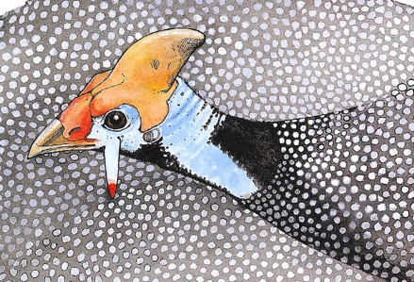

A big group of birds gathered together to hold an important meeting.

They wanted to choose a monarch, who would be King or Queen of the birds.

The monarch would be a special person to whom all the other birds would listen and pay attention.

An old wise parrot decided that the competition should be an exciting race to see who could fly highest.

The last two birds in the race were a clever wren and an eagle of great size and distinction.

The wren won, but there was a fuss because some of the birds thought he had cheated.

What do you think – was the wren a clever little thing or was the eagle just an extremely unlucky bird?

You make a decision!

The Mums’ Letters

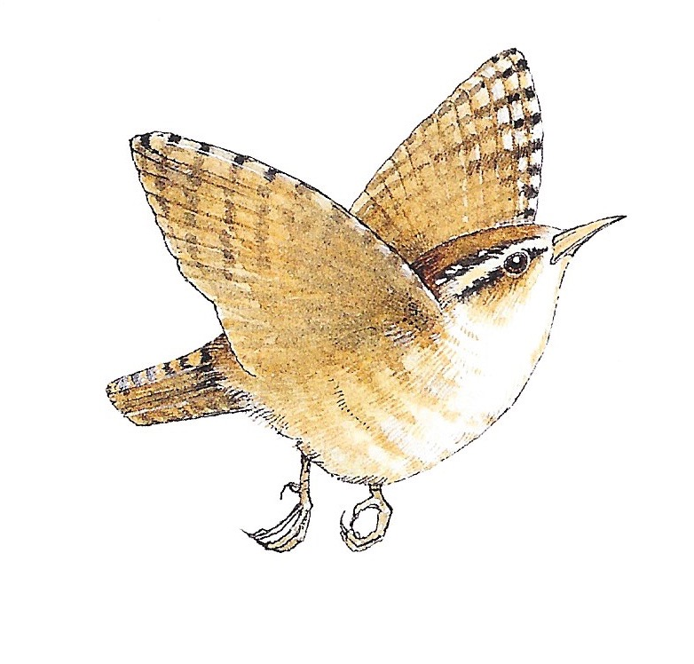
After the competition, the Eagle’s mum and the Wren’s mum both wrote letters to the Parrot.

The Eagle’s mum wanted to persuade the Parrot that the Eagle should have won.

The Wren’s mum wanted to persuade the Parrot to confirm that, yes, the Wren was the rightful winner.

Instructions:
You are going to either write the letter from the Eagle’s Mum to the Parrot or the letter from the Wren’s mum to the Parrot.

1. Use the letter paper.
2. Make up an address for the Eagle or Wren’s Mum at the top of the page.
3. Add the date on the line below.
4. Begin your letter on the left hand side, Dear Parrot,
5. Say who you think should have won.
6. Now write sentences trying to persuade the Parrot to agree with you.
You must give reasons and then tell him why you think you are right.
Try to come up with three reasons. Give each reason its own paragraph.
7. Use these conjunctions to help introduce your different reasons.

because since as

You can use the second letter page if your writing fills the first page.
__________________________
__________________________
__________________________
__________________________

__________________________

______________________________

__________________________________________________________________________________________________________________________________________________________________________________________________________________________________________________________________________________________________________________________________________________________________________________________________________________________________________________________________________________________________________________________________________________________________________________________________________________________________________________________________________________________________________________________________________________________________________________________________________________________________________________________________________________________________________________________________________________________________________________________________________________________________________________________________________________________________________________________________________________________________________________________________________________________________________________________________________________________________________________________
__________________________________________________________________________________________________________________________________________________________________________________________________________________________________________________________________________________________________________________________________________________________________________________________________________________________________________________________________________________________________________________________________________________________________________________________________________________________________________________________________________________________________________________________________________________________________________________________________________________________________________________________________

