What to do today
IMPORTANT! Parent or Carer – Read this page with your child and check that you are happy with what they have to do and with any weblinks or use of the Internet required.

1. Story time
Listen to The King of the Birds, written by Helen Ward.
https://www.youtube.com/watch?v=C1ETMDoDd18&feature=youtu.be
2. Comparing stories
Think about both The Queen of the Birds and The King of the Birds.
In many ways the two versions of the story are very similar, but there are also some differences.
- On Differences, note down as many of the differences between the two versions of the story as you can.
- Use bullet points to create a list.
- Think about the question: does it matter to you that there are differences? Say what you think and explain why you feel that.

3. Writing dialogue
Work through the PowerPoint slides, Punctuating Direct Speech. Or if this isn’t possible, read through the reminders on writing and punctuating speech.
- Read the The Eagle and the Wren’s Argument.
- On the paper, create and write an argument between the two birds as correctly punctuated dialogue.

Now try this Fun-Time Extra
- Look at the A-Z of British birds on the RSPB’s website. https://www.rspb.org.uk/birds-and-wildlife/wildlife-guides/bird-a-z/
Which do you think is the most amazing bird of all?
Draw it and write about it.

Differences

In the box below, note all the differences between the two versions of the story that you spotted.
Use bullet points to create a list.

Does it matter that there are differences between the two versions? Say what you think and explain why you feel that.

__________________________________________________________________________________________________________________________________________________________________________________________________________________________________________________________________________________________________________________________________________________________________________________________________________________________________________________
Writing and punctuating speech
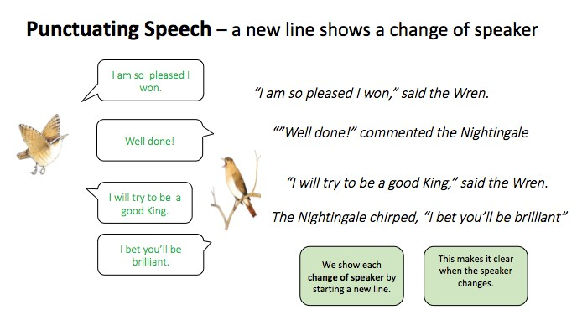
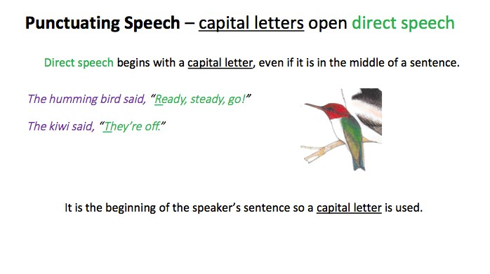
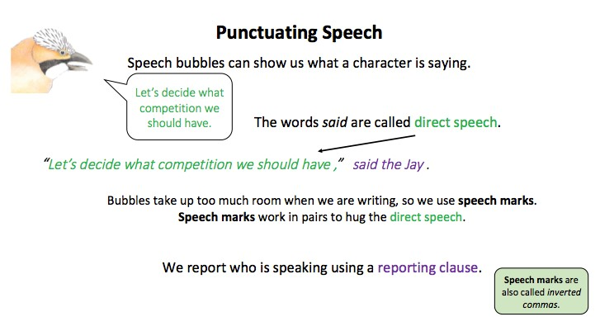
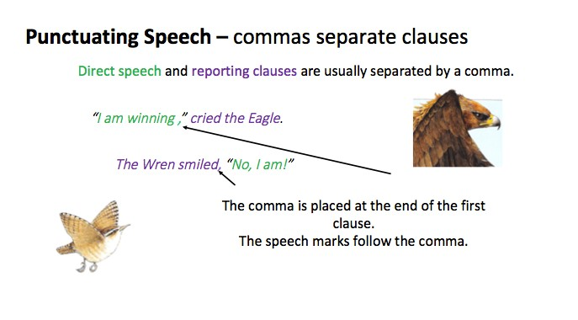

The Eagle and The Wren’s Argument

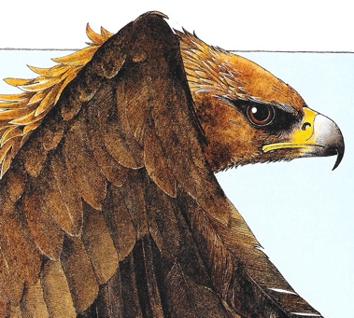
Imagine how the eagle felt at the end of the race.
- Did he feel he had been cheated?
- How did he feel about the wren?
- Did he feel the wren had cheated?
- Should the wren have been punished not rewarded?
- What might he have said to the wren?
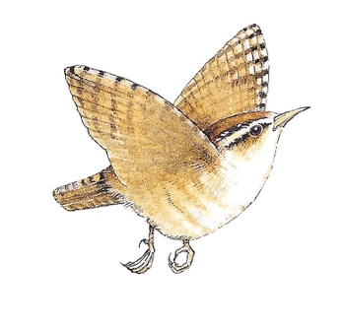
Imagine how the wren felt at the end of the race?
- Did she feel proud of herself?
- Do you think she felt a tiny bit ashamed of herself?
- Did she feel that she deserved to be king?
- Do you think she would have said that being clever was more important than flying higher?
- Did she feel sorry for the eagle?

Rehearse a conversation between the wren and the eagle at the end of the race.
- What did the eagle say?
- What did the wren say?
- How did the conversation continue?

Write the conversation on the next page using correctly punctuated speech.

The Eagle and The Wren’s Argument

