What to do today
IMPORTANT! Parent or Carer – Read this page with your child and check that you are happy with what they have to do and with any weblinks or use of the Internet required.

1. Story time
Listen to the second half of Wilf Merttens’ telling of The Queen of the Birds.
http://player.hamilton-trust.org.uk/story_telling_display.php?cid=893
- Compare what happened in the story with the predictions or story summary you wrote yesterday.

2. Homophones
Read the Sentences about the story.
Follow the instructions.
- Choose the correct homophone for the context in each sentence.
- Check with the Answers.
- Use My homophone sentences to record your sentences.

3. Similes
Read the short text about The Golden Eagle.
- Identify and highlight the similes used in the description.
- Read the information on the Wren Fact File.
- On My description of a wren, draw a picture of the bird.
- Write a paragraph about a wren
- Include at least one simile in your description.

Now try this Fun-Time Extra
- On Competition, draw and write about a competition that you have been in.

Sentences about the story

Instructions:
Each of the sentences below contains a choice.
You have a pair of homophones – words that sound the same but which are spelt differently and mean different things.

- Put a ring around the right word in each sentence.

- Check the Answers.

3. On My homophone sentences, write a sentence for each word that you did not circle.

Challenge!
Make your sentences have something to do with The Queen of the Birds?

Sentences:

I could here/hear the goose honking loudly.

The hungry bird ate a bright red berry/bury.

It would be fare/fair to have a running race to choose the Queen of the Birds.

Male/mail birds are often bright and colourful while female birds tend to have simpler feathers.

The winner of the competition ought to get a meddle/medal.

Usually, planes/plains fly higher in the sky than birds.

This is a great/grate day for a race, thought the falcon.

Answers

These are the correct spellings of the homophone words for the sentences to make sense.

The hungry bird ate a bright red berry.

It would be fair to have a running race to choose the Queen of the Birds.

I could hear the goose honking loudly.

Male birds are often bright and colourful while female birds tend to have simpler feathers.

The winner of the competition ought to get a medal.

Usually, planes fly higher in the sky than birds.

This is a great day for a race, thought the falcon.

My Homophone Sentences

The Golden Eagle

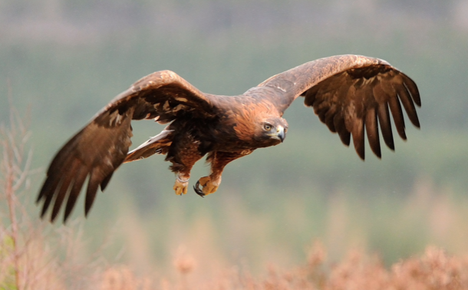

Golden eagles are majestic birds, soaring over the hills of Scotland like huge, silent gliders. Their bodies can be a metre long and their wings can be up to an incredible two metres across from tip to tip. Yet despite being so big, they can move as swiftly as the wind, hunting smaller birds and mammals with amazing agility. Golden eagles’ feathers are a beautiful sandy brown, while their talons are like sharp vices, ready to grip onto their prey after catching it. If ever you are lucky enough to see a golden eagle, listen for its call – an eerie, lonely sound, like the distant cry of a baby. And if one is ever hunting YOU, run as fast as lightning for cover!

This passage contains similes. Similes allow us to describe something by comparing it to something else that it is like.
There are two ways to write a simile:
- Using the word like: Sandy hid behind the chair like a frightened mouse.
- Using the words as...as: Sandy felt as frightened as a tiny mouse.

Highlight the 5 similes used in the passage about the golden eagle. Check with the Answers to see if you got them all.

Golden Eagle Similes

Answers

Golden eagles are majestic birds, soaring over the hills of Scotland like huge, silent gliders. Their bodies can be a metre long and their wings can be up to an incredible two metres across from tip to tip. Yet despite being so big, they can move as swiftly as the wind, hunting smaller birds and mammals with amazing agility. Golden eagles’ feathers are a beautiful sandy brown, while their talons are like sharp vices, ready to grip onto their prey after catching it. If ever you are lucky enough to see a golden eagle, listen for its call – an eerie, lonely sound, like the distant cry of a baby. And if one is ever hunting YOU... run as fast as lightning for cover!

Wren Fact File

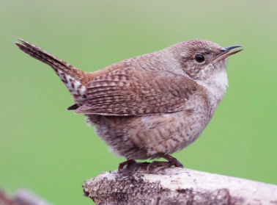

Size: Very small. Wrens are the smallest bird in Britain – about 8cm long from end of beak to end of tail
Weight: Very light – about 7 grams
Colouring: Brown on top, grey on its tummy, speckled near its tail
Body shape: Round
Eyes: Tiny, dark brown
Beak: Short, slightly curved
Legs: Thin

My Description of a Wren

__________________________________________________________________________________________________________________________________________
__________________________________________________________________________________________________________________________________________
__________________________________________________________________________________________________________________________________________
____________________________________________________________________________________________

Competition

