What to do today
IMPORTANT! Parent or Carer – Read this page with your child and check that you are happy with what they have to do and with any weblinks or use of the Internet required.

1. Story time
Open http://player.hamilton-trust.org.uk/story_telling_display.php?cid=893
Listen to Wilf Merttens tell the first half of a story of The Queen of the Birds.
- Stop at 7 mins 40 secs.

2. Making predictions
Think about what has happened in the story so far.
- Read each of the prompts on What do you think will happen next?
- Write answers in the spaces provided.
- OR, if you know the story already, use How the story goes on from here to explain what does happen in the second part of the tale in as much detail as you can.

3. Giving opinions
Read the Open letter from Y3 at Cottlestone Primary.
The children have decided to have a class King or Queen.
- Advise them on how to choose their class monarch.
- Record your suggestions on the Feedback Form.

Now try this Fun-Time Extra
- Go to https://www.youtube.com/watch?v=Gui3IswQ0DI and do as Wilf Merttens suggests – watch the crows solve the amazing puzzle!
- On Stone the Crows!, write what amazing things the crow could do.

What do you think will happen next?

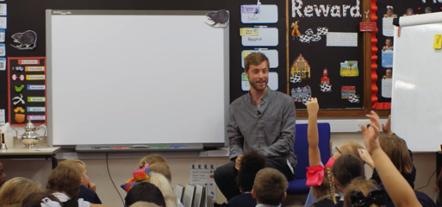

What kind of competition do you think the birds will have?

__________________________________________________________________________________________________________________________________________________________________________________________

Which bird do you think will win the competition?

__________________________________________________________________________________________________________________________________________________________________________________________

How will they win the competition?
__________________________________________________________________________________________________________________________________________________________________________________________

Will the other birds be happy with that outcome?

__________________________________________________________________________________________________________________________________________________________________________________________

How the story goes on from here

Cottlestone Primary School,
Long Lane,
Cottlestone,
Kent CT7 4UP

26 May 2020

Dear Year 3 children around the country,

We have decided that we should have a King or Queen for our Y3 class here at Cottlestone Primary School.

The problem is, we don’t know how to choose who our King or Queen will be! Can you help us to decide?

Do you think we should decide by having a competition? What sort of competition should it be? Please tell us some really good ideas for a competition.

We are a bit worried that some people will feel a competition is unfair as they may not be very good at the thing the competition is about. Perhaps the competition should have lots of different things in it so that no one feels left out?

What should we say to people who feel that a competition isn’t fair and get upset?

If we don’t have a competition to decide who will King or Queen, what other ways could we use to choose our class monarchs?

Should they be monarch all year long or should we change King or Queen from time to time so that others get to have a go?

Please help us by completing the attached form and sending it back to us as soon as possible. Please write your suggestions in full, punctuated sentences.

Yours sincerely,

Class 3 at Cottlestone Primary School.

Cottlestone Primary School

Feedback Form

What sort of competition could we have to decide who our class King or Queen will be? Use extra paper and suggest more than one thing if you have lots of good ideas.
__________________________________________________________________________________________________________________________________________________________________________________________________________________________________________________________________________________________________________________________________________________________________________________________________________________________________________________

What should we say to anyone who doesn’t feel that that sort of competition is fair?
______________________________________________________________________________________________________________________________________________________________________________________________________________________________________________________________________________________________________________________

What other ways could we choose our class Monarch?
________________________________________________________________________________________________________________________________________________________________________________________________________________________________________________________

How long do you think someone should be our class King and Queen for?
____________________________________________________________________________________________________________________________
Stone the Crows!
(find out what this funny expression means)

