What to do today
IMPORTANT! Parent or Carer – Read this page with your child and check that you are happy with what they have to do and with any weblinks or use of the Internet required.

1. Story time
Think about two versions of The Little Story that you have read and heard.
- If you need to, re-watch and/or re-read the story.
- Summarise your opinions about the two versions on My Thoughts About The Little Story.

2. Planning a story
You are going to make up a story for two of the characters that the Red Gold Dragon keeps in his golden heart.
- Look again at pages 5 and 11 of the story.
- Choose two of the characters from these pages.
- Use My Story Planner to capture your ideas for a short story featuring these characters
- Plan to include some direct speech between the characters in your story.

3. Write the story
Write out your story in a special mini story book.
- Use Conjunctions to link ideas together in your sentences
- Add some illustrations to your pages.

Now try this Fun-Time Extra
- Read and tell your story to someone in your family. Do they prefer it when you read or tell your tale?

My Thoughts About The Little Story

- Write a full sentence explaining which version of the story you preferred, the oral storytelling or the book.

______________________________________________________________________________________________________________________________________________

- Write a paragraph giving at least at least two reasons why you preferred that version of the tale.

Use conjunctions to link your ideas and to explain your reasons

because since as for

although however but or yet

My Story Planner

Which two characters is the story going to be about?
What ordinary, normal things are they doing at the beginning of the story?

Consider some direct speech you could include in this part of the story.
What problem or challenge or tricky situation occurs in the middle of the story to cause the characters some trouble?

Consider some direct speech you could include in this part of the story.
What clever things do they do to get out of trouble by the end of the story?

Consider some direct speech you could include in this part of the story.
Making a Mini Story Book

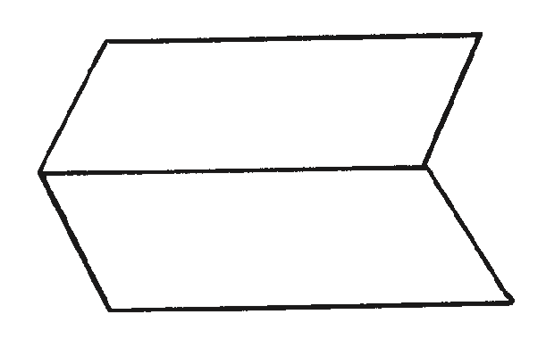
- Fold a large sheet of paper in half lengthways and then unfold it.

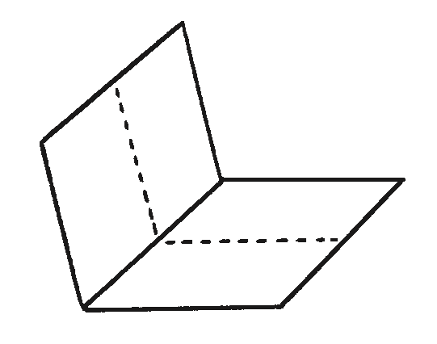
- Fold the same sheet of paper in half widthways and leave it folded.

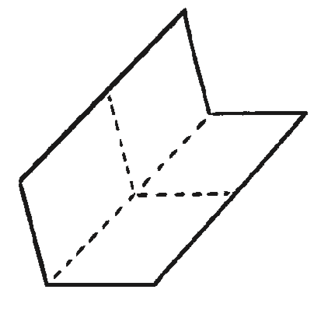
- Fold it in half again in the same direction and then unfold the last fold.

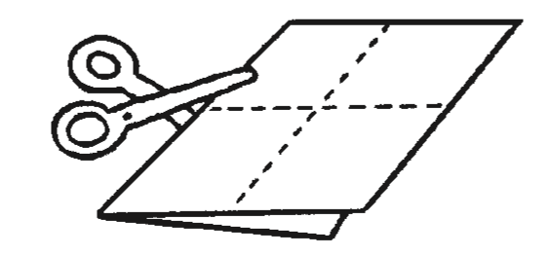
- Cut along the centre crease until you reach the middle of the piece of paper.

- Unfold the paper completely. There should be a slit through the middle of the paper. Fold the paper in half lengthways again and then push the two ends inwards towards each other to create a star shape with four arms.
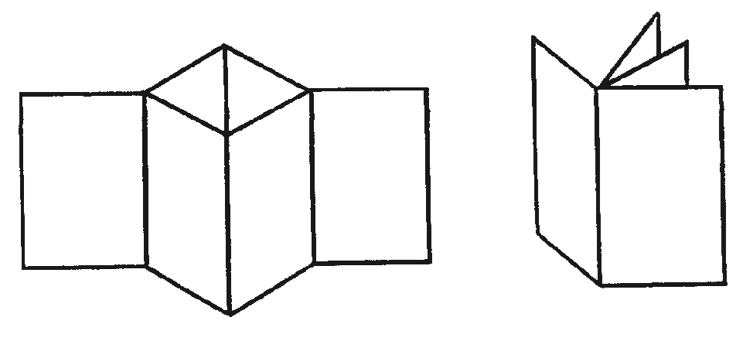

- The four arms are the pages of the book. Fold all of the arms around to face the same direction and the book is complete.

Conjunctions
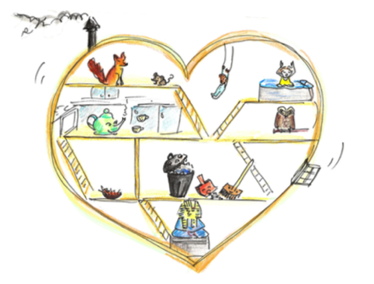
Join ideas together in your story sentences using these and other conjunctions.

and although but

since as however yet

for or

Try to use several different conjunctions in your story.

