What to do today

IMPORTANT! Parent or Carer – Read this page with your child and check that you are happy with what they have to do and with any weblinks or use of the Internet required.

1. Story time
Re-read The Little Story That Didn’t Want to Be Told.
- The Cat is described as nice, clever and fat. Suggest three new words that mean the same things as these.

2. Direct Speech
- Find the speech bubbles on page 11 of the story.
- Read them aloud in a characterful way so that your voice shows how each speaker is feeling.
- Now find the three examples of direct speech to be found in the text.
- Check on Direct Speech in The Little Story to check you got each one.
- Carefully work through the PowerPoint: Punctuating Direct Speech but don’t read the last slide. If this is not possible, read through the Learning Reminders.

3. Writing dialogue
Look at the final slide of the PowerPoint.
- Carefully read the instructions in the green box on the right hand side of the slide.
- Write your conversation down on Cat Chat.
- Read your conversation out, changing your voice with each new speaker so that you can tell who is who and how they are feeling.

Now try this Fun-Time Extra
- Find a comic you like or use the page from Calvin and Hobbes.
- Turn the speech bubbles into punctuated direct speech.
Direct Speech in The Little Story

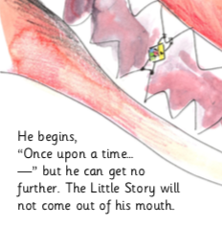

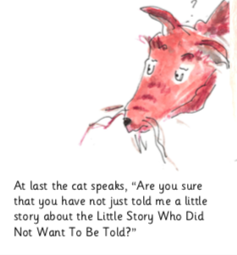

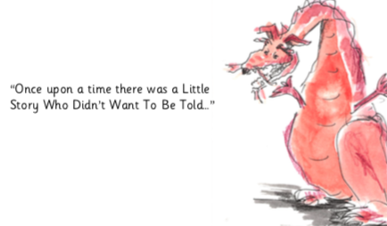

Learning Reminders about Direct Speech
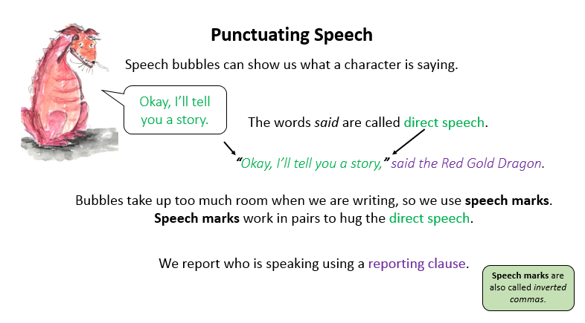 | 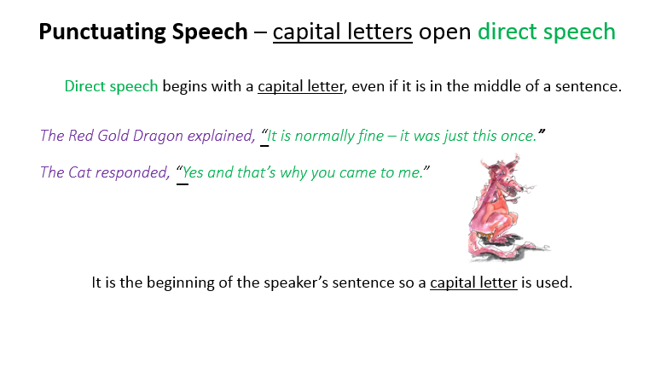
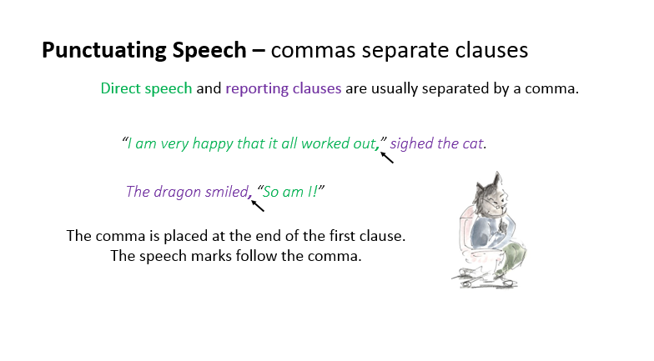 | 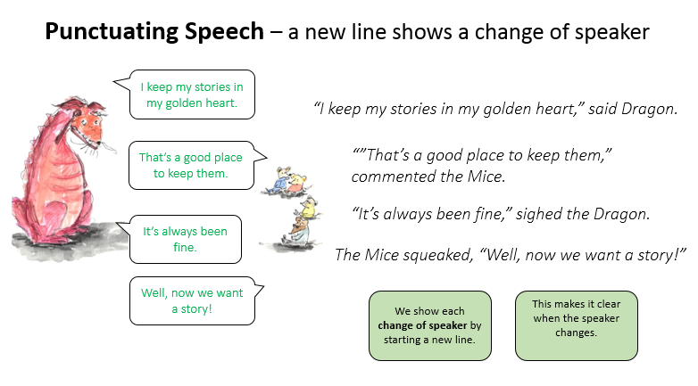

Cat Chat

In this comic strip, the little boy is called Calvin. His pet tiger is called Hobbes.

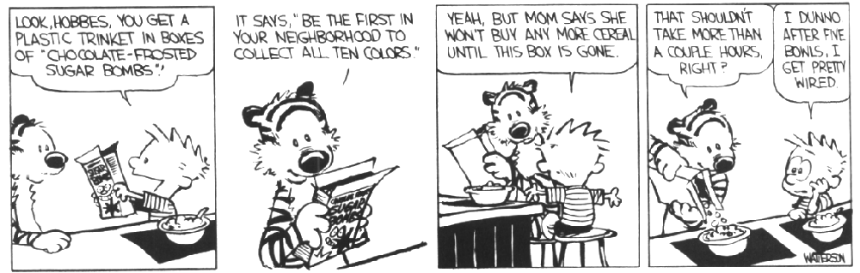

Write out Calvin and Hobbes’ conversation as punctuated direct speech on the lines below.

_____________________________________________________________________________________________________________________________________________________________________________________________________________________________________________________________________________________________________________________________________________________________________________________________________________________________________________________________________________________________________________________________________________________________________________________________________________________________________________________________

