What to do today
IMPORTANT! Parent or Carer – Read this page with your child and check that you are happy with what they have to do and with any weblinks or use of the Internet required.

1. Story time
Go to https://www.youtube.com/watch?v=RbyUrb0X5iU&t=94s
Listen to the reading of The Way Back Home, also written by Oliver Jeffers.
When you get to ‘...and his torch began to go out,’ pause (about 1.35).
- Answer the story questions on The Way Back Home.
- Continue listening until the line, ‘They weren’t alone any more’ (about 2.18).

2. Making predictions
Read the information on Question and Statement Sentences.
- Answer the Questions about types of sentence.
- Read the Prediction Questions.
- Follow the instructions and make your predictions.

3. Imaginative writing
The boy uses his plane to get to the moon.
If you found an aeroplane in your cupboard, where would you use it to go? Why would that be the best place to visit? What would you do there?
- Write several sentences in response to each of these prompts on If I Could Fly...

Now try this Fun-Time Extra
- Go and have a look in your cupboards. Bring out some toys or games or books you haven’t played with for a while. What are they? What do they do? Enjoy them again like the boy enjoys his aeroplane.
Story Questions

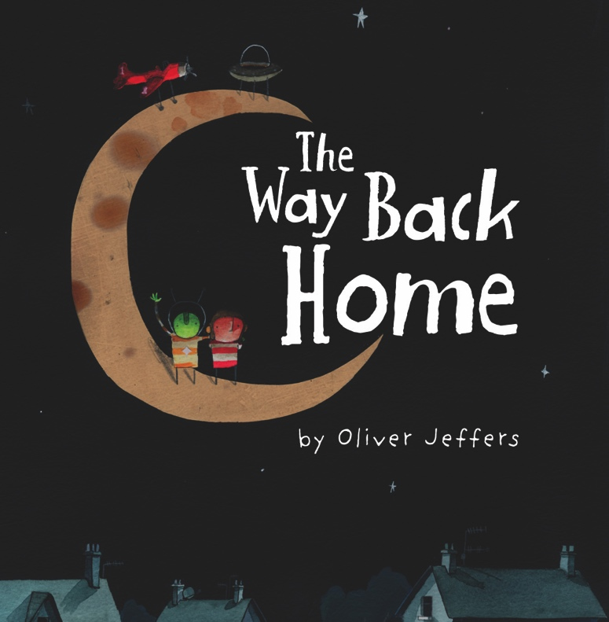

- If the boy has an aeroplane in his cupboard, what else might he have stored in there?
- What would he use the things you have thought of for?

- Describe what the moon looks like in the story in as much detail as you can.

- How do you think the boy felt when his torch started to go out? Why do you think that?

Question and Statement Sentences

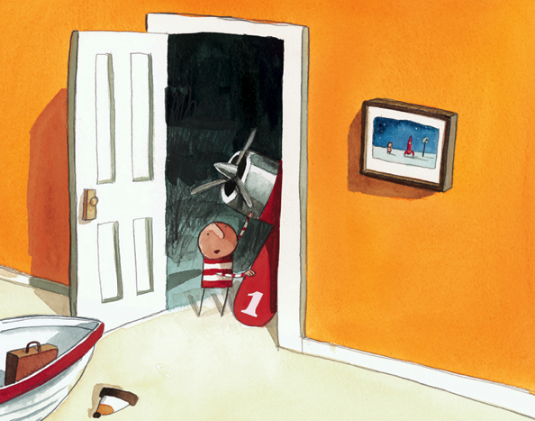

A sentence is a question when it asks the reader something.
Is that my aeroplane?
Can I fly to the moon?
Who is that in the UFO?

Questions often begin with special ‘question words’.
Why What When Where Which Who How

They can also start with the ‘question form’ of a verb.
Can… Do... Are... Have... Will... Is...

Questions start with a capital letter. They end with a question mark instead of a full stop.
?
A sentence is a statement when it simply gives the reader some information.
This is my aeroplane.
I can use it to fly to the moon.
There is a Martian in that UFO!

Like all sentences, statements begin with a capital letter. They usually end with a full stop. Sometimes they end with an exclamation mark if the statement is being made in a forceful way or with extra emphasis.

Questions about types of sentence

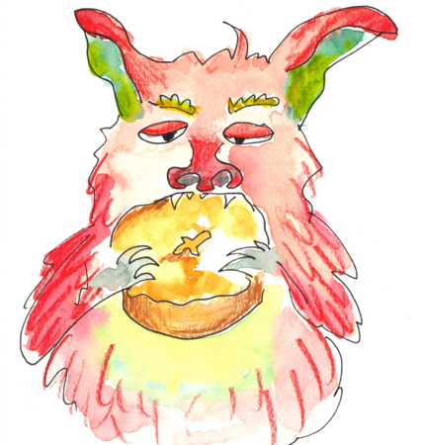 | 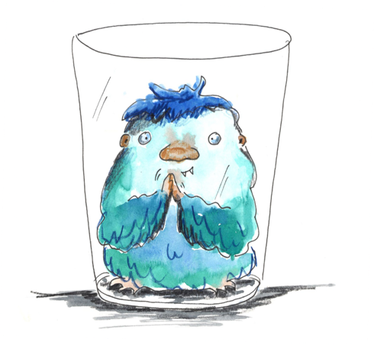 | 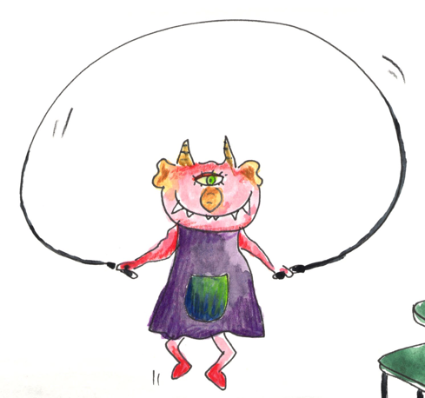

Write ‘question’ or ‘statement’ or ‘exclamation’ beside each sentence below.
Then add the correct end-of-sentence punctuation.

- The alien is eating his dinner
- Why is the alien in a glass
- Is skipping good for you
- What a very tiny alien
- Are you scared of aliens
- How amazing
- The skipping alien is the fittest of them all

Write four words which are commonly used to start questions.

What type of letter must be used to start a sentence?

What punctuation mark is used if a sentence is forceful or said with particular emphasis?

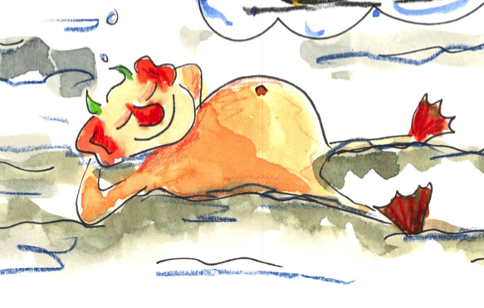
Prediction Questions

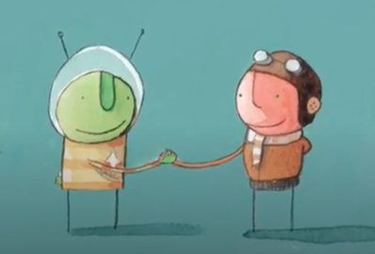

Read each question:

how will the boy get petrol for his plane

what will the Martian do to fix his spaceship

will the boy and the Martian visit Earth or Mars or both

what does the penguin do back on Earth while the boy is stuck on the moon

what will happen at the end of the story

What to do now:
- Copy the first question out on My Predictions, adding a capital letter and a question mark.
- Write a prediction statement answer. If you know already know how the book goes, answer the question in as much detail as you can.
- Do the same for the other questions.
- Write some questions of your own that you’d like to ask the boy or the Martian.

My Predictions

If I Could Fly...

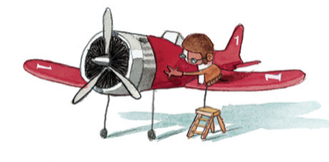

ANSWERS Questions about types of sentence

Write ‘question’ or ‘statement’ or ‘exclamation’ beside each sentence below.
Then add the correct end-of-sentence punctuation.

- The alien is eating his dinner. Statement
- Why is the alien in a glass? Question
- Is skipping good for you? Question
- What a very tiny alien! Exclamation
- Are you scared of aliens? Question
- How amazing! Exclamation
- The skipping alien is the fittest of them all. Statement

Write four words which are commonly used to start questions.
Any of: Why What When Where Which Who How
Or possibly: Can… Do... Are... Have... Will... Is...

What type of letter must be used to start a sentence?
Capital letter

What punctuation mark is used if a sentence is forceful or said with particular emphasis? Exclamation mark

