What to do today
IMPORTANT! Parent or Carer – Read this page with your child and check that you are happy with what they have to do and with any weblinks or use of the Internet required.

1. Story time
Go back to https://www.youtube.com/watch?v=cRAAQ8EWzig.
Listen to the reading of Lost and Found again.

2. Verbs: the past and present progressive
Read the information page on Progressive Verb Forms – Present and Past.
- On two slips of paper, write headings: Past Progressive and Present Progressive
- Read each of the Sentences to Sort.
- Cut out the sentences and place them under the correct heading.
Extra challenge: re-write those sentences in the present progressive as sentences in the past progressive on Penguin’s Progressive Challenge.

3. Looking after a sad penguin
Aside from taking it back to the South Pole as the boy does, what would YOU do if a sad penguin turned up at your door?
- Write about what you’d do on What I would do for a sad and lonely penguin.
- Try to think of at least three different things you would do and go into as much detail as you can.
- Use and, but and so to join the ideas in your sentences together.

Now try this Fun-Time Extra
- Have you ever felt sad and lonely? Draw and write all about it on A time when I was sad and lonely.

Progressive Verb Forms – Present and Past
To show that a present action is in progress for a period of time, or at the same time as something else, we can use the present progressive form.
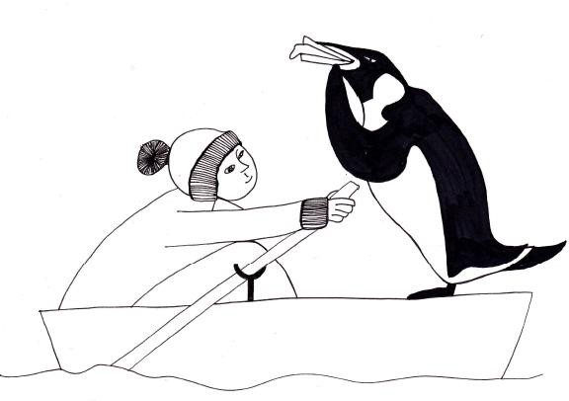

The boy is telling stories. They are travelling by boat. We are discussing a story.

Stories can take a while to tell.
A journey to the South Pole takes a long time. We are still talking about the story.

To show that a past action was in progress for a period of time, or at the same time as something else, we can use the past progressive form.

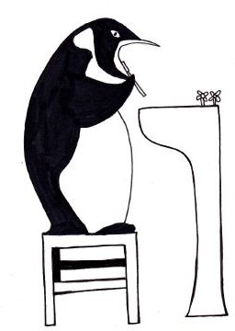
The penguin was brushing his beak.
The boy was talking while he was having a bath. He was waiting when the boy opened the door.
They were hunting for the South Pole.

It takes more than one brush to clean a beak!
The bath and the talking happened at the same time.
The door was opened while the penguin continued to wait.
To write in the present progressive or past progressive form: Add -ing to the end of the main verb.
Add a helping verb before the main verb (is, are, was, were).

Progressive or Simple – which to choose?

He jumped.  Once – it was quick. | She dropped the ball.  Once – it got lost in the park.
He was jumping.  For the duration of the song – he was jumping all the time the music played. | She was dropping the ball.  Continually – as she walked, it bounced back and she dropped it again.

Sentences to Sort

The boy was asking where penguins come from. | The penguin is looking sadder than ever.
The birds are ignoring him. | They are pushing the rowboat out to sea.
He was running down to the harbour. | They were pushing the rowboat out to sea.
The penguin was looking sadder than ever. | The boy is asking where penguins come from.
The birds were ignoring him. | The boy is making a big mistake.
The boy was making a big mistake. | He is running down to the harbour.

Penguin’s Progressive Challenge

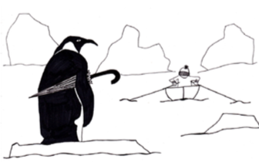

Rewrite each sentence in the present progressive in the past progressive.

______________________________________________________________________________________________________________________

________________________________________________________________________________________________________________________

______________________________________________________________________________________________________________________

_______________________________________________________________________________________________________________________

________________________________________________________________________________________________________________________

________________________________________________________________________________________________________________________

What I would do for a sad and lonely penguin

A time when I was sad and lonely

Present Progressive | Past Progressive
The penguin is looking sadder than ever. | The penguin was looking sadder than ever.
The birds are ignoring him. | The birds were ignoring him.
They are pushing the rowboat out to sea. | They were pushing the rowboat out to sea.
The boy is asking where penguins come from. | The boy was asking where penguins come from.
The boy is making a big mistake. | The boy was making a big mistake.
He is running down to the harbour. | He was running down to the harbour.
ANSWERS - Sentences to Sort

