What to do today
IMPORTANT! Parent or Carer – Read this page with your child and check that you are happy with what they have to do and with any weblinks or use of the Internet required.

1. Story time
Go back to https://www.youtube.com/watch?v=7u1oQXR6fOA.
Listen (from 5.58 mins) to Wilf Merttens tell the remainder of the story of Cinderella.

2. Learning how to write speech
Look at Writing a Conversation.
- Read the speech bubble conversation between Cinderella and her friend, Goldilocks.
- Look carefully at how the speech bubbles are turned into punctuated sentences.

3. Writing the Ugly Sister’s conversation
You are going to write a conversation between one of the Ugly Sisters and her friend, Mrs Beanstalk.
- Write your conversation on A Conversation with Mrs Beanstalk.
- Fill in the speech bubbles.
- Write them out as punctuated sentences below the pictures.

Now try this Fun-Time Extra
- Think about Cinderella’s glass shoes. They sound pretty cool. But what would your absolutely ultimate shoes be like?
- Draw your shoes on Fabulous Footwear and write sentences explaining what they’d be like and what they’d be able to do.

Writing a conversation
2.
1.
My stepsisters are absolutely horrible!
Oh you poor thing! What are you going to do?

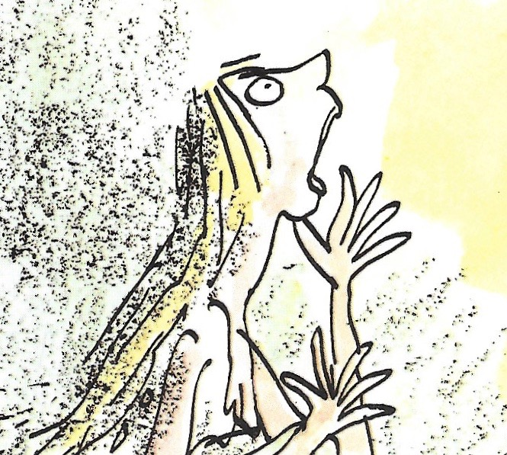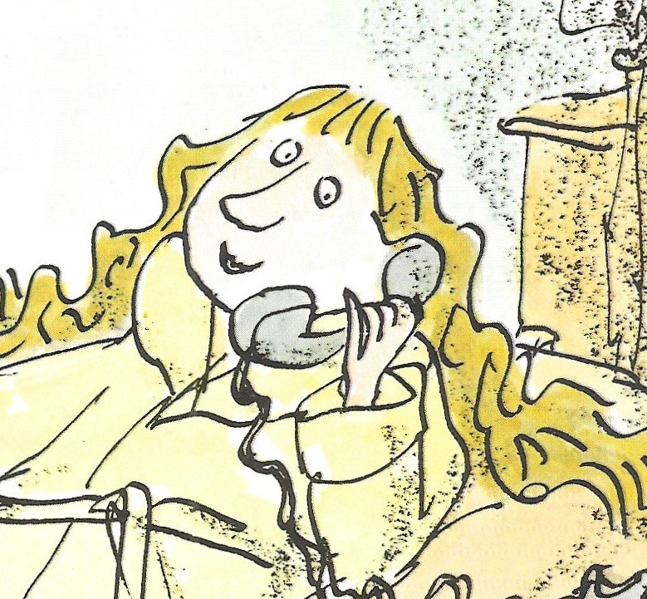
3.

Get my Fairy Godmother to turn them into toads!

‘My stepsisters are absolutely horrible,’ said Cinderella miserably.

‘Oh, you poor thing. What are you going to do?’ sympathised Goldilocks.

‘Get my Fairy Godmother to turn them into toads!’ said Cinderella gleefully.

Reporting clauses, showing who is speaking and how they are feeling.
New speaker? New line.

A Conversation with Mrs Beanstalk

2.
1.

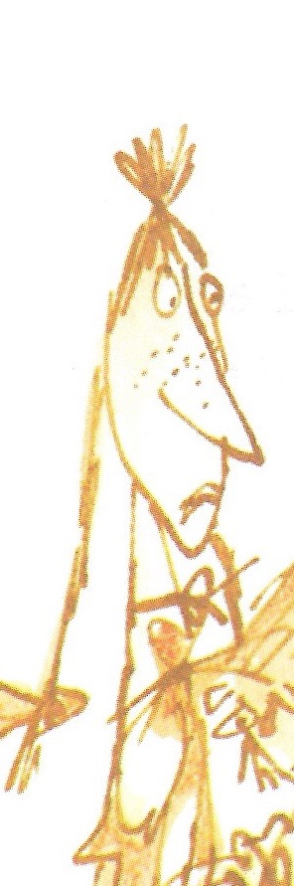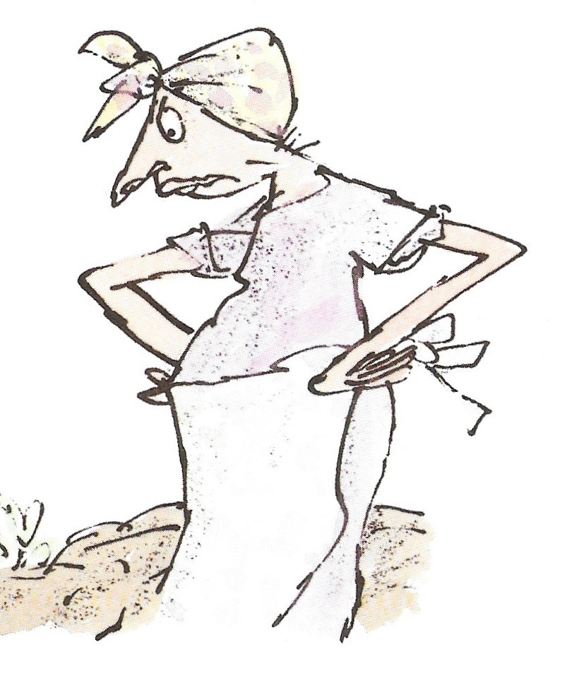

3.

________________________________________________________________________________________________________________________________________________________________________________________________________________________________________________________________________________________________________________________________________________________________________________________________________________________________________________________________________________________________________________

Fabulous Footwear

______________________________________________________________________________________________________________________________________________________________________________________________________________________________________________________________________________________________________________________________________________________________________________________________________________________________________________________________________________________________________________________________________________________________________________

