What to do today
IMPORTANT! Parent or Carer – Read this page with your child and check that you are happy with what they have to do and with any weblinks or use of the Internet required.

1. Story time
Go to https://www.youtube.com/watch?v=7u1oQXR6fOA.
Listen to the first part of Cinderella, told by Wilf Merttens.
Stop at the point where Cinderella arrives at the ball at 5.58 mins.

2. Describing characters
Read the profile of The Fairy Godmother.
- Which parts of the description do you really like? Say why you like these parts of the profile the best.
- Draw either Cinderella, one of the Ugly Sisters or the Prince on a copy of the Character Profile Page.
- Write as many sentences as you can describing how you think your character looks and what they are like as a person.

3. Writing diary entries
You are going to write two entries in Cinderella’s diary.
- Read the Diary Writing Instructions.
- Use the Diary pages to write out Cinderella’s entries.

Now try this Fun-Time Extra
- Do you help out around the house like Cinderella does for her father? What do you do? Make a list of things you help with and do a drawing of you at work on Me helping at home.
- Are there other things you’d love to help your family with in the future? Add these to your list too.

The Fairy Godmother

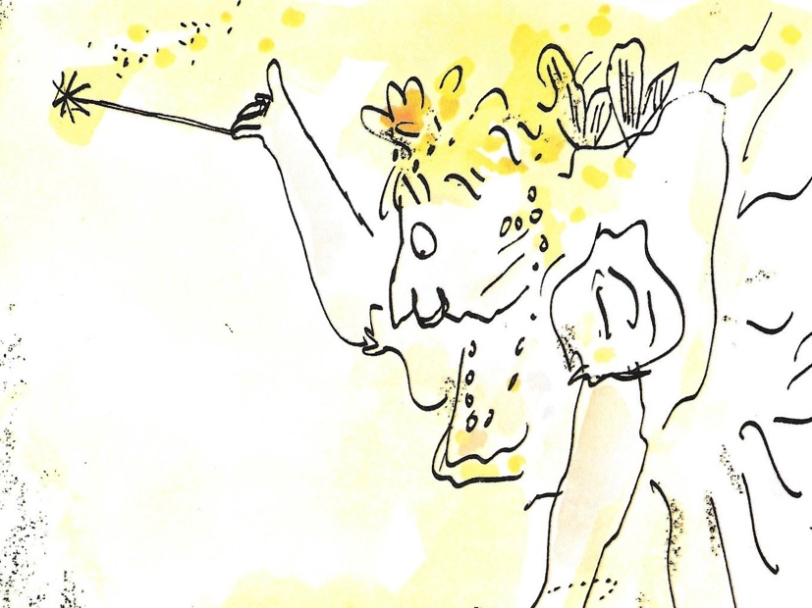

Cinderella’s Fairy Godmother is tall and really rather chubby. She has a fountain of golden hair piled up on top of her head and a cheerful smile on her lips. She wears a long white dress with puffy sleeves and a beautiful necklace of shimmering pearls around her neck. On her ears she has twinkling silver earrings that glitter and blink in the candlelight. Most importantly of all, she carries a long slender wand that she twists and twirls with the utmost elegance. As she grants her wishes, the end of the wand glows with light, and small sparkles like tiny fireworks flash and crackle in the air.

The Fairy Godmother is endlessly patient and kind. She looks out not just for Cinderella, but for anyone who needs a helping hand. However, she does ask that you listen to her very carefully. It is never a good idea to ignore a Fairy Godmother’s instructions and if people really make her cross... well, let’s just say that that wand can be used for turning people into all sorts of not very beautiful animals, just like that!

Character Profile Page

____________________________________________________________________________________________________________________________________________________________________________________________________________________________________________________________________________________________________________________________________________________________________________________
________________________________________________________________________________________________________________________________________________________________________________________________________________________________________________________
____________________________________________________________________________________________________________________________
Diary Writing Instructions

You are going to pretend to be Cinderella.
You are going to write two entries in Cinderella’s diary.

The first entry will be for the day before your stepmother and the Ugly Sisters come to live in your house.

The second entry will be for the day after your stepmother and stepsisters move in.

For the first entry you will write about how excited you are to think that your two stepsisters are going to come and live with you.

Dear Diary,
I am so excited!

Write about all the exciting things you are looking forward to doing with them and how much you are going to enjoy having them around.

Have fun imagining the kind of things you’d like to do with your new sisters.

For the second entry you will write about how upset you are because actually your stepsisters have turned out to be horrible and cruel.

Dear Diary,
What an awful day it has been!

Write about all the unkind things they have said and done, and how they haven't helped with anything in the house but have just been lazy and mean.

Go into lots of detail about all the dreadful things your terrible sisters do!

This Diary is the Property of Cinderella.
Do NOT read it unless you have permission!
_______________________________________________________________________________________________________________________________________________________________________________________________________________________________________________
___________________________________________________________________________________________________________________________________________________________________________________________________________________________________________________________________________________________________________________________________________________________________________________________________________________________________________________________________________________________________________________________________________________________________________________________________________________________________________________________________________________________________________________________________________________________________________________________________________________________________________________________________________________________________________________________________________________________________________________________________________________________________________________________

Me helping at home

