What to do today
IMPORTANT! Parent or Carer – Read this page with your child and check that you are happy with what they have to do and with any weblinks or use of the Internet required.

1. Story time
Read The Rag Doll to the Heedless Child by David Harsent.
- Read the glossed words.
- How is the doll feeling in the poem?
- How can we tell that?

2. Making inferences
Think about what the child in the poem could have done to upset the doll.
- Read the suggestions on What could the child have done?
- Add any further ideas of your own.

3. Writing a letter
You are going to write a letter from the rag doll to the child.
Use the letter blank to write your letter.
- Give the child a name.
- Get the doll to say how she is feeling.
- Get the doll to say why she is so sad.
- Get the doll to say why she still really loves the child though!
- Add a drawing at the bottom of the page.

Now try this Fun-Time Extra
- The heedless child is very sorry for what they have done. Write an apologetic reply to the doll from the child.

The Rag Doll to the Heedless* Child

I love you
with my linen heart.
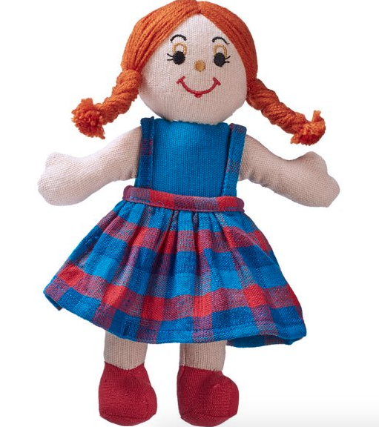

You cannot
know how these

rigid lumpy arms
shudder in your grasp,

or what
tears dam up against

these blue-eye smudges at
your capriciousness**.

At night I watch you sleep;
you’ll never know

how I thrust my face
into the steam

of your warm breath;
and how

love-words choke me behind
this sewn-up mouth.

David Harsent

* heedless – careless, uncaring, thoughtless
** capriciousness – moodiness, keeping changing your mind.

What could the child have done to make the rag doll sad?
Maybe they...

- haven’t played with her for ages
- have spilt a drink on her
- haven’t repaired a rip in her clothes
- haven’t tucked up with her at night for a while
- forgot to take her on a sleep-over
- ignored her birthday
- have let a careless friend borrow her for ages
- have stuffed her at the bottom of the toy chest and forgotten her
- have got toothpaste on her
- have left her out in the garden overnight

Can you think of other reasons the rag doll might be sad about the child?

Add any other ideas you have here:

________________________________________________________________________________________________________________________________________________________________________________________________________________________________________________________

__________________________________

Dear _______________________

________________________________________________________________________________________________________________________________________________________________________________________________________________________________________________________________________________________________________________________________________________________________________________________________________________________________________________________________________________________________________________________________________________________________________________________________________________________________________________________________________________________________________________________________________________________________________

