What to do today
IMPORTANT! Parent or Carer – Read this page with your child and check that you are happy with what they have to do and with any weblinks or use of the Internet required.

1. Story time
Reopen https://www.youtube.com/watch?v=jNOYgRf5jes.
- Listen to the remainder of Dogger.
- What do you think of the little girl who buys Dogger?
- What do you think of Bella at the end of the story? Why?

2. Plan to write a story
Follow the instructions on Planning and writing a new story about a lost toy.
- Use the Planner to capture ideas for your own story about a child and a lost toy.

3. Writing a story
Write your new story out.
- Use your best handwriting
- Use lots of good describing words in your writing.

Now try this Fun-Time Extra
- Add illustrations to your story.
- Read your story aloud to your family or copy it and send it to relatives.

Dogger Story Map

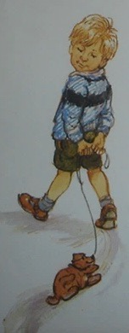  Dave and Dogger are having a very normal day doing all the usual kind of things they do. | 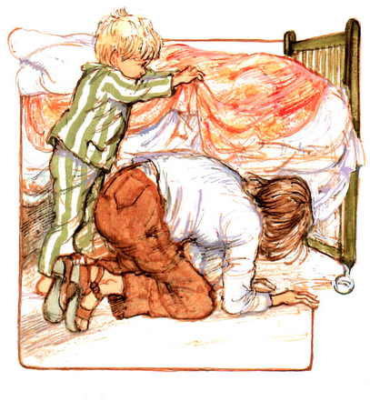  But then Dave loses Dogger, and he and his family look everywhere for the lost toy. | 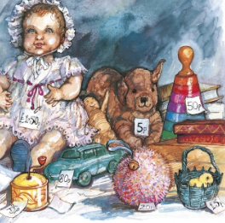  Just when it looks like he will never see his favourite toy again, Dave gets Dogger back!

Planning and writing a new story about a lost toy

What to do:
A. Planning

1. Think about the story of Dogger and look at the Dogger Story Map.
2. Think of a child to be in your new story and decide what favourite toy they have.
Fill in their names at the top of the Planner.
3. Think of one or two ordinary, everyday things the child could be doing with their toy before it gets lost.
Write these ideas in the first column of the Planner.
4. Think of how the toy gets lost and of one or two places where the child then sadly looks for it.
Write these in the second column of the Planner.
5. Think up how the toy gets found.
Write this in the last column of the Planner, along with how the child and their toy celebrate being back together again!

B. Writing

1. Make a mini book (see the instructions) or use the writing paper to write your whole story down on.
2. Write your story out as a series of correctly punctuated sentences. Each idea or note on your Planner will become at least one full sentence in your story.
3. Remember to use capital letters at the start of all your sentences and full stops at the end of all your sentences.
4. Use your very best handwriting.

Planner

Child: ____________________________________ Favourite toy: ____________________________________

1. The ordinary things the child is doing before their toy gets lost: | 2. How their toy gets lost and where they search for it: | 3. How their toy gets found and what they do to celebrate:

Mini Story Books Instructions

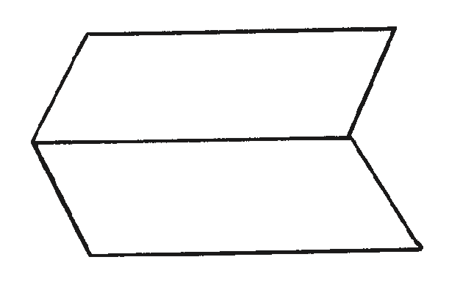
- Fold a sheet of paper in half lengthways and then unfold it.

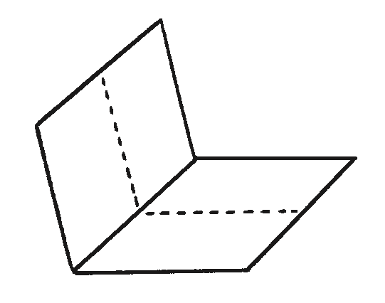
- Fold the same sheet of paper in half widthways and leave it folded.

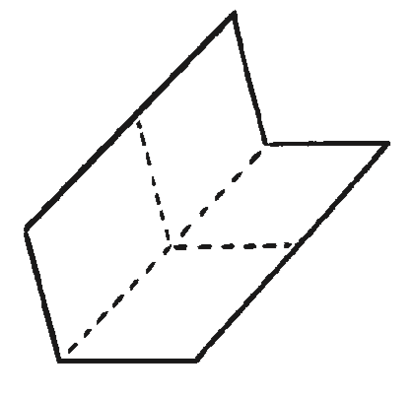
- Fold it in half again in the same direction and then unfold the last fold.

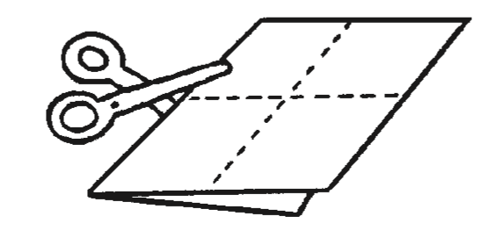
- Cut along the centre crease until you reach the middle of the piece of paper.

- Unfold the paper completely. There should be a slit through the middle of the paper. Fold the paper in half lengthways again and then push the two ends inwards towards each other to create a star shape with four arms.
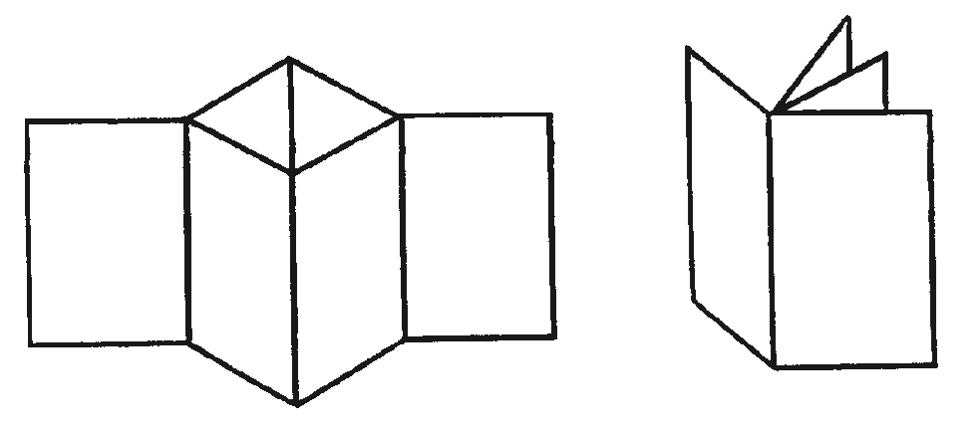

- The four arms are the pages of the book. Fold all of the arms around to face the same direction and the book is complete.

