What to do today
IMPORTANT! Parent or Carer – Read this page with your child and check that you are happy with what they have to do and with any weblinks or use of the Internet required.

1. Story time
Open https://www.youtube.com/watch?v=jNOYgRf5jes.
- Listen to the first half of Dogger by Shirley Hughes, up to when Dogger goes missing (about 3 mins 30 secs in).
- How is Dave feeling at this point in the story?

2. Making a ‘Lost’ poster
Read the Lost poster for a missing rag doll called Jemima.
You are going to create a ‘Lost’ poster for Dogger.
- On the poster template, draw Dogger. Explain what happened to him.
- Describe Dogger using good adjectives and adverbs.
- Say how you, Dave, are feeling about not having him.
- Offer a reward for his safe return.

3. Writing about a really precious toy
Dogger is Dave’s most precious toy. Think of a really precious toy you have.
- On My Most Precious Toy, say what your precious toy is. Describe it.
- Think of three reasons why it is so special. Use the conjunctions because, since and as to help explain each of the reasons it is important to you: I love it because... It’s important to me as...
- Underneath your writing, do a drawing of your toy.

Now try this Fun-Time Extra
- On Don’t Worry, suggest the calming and kind advice you would give to someone who had lost a very special toy.
- On My Bedroom Toys, draw and write about what your bed looks like at nighttime – is it like Bella’s bed with all her teddies crammed in it?!

LOST

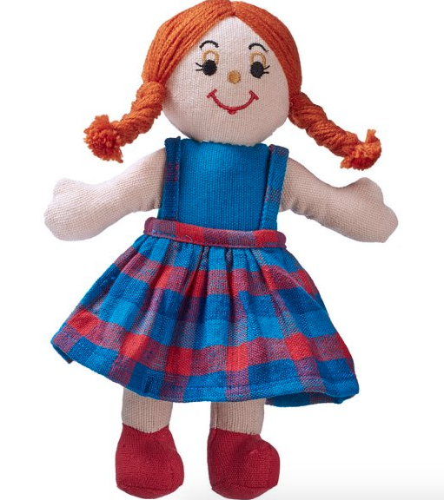

Have you seen my favourite rag doll, Jemima?

I think I might have dropped her in the park or at the shops.

She has long orange hair and a very cheeky grin. Her dress is blue and red and she is wearing a pair of natty velvet boots. Although she isn’t very big, she has left a huge hole in my heart by getting lost and I really miss her. She helps me to get to sleep at night – and also makes sure none of my other toys misbehave!

If anyone sees Jemima, please telephone 0772 678911.

There is a reward of £5 for anyone who helps me get her back.

Thank you!

LOST

_______________________________________________________________________________________________________________________________________________________________________________________________________________________________________________________________________________________________________________________________________________________________________________________________________________________________________________________
_______________________________________________________
My Most Precious Toy

because since as

Don’t Worry

My Bedroom Toys

__________________________________________________________________________________________________________________________________________________________________________________________________________________________________________________________________________________________________________________________________________________________________________________________________________________________________________________

