What to do today
IMPORTANT! Parent or Carer – Read this page with your child and check that you are happy with what they have to do and with any weblinks or use of the Internet required.

1. Story time
Go to https://www.youtube.com/watch?v=uwQCQ1V_ZWM&feature=youtu.be and listen to the story, Maisie and the Dragon, written by Philippa Danvers.
Look out for the dragon in the pictures as you watch.
- Say what your favourite part of the story was.
- Why did you like that bit especially?

2. Using prepositions for description
Look at the picture of Maisie in the Woods.
- Follow the instructions to learn about and use prepositions.
- Check with the Answers at the end of this document.

3. Writing dialogue
Look at the instructions on Conversation with a Dragon.
- Draw one of the pictures and add in speech balloons for the characters.
- Now write the speech in sentences using speech marks to ‘hug’ the speech and a reporting clause to tell us who said it.

Now try this Fun-Time Extra
- Use the Maisie and the Dragon Storyboard Page to help tell the story to other people in your family. Use Skype to tell the story to people who you can’t visit at the moment.

Maisie in the Woods
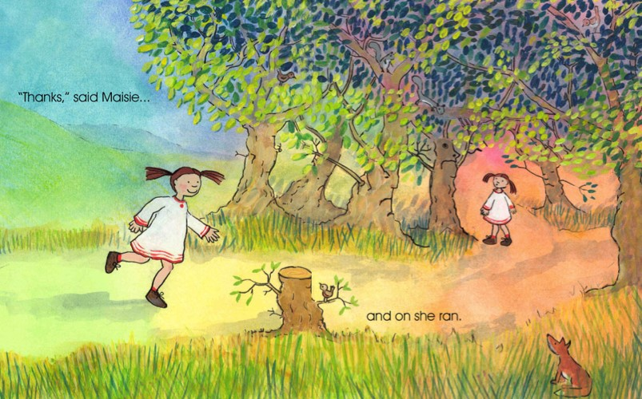

Instructions

1. Look really carefully at the picture of Maisie in the Woods.

2. Point out any animals or strange or funny creatures you can spot in the picture.
Give yourself one point for each animal or creature you spot.
How many points did you get altogether?

3. Read this descriptive passage that goes with the picture:

Maisie ran towards the woods. A tiny bird sat cheeping on a tree stump, while a curious brown fox hid in the long grass next to the path. Maisie could see that some of the trees had funny faces on them, while, above her head, squirrels dashed along the tree trunks and other birds peeked between the gently swaying leaves. Under the canopy of branches, the path continued to run through the wood. Maybe the dragon had gone this way earlier? Maisie decided she would run down the path and see where it took her.

3. Some of these prepositions are used in the passage. Prepositions help us to describe places and things by saying where things are, what is happening and how things relate to one another.

on in under next to below beside through above inside along between with outside on top of underneath

4. Re-read the passage and highlight the prepositions you can find.
How many did you find?
Check on the Answers page to see if you got them all.

5. Look at the picture of Maisie by the playground

6. Underneath the picture, write sentences about what's going on using as many of the prepositions from the box above as you can.

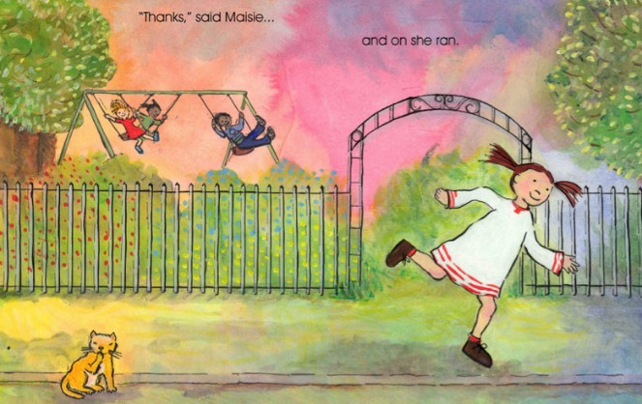

____________________________________________________________________________________________________________________________________________________________________________________________________________________________________________________________________________________________________________________________________________________________________________

A Conversation with a Dragon
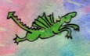
What to do:

- Choose one of the four pictures of the dragon below: with the ducks, school playground, supermarket, or with the pony.
- On Speech!, draw a small version of the scene you chose at the bottom of the box.
- Tell someone what you think the dragon is saying in the picture.
- Tell someone what you think one of the other characters in your picture (one of the ducks, the child in the shop, the pony) are saying back to the dragon.
- Draw in nice big speech bubbles for the dragon and the other character.
- Write in the bubbles what each person or creature is saying.
- Re-write your speech bubbles on the lines underneath your drawing as sentences with speech marks (inverted commas).
Remember –
- Speech marks ‘hug’ the words that are spoken: “Hello, Dragon!”
- We use a ‘reporting clause’ to show who is speaking: said the duck.
- We start a new line when a new person starts speaking.

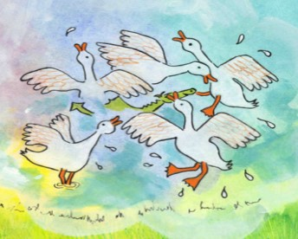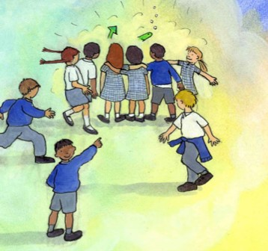

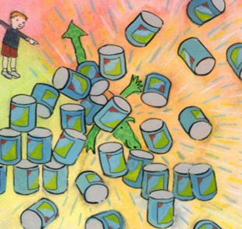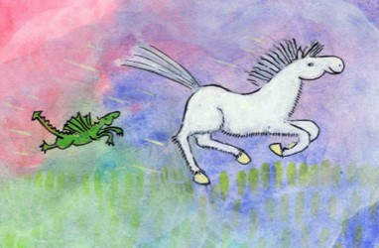

Speech!

_________________________________________________________________________________________________________________________________________________________________________________________________________________________________________________________________________________________________________________________________________

Answers

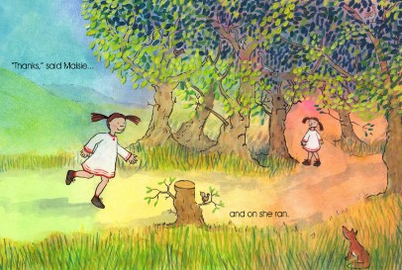

Maisie ran towards the woods. A tiny bird sat cheeping on a tree stump, while a curious brown fox hid in the long grass next to the path. Maisie could see that some of the trees had funny faces on them, while, above her head, squirrels dashed along the tree trunks and other birds peeked between the gently swaying leaves. Under the canopy of branches, the path continued to run through the wood. Maybe the dragon had gone this way earlier? Maisie decided she would run down the path and see where it took her...

on in under next to below
beside through above
inside along
between with outside on top of underneath

