What to do today
IMPORTANT! Parent or Carer – Read this page with your child and check that you are happy with what they have to do and with any weblinks or use of the Internet required.

1. Story time
Open https://www.youtube.com/watch?v=VZJZh2ZTOqs watch the video-clip from the film Mary Poppins, in which two children, Jane and Michael, sing about what their perfect nanny/babysitter/child minder would be like.
- Do you think the children’s ideas for their perfect child minder are good ones?

2. Planning to write an email
You are going to plan an email to a company called Child Minders R Us asking them to send the perfect babysitter.
- Carefully read the instructions on how to plan your email on Writing an email to Child Minders R Us.
- Use The Perfect Babysitter to capture all your brilliant ideas.

3. Writing an email
Now you are going to write your email to Child Minders R Us.
- Use the blank email form to write your message.
- You can use the second, blank page if your need more space to continue your writing.
- Use your best handwriting. Punctuate all your sentences correctly with initial capital letters and full stops.

Now try this Fun-Time Extra
- Try and learn some of the song you heard in the Mary Poppins video off by heart.
Writing an email to Child Minders R Us
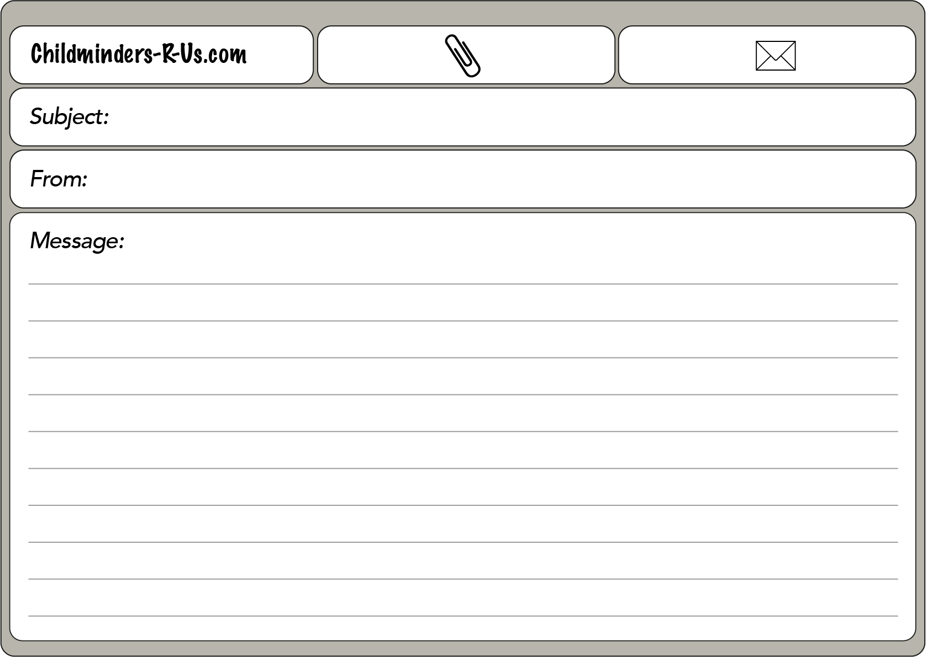

You are going to write an email to a company called Child Minders R Us.
They send babysitters round to look after children when their families have to go out.
You will write and explain what you really want your babysitter to be like and what you really don’t want them to be like.

Planning your email:
1. Start by deciding the four things you want your babysitter to have, to be like or to do.
2. Note these down on The Perfect Babysitter.
3. Now note down the four things you very much don’t want your babysitter to have, to be like or to do.

Writing your email:
1. Take a blank email page.
2. Give the subject (e.g. Our new babysitter; The perfect babysitter).
3. Say who the email is from.
4. In the Message part of the email paper, write a full, punctuated sentence listing the four things you really want your babysitter to have or to be like. Use commas and and to separate the items in your list.
5. Do the same for the things you absolutely don’t want your babysitter to have or to be like or to do.
6. Finish by saying how much you are looking forward to meeting your babysitter and promising how good you will be!

The Perfect Babysitter

Things I want the babysitter to have, be like or do | Things I really do not want the babysitter to have, be like or do

