What to do today
IMPORTANT! Parent or Carer – Read this page with your child and check that you are happy with what they have to do and with any weblinks or use of the Internet required.

1. Story time
Return to https://www.youtube.com/watch?v=Q7ez-9Yuc_A&feature=youtu.be and listen to My Uncle is a Hunkle for the last time.

2. Writing list sentences using commas
Read the information on Using commas to write list sentences.
- Read the sentences on Where should the commas go?
- Place the commas in the first set of sentences.
- Rewrite the second set of sentences, adding commas and the word and in the correct places.

3. Writing about what might be in Uncle Ted’s rucksack
Imagine that Uncle Ted is coming to babysit you.
- On In Uncle Ted’s Rucksack, write down four exciting things you hope he might bring with him.
- Use these things to write a list sentence using commas and the word and: I really hope Uncle Ted will have...
- Pick your very favourite of these four things.
- Draw it.
- Explain why it would be so amazing if Uncle Ted brought it round.
- Use because to explain why: I’d love it if Uncle Ted brought round ... because...

Now try this Fun-Time Extra
- Go to https://milkmonitor.me and have fun exploring Lauren Child’s own website.

Using commas to write list sentences

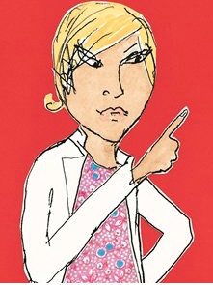

When we are writing sentences that list things we use commas to separate the items in the list.

Instead of a comma we use and between the last two things in the list.

When you read a list sentence you pause a bit at each comma.

Clarice’s favourite colours are orange, green, blue and pink.

Minal Cricket loves football, guinea pigs, climbing trees and firemen.

Sometimes lists are made up of single word items:

orange, green, blue and pink.

Sometimes each part of the list is longer, with adjectives, adverbs and other words:

Uncle Ted had two huge ice creams, some bags of cheesy crisps, a massive bottle of Coke and a bright green picnic blanket under his arm.

In the afternoon Grandad watched an episode of his favourite TV show, talked to Mrs Stampney, played a game of chess with Kurt and took Albert out for a walk.

Where should the commas go?
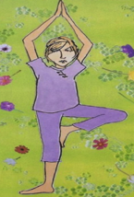
Instructions: These three sentences contain lists with the commas missing.
Put the commas in the right places.

Clarice Bean lives with her big sister Marcie her brother Kurt and her little brother Minal Cricket.

Clarice’s Grandad likes to eat doughnuts watch TV play Scrabble and go round to Mrs Stampney’s.

When he is pretending to be a cowboy, Uncle Ted has a lasso a cowboy hat a sheriff’s badge and a pair of cowboy boots.

These three sentences have the commas missing and are also missing the word and. Rewrite the sentences adding the commas and the word and.

Albert’s hutch contains a water bottle a bowl of food some clean straw a wheel.
____________________________________________________________________________________________________________________________________

At the hospital the nurses had sticky plasters little cartons of orange juice long bandages medicine.
____________________________________________________________________________________________________________________________________

The fireman arrived carrying huge long ladders thick ropes sharp axes big yellow helmets.
____________________________________________________________________________________________________________________________________
In Uncle Ted’s Rucksack
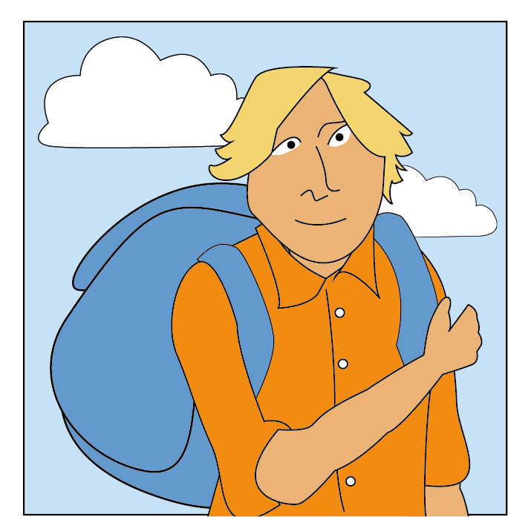

I really hope Uncle Ted has these four things in his rucksack:

This is my list sentence for the four things, using commas and and:

__________________________________________________________________________________________________________________________________________________________________________________________

My favourite thing would be: | This is why it would be my favourite:  _______________________________________  _______________________________________  _______________________________________  _______________________________________  _______________________________________  _______________________________________  _______________________________________  _______________________________________

Where should the commas go?
Answers

Clarice Bean lives with her big sister Marcie, her bother Kurt and her little brother Minal Cricket.

Clarice’s Grandad likes to eat doughnuts, watch TV, play Scrabble and go round to Mrs Stampney’s.

When he is pretending to be a cowboy Uncle Ted has a lasso, a cowboy hat, a sheriff’s badge and a pair of cowboy boots.

Albert’s hutch contains a water bottle, a bowl of food, some clean straw and a wheel.

At the hospital the nurses had sticky plasters, little cartons of orange juice, long bandages and medicine.

The fireman arrived carrying huge long ladders, thick ropes, sharp axes and big yellow helmets.

