What to do today
IMPORTANT! Parent or Carer – Read this page with your child and check that you are happy with what they have to do and with any weblinks or use of the Internet required.

1. Story time
Go back to https://www.youtube.com/watch?v=Q7ez-9Yuc_A&feature=youtu.be and re-listen to the Clarice Bean story, My Uncle is a Hunkle.

2. Describing words in a character profile
Look at Clarice’s Mum.
- Read the description of Clarice’s Mum.
- Follow the instructions and use different coloured pens to highlight all the nouns, adjectives and adverbs you can find.
- Check with the Answers sheet to see how well you did!

3. Writing a character profile
Look at the pictures of Other Characters in the Story.
- Choose your favourite of the characters.
- On My Favourite Character, write all about that person.
- Use really good adjectives and adverbs to describe the people, animals and objects in your writing.
- Make sure all your sentences are correctly punctuated, with initial capital letters and full stops.
- Draw a picture of your character in the style of Lauren Child.

Now try this Fun-Time Extra
- You've seen who lives in Clarice Bean’s home, now write profiles of some of the people who live in your home. Use Some of My Family to write down your profiles. Add drawings of the people too.
- Whose family is funnier, yours or Clarice Bean’s!? Why?

Clarice’s Mum

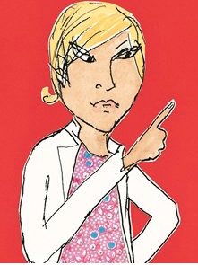

1. Read this short description of Clarice’s Mum.

Clarice’s Mum has quite long blonde hair. She wears a very smart white jacket and an extremely pretty dress covered in tiny flowers. She is very happy and cheerful and looks after Clarice and her funny brothers and sisters. When she comes back from a holiday she brings them all beautiful souvenirs and nice gifts. Clarice’s Mum is usually calm but sometimes she gets very upset and angry!

2. What to do next:
- Use a coloured pen to find all the nouns (things, objects or people) in the text. One has been done for you.
- Now use a different colour to highlight all the adjectives used to describe the nouns. Two have been for you. Long and blonde describe Mum’s hair.
Adjectives often come just before the noun but sometimes they are further on in the sentence: Her hair is long and blonde.
- Now use a third coloured pen to highlight the adverbs in the writing.
Adverbs tell you a bit more about the adjectives in sentences.
They often end in –ly, but not always. Here are some common examples:

really very quite extremely
completely nearly rather perfectly

Answers

Clarice’s Mum has quite long blonde hair. She wears a very smart white jacket and an extremely pretty dress covered in tiny flowers. She is very happy and cheerful and looks after Clarice and her funny brothers and sisters. When she comes back from a holiday she brings them all beautiful souvenirs and nice gifts. Clarice’s Mum is usually calm but sometimes she gets rather upset and angry!

Other Characters in the Story

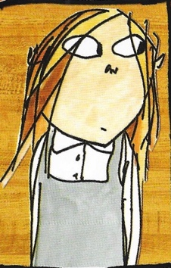  Clarice Bean | 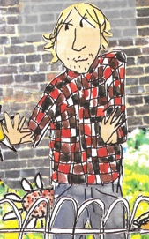  Uncle Ted
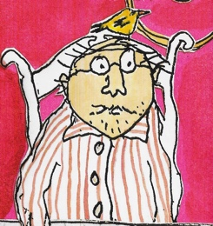  Granddad | 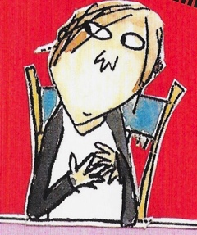  Kurt
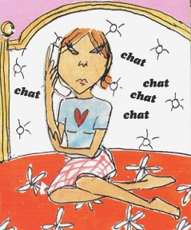  Marcie | 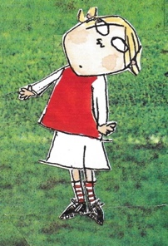  Minal Cricket

My Favourite Character

Some of My Family

Picture | Description

Whose family is funnier, yours or Clarice Bean’s?

________________________________________________________________________________________________________________________________________________________________________________________________________________________________________________________

