What to do today
IMPORTANT! Parent or Carer – Read this page with your child and check that you are happy with what they have to do and with any weblinks or use of the Internet required.

1. Story time
Go to https://www.youtube.com/watch?v=Q7ez-9Yuc_A&feature=youtu.be and listen to the reading of My Uncle is a Hunkle, written by Lauren Child.

2. What a disaster!
Think about all the things that went wrong when Uncle Ted came over to babysit.
- Record as many of these as you can remember in a numbered list on Accidents and Disasters.
- Read the Checklist to see how many of the accidents and upsets you remembered.
- Did you get the accidents in the right story order?

3. Writing about a disaster
Select one event from the list of disasters that you thought really funny.
- On My Favourite Disaster, write sentences about what happened at this point in the story in as much detail as you can.
- Use suggested Conjunctions to join together ideas in your sentences.
- Add a drawing of this bit of the story to your page.

Now try this Fun-Time Extra
- On The time we had a disaster, draw and write about a (possibly babysitter-related) disaster that happened to you or your family.
- If you prefer, make up a story about a funny disaster happening at your house.

Accidents and Disasters

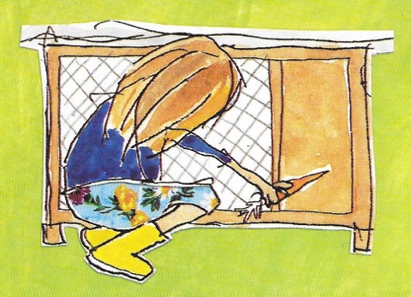

_______________________________________________________________________________________________________________________________________________________________________________________________________________________________________________________________________________________________________________________________________________________________________________________________________________________________________________
_______________________________________________
_______________________________________________

Disasters Checklist

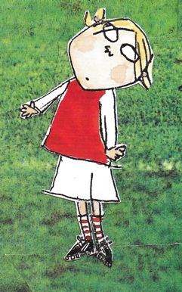

- Albert the guinea pig escapes from his hutch.
- Clarice Bean argues with Minal Cricket and flips his nose with a carrot.
- Minal gets knocked out playing football.
- Minal has to go to hospital for an X-ray.
- Granddad gets lost and goes to watch TV at Mrs Stampney’s.
- Robert Granger takes Albert and says he belongs to him.
- Minal gets his head stuck in the railings.
- The whole fire brigade turns up at the house.

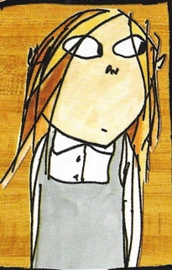

My Favourite Disaster

Conjunctions

Join ideas together in your sentences about the disasters when Uncle Ted came to babysit using these conjunctions.

and although but

since as however

Try to use different conjunctions in your sentences.

Example:
Minal Cricket let Albert out of his cage and he ran away. Everyone tried to catch Albert but they couldn’t find him. In fact Albert was not very far away as Robert Granger had taken him. Robert Granger was pretending that Albert was his pet although Clarice did not believe him at all.
The time we had a disaster

