What to do today
IMPORTANT! Parent or Carer – Read this page with your child and check that you are happy with what they have to do and with any weblinks or use of the Internet required.

1. Story time
Read the poem The Magic Pebble by Roger McGough.
- Have you ever brought back something special from an outing or holiday, like the person here brings back the pebble from Wales?
- What was the object? Do you still have it?

2. Describing a special, magical object
Find your special holiday object or look for another unusual thing in your house. If you have a garden, maybe see if you can spot a pebble, leaf, stick or other object that catches your eye.
- If it isn’t already magical, give your object magic power by whispering a spell over it – Abracadabra, zig zag zoo!
- Follow the instructions on Describing a Magical Object to write about your special thing.

3. It’s magic!
Look at all the magical things that the pebble in the poem can do.
- Which is your favourite of these?
- Why does that one appeal to you the most?
- Read the instructions on My Magical Object’s Powers and write about what magical things your special object can do.

Now try this Fun-Time Extra
- Write about a special outing or holiday that you have been on. On My Holiday, draw a picture of you on your holiday.

The Magic Pebble

My favourite thing is a pebble
That I found on a beach in Wales
It looks like any other
But its magic never fails.

It does my homework for me  Makes difficult sums seem clear  School dinners taste delicious  It makes teachers disappear  It turns water into lemonade  A bully into a frog  When I’m in need of company  It becomes a friendly dog | 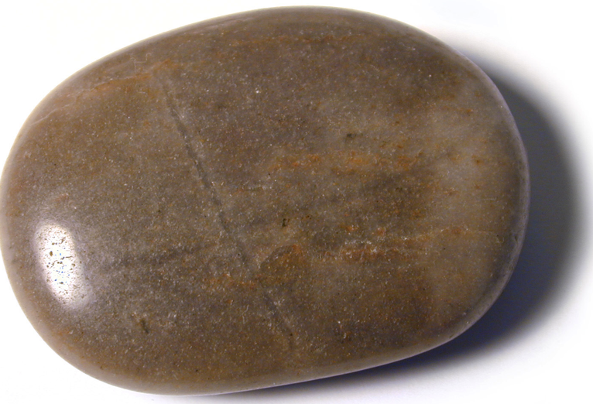

One, two, three and Whoosh!
You’re in a foreign land
Space travel is so easy
Simply hold it in your hand

Close your eyes and make a wish
And wish your wish comes true
For the magic in this pebble
Has been waiting here for you.

By Roger McGough,
from Happy Poems, edited by Roger McGough.

Describing a Magical Object

- When you have found your special thing and made it magical, draw it on My Magical Object. Look carefully at it.

- Think of three adjectives (describing words) you could use to describe it (e.g., if it was a pebble you might use round, small, hard, brown).

- Begin to write a sentence about your object: My pebble is...

- When you get to the adjectives put a comma (,) between the first and the second adjectives: My pebble is round, hard brown

- Use the word and instead of another comma between the second and the third adjectives: My pebble is round, hard and brown.

- Think of three things your special object makes you feel – safe, cheerful, calm.

- Write a second sentence using these adjectives.

- Remember to use commas and the word and to break up the words in your adjective list –
My pebble makes me feel safe, cheerful and calm.

My Magical Object

________________________________________________________________________________________________________________________________________________________________________________________________________________________________________________
____________________________________________________________

My Magical Object’s Powers

My Holiday

