What to do today
IMPORTANT! Parent or Carer – Read this page with your child and check that you are happy with what they have to do and with any weblinks or use of the Internet required.

1. Reading poems
Read and enjoy the poem Tell it the to the Dog by Joshua Siegal.
- Highlight the pairs of rhyming words in the poem.
- Why do you think it makes the child feel better to tell the dog about their problems?

2. Moaning to a pet
What would you moan about to a pet or animal?
- Think of four different things: maybe something to do with the weather, school, food, bedtime, rules, brothers or sisters, etc.
- Use each of the speech bubbles on Moaning to a Pet to write out sentences explaining your things: I am fed up because it is always raining...; I really hate eating peas because they...
- Use good word spaces in your sentences. Don’t forget to use a capital letter and a full stop for each sentence.

3. Poem writing
Write a poem about telling a pet your worries and problems.
- Carefully read the instructions on Writing a Rhyming Poem.
- When you have drafted your poem on the Planner, copy it out in your best handwriting onto the poem paper.

Now try this Fun-Time Extra
- Decorate your poem with pictures that go with your lines.
- Can you learn your poem off by heart?

Tell it to the Dog

If you have had  an awful day  and no one wants  to come and play  and all your woes  won’t go away,  just tell it to the dog.  If everybody  picks on you  and all your plans  have fallen through;  if you feel lonely,  sad and blue,  just tell it to the dog.  Dogs do not judge.  They understand.  They rub your leg.  They lick your hand.  If you feel lost  in no-man’s-land  just tell it to the dog. | Dogs keep your secrets  safe within.  They don’t care if  you lose or win.  So turn that frown  into a grin  and tell it to the dog.  (Or, failing that,  make do with the cat…)  by Joshua Seigal
 | 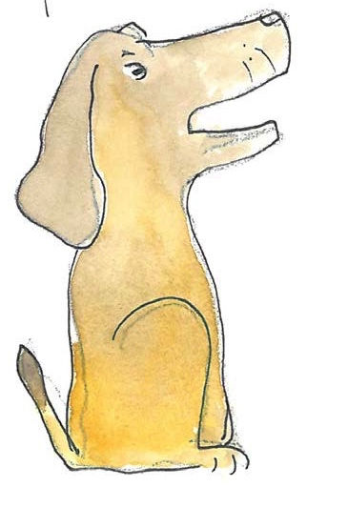

From Happy Poems,
edited by Roger McGough.

Moaning to a Pet

Writing a Rhyming Poem

Instructions:

1. Think of the pet or animal for your poem, e.g. a hamster.
This will be your title on your Poem Planner: Tell it to the Hamster.

2. Reread the first line of the poem: If you have had an awful day...

3. At the end of the second line, in the yellow box, add a word that rhymes with day.
If you are not sure which word to use, try one these…

stay say tray grey may spray clay hooray away

4. Now write the sad, ‘moany‘ line that ends in the rhyming word you have chosen: and the sky has been all cloudy and grey.

5. On the next line, add in your animal’s name: Just tell it to the hamster.

6. Reread the next line of the poem, If everybody picks on you,

7. Fill in the next yellow box with a word that rhymes with you. Use your own word or try one of these:

shoe too queue loo do few goo true boo new

8. Write the sad, ‘moany’ line that ends in that rhyming word: and you managed to get stuck in the loo,

9. Again, add your animal’s name to the next line: Just tell it to the hamster.

10. Do the same thing one last time for the line: Hamsters do not judge, they understand.

grand sand band hand brand land planned

e.g. They... bounce around like a rubber band.

11. Complete the last line on the Planner: Just tell it to the hamster!

My Poem Planner: Tell it to the ______________________________________

If you have had an awful day
and __________________________________________________________________________________________ ,

Just tell it to the _____________________________ .

If everybody picks on you
and ___________________________________________________________________________________________,
Just tell it to the _____________________________ .

__________________________ do not judge, they understand,

they __________________________________________________________________________________________.
Just tell it to the ___________________________ !

(and failing that... make do with the cat.)

______________________________________________________________

