What to do today
IMPORTANT! Parent or Carer – Read this page with your child and check that you are happy with what they have to do and with any weblinks or use of the Internet required.

1. Story time
Go to https://www.youtube.com/watch?v=C_U2TNtAUVk and listen to the reading of Willy the Dreamer.
- Compare this to the other two Anthony Browne books you have seen.
- Which is your favourite of the three? Why is that?

2. Learning about book reviews
Read the information on All About Book Reviews.
- Read the review of Willy the Dreamer by ‘Mr Hamilton’ below.
- Does Mr Hamilton’s review display all the features listed? Tick them off, one by one.

3. Writing a book review
Write a book review of either Willy the Wimp or Willy the Champ.
- Re-watch the story you want to write your review about.
- Write your review using the My Book Review template.
- Try using some of the Book Review Adjectives in your descriptions.
- Keep looking back at All About Book Reviews to check you have included all the features required.
Challenge: Instead of using the template, write your review out on paper without any headings to help you.

Now try this Fun-Time Extra
- You have got to know Willy and Millie pretty well this week!
- Make a mini-book and write your own Willy book with pictures!

All About Book Reviews

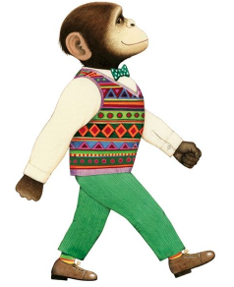

A book review tells you what a person thinks about a book they have read.

A review...

1. Tells you the name of the book.
2. Sums up the book in a word or short phrase: ... is fantastic, cool, an amazing story, a brilliant book/is awful, dreadful, a horrible book.
3. Tells people the main thing that happens in the book.
4. Picks out one or two things that are really good about the book (this might include the pictures as well as the writing).
5. Suggests who else might like the book.
6. Awards the book gold stars out of 5 to show how good the reviewer thinks it is.

Mr Hamilton’s Book Review of Willy the Dreamer
https://www.amazon.co.uk/Willy-Dreamer-Chimp-Anthony-Browne/dp/1406313572/ref=sr_1_1?dchild=1&keywords=willy+the+dreamer&qid=1589285109&sr=8-1
Scroll down and read the review or read it below

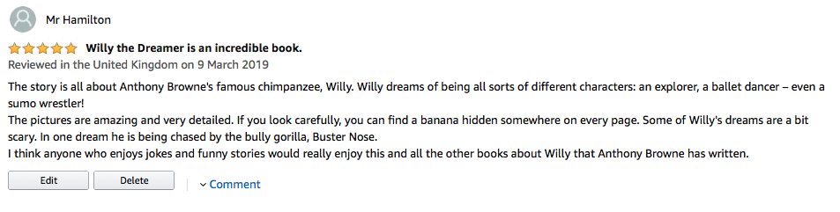

My Book Review
by _____________________________________

This is a review of _________________________________

I think the book is _________________________________________

The book is about ________________________________________________________________________________________________________________________I really like
____________________________________________________________________________________________________________________________________________________________________________________

I think the book would appeal to
________________________________________________________________________________________________________________________

Gold stars:

My Book Review
_________________________________________________________________________________________________________________________________________________________________________________________________________________________________________________________________________________________________________________________________________________________________________________________________________________________________________________________________________________________________________________________________________________________________________________________________________________________________________________________________________________________________________________________________________________________________________________________________________________________________________________________
_____________________________________________________________________________________________________________________________________________________________________

Gold Stars:
Book Review Adjectives

amazing
brilliant
funny
hilarious
touching
thought-provoking
distinctive
enjoyable
extraordinary
outstanding
moving
powerful
sad
superb
unforgettable
arresting

Mini Story Books Instructions

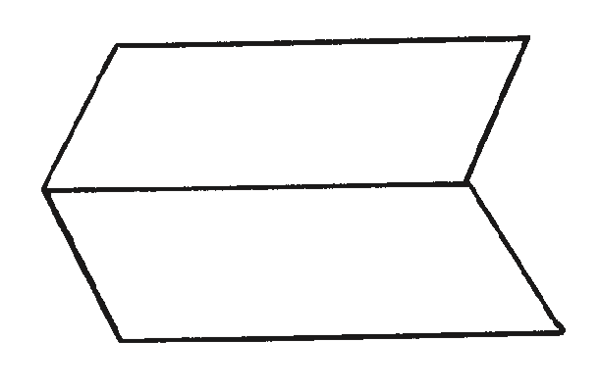
- Fold a sheet of paper in half lengthways and then unfold it.

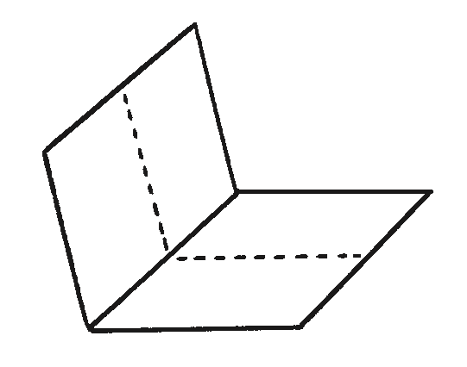
- Fold the same sheet of paper in half widthways and leave it folded.

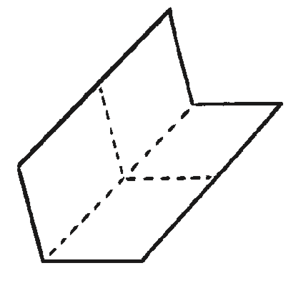
- Fold it in half again in the same direction and then unfold the last fold.

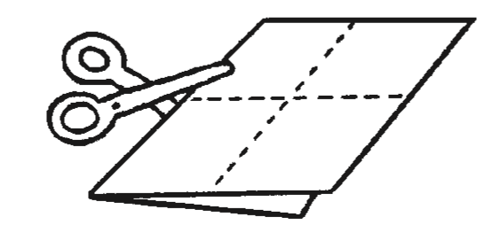
- Cut along the centre crease until you reach the middle of the piece of paper.

- Unfold the paper completely. There should be a slit through the middle of the paper. Fold the paper in half lengthways again and then push the two ends inwards towards each other to create a star shape with four arms.
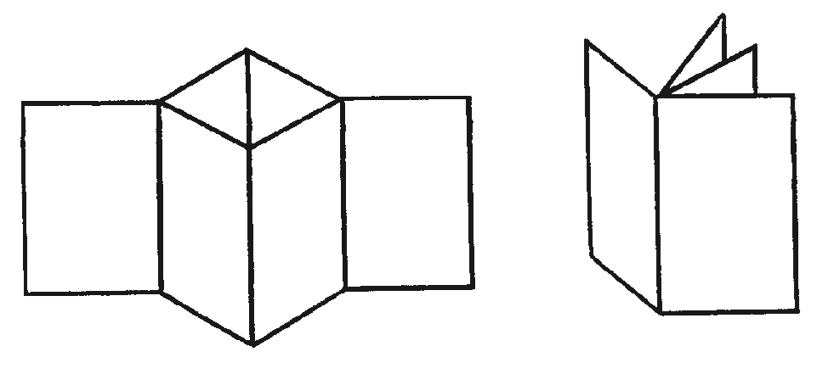

- The four arms are the pages of the book. Fold all of the arms around to face the same direction and the book is complete.

