What to do today
IMPORTANT! Parent or Carer – Read this page with your child and check that you are happy with what they have to do and with any weblinks or use of the Internet required.

1. Story time
Go to https://www.youtube.com/watch?v=QhI8duqNzas and listen to the reading of Willy the Champ by Anthony Browne.
- What things are the same in both this story and Willy the Wimp? What things are different?

2. Descriptive writing using adjectives and adverbs
Write descriptive sentences about a character from Willy the Champ.
- First read about using adjectives and adverbs on Descriptive Writing.
- Follow the instructions and write a profile for a character in the story.

3. Descriptive writing using prepositional phrases
Look carefully at the picture from the book of Willy and Millie in the Park. What odd or strange things can you see in the picture?
- Follow the instructions on Prepositional Phrases and write sentences containing prepositions about all the funny things you noticed.

Now try this Fun-Time Extra
- In the book, it says that Willy’s three favourite things to do are reading, listening to music and walking in the park.
- What are your three favourite things to do? Draw and describe each of them on My three favourite things to do.

Descriptive writing using adjectives and adverbs

In writing we use adjectives to describe nouns (things, objects, names). Often the adjectives come just before the noun:

the funny picture
a bright day

If we have two adjectives next to each other we put a comma between them.

a big , strong gorilla
some tall , green trees

Sometimes the adjectives are further away from the noun.

The pool was warm and blue.
Willy woke up feeling brave and heroic.

We also use adverbs to tell us a bit more about adjectives we have used.

the very funny picture
a really big, strong gorilla
The pool was extremely warm and amazingly blue.

What to do:
- On the Profile page, draw a picture of either Willy, Millie or Buster Nose.
- Under the picture, write descriptive sentences about your character.
- Use adjectives and adverbs in your description.
- Remember to put a comma between two adjectives as needed.
- Try using some of these adverbs if you get stuck.

really quite very
extremely
amazingly incredibly impressively
extraordinarily

This is a profile of...

____________________________

__________________________________________________________________________________________________________________________________________________________________________________________
__________________________________________________________________________________________________________________________________________________________________________________________
________________________________________________________________________________________________________________________________________________________________________________________________________________________________________________________
Willy and Millie in the Park
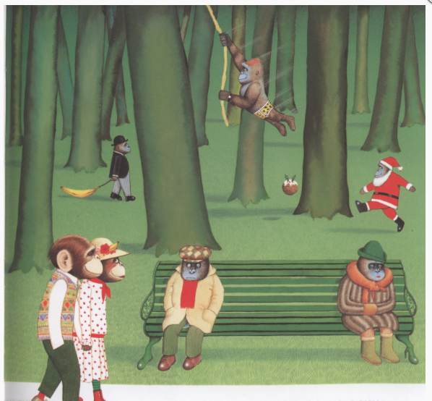

Prepositional Phrases

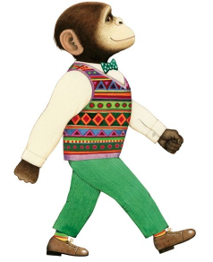

Describing where things are, we use prepositions to help us be specific.

in on under above below inside
next to between underneath beside through with over behind
in front of on top of from

- Shy Willie stood behind the brick wall.
- Millie sat quietly between Willy and her friend.
- The horrible gorilla gang swam in the pool.

The preposition allows us to add a short phrase to a description.

What to do:

- Choose one of the funny things going on in the picture and on In the Park...

- Write a sentence about it that includes a prepositional phrase: Tarzan is flying through the trees.

- Now do the same for all the other funny things you spotted.
Try to use a different preposition in each sentence.

- Can you use two prepositions in the same sentence? Tarzan is flying through the trees on a bright yellow rope.

In the Park

My three favourite things to do

______________________________________________________
______________________________________________________

______________________________________________________
______________________________________________________

______________________________________________________
______________________________________________________

