What to do today
IMPORTANT! Parent or Carer – Read this page with your child and check that you are happy with what they have to do and with any weblinks or use of the Internet required.

1. Story time
Go back to https://youtu.be/pTcflwvOYvc .
Finish The Rainbow Bear.
- How did you feel when the Rainbow Bear was captured and put in the cage?
- Do you think it is alright to keep wild animals in cages? Why/not?

2. Fact, fiction and opinion
Read the sentences on The Rainbow Bear: Fact or Fiction or Opinion?
Some of the sentences are factual, some of them are fiction (made up).
One sentence is an opinion – something that some people think is true but that other people don’t.
- Read the sentences.
- Decide which ones are facts, which ones are fiction – and which one is an opinion.
- Check your choices against the Answers page.

3. Choosing a favourite book
Think of the three books you have heard – Tigress, The Ice Bear and The Rainbow Bear.
- Which of the three books did you think was best?
- Why did you like that one the most? Explain your answer on My Favourite Story.

Now try this Fun-Time Extra
- Write to or call a relative to tell them all about your favourite book.

The Rainbow Bear: Fact or Fiction or Opinion?

- Rainbows can be caught.
- Polar bears hunt seals and arctic foxes.
- Humans and polar bears can talk to each other and understand each other.
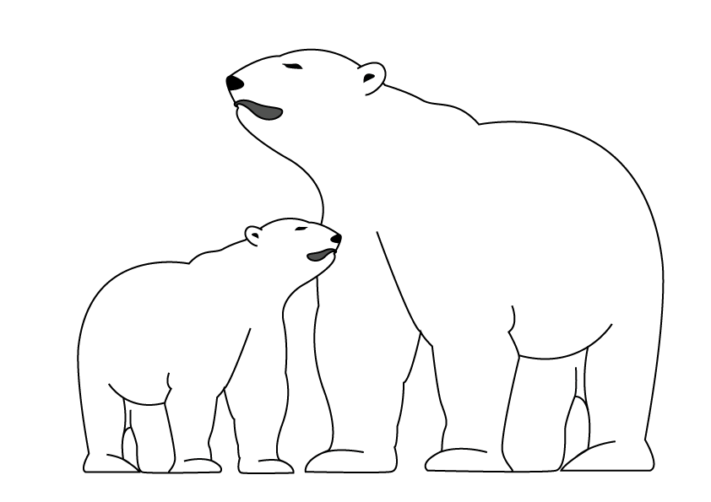
- Polar bears have fur that looks white to camouflage them in the snow.
- Animals shouldn’t be kept in zoos.
- A rainbow can turn a polar bear into a multi-coloured animal.
- Polar bears are good swimmers.
- Polar bears make dens as homes.
- There is an animal called a sea bear.
- Polar bears eat human rubbish and waste that has been dumped in their environment.
- Polar bears have a great sense of smell and follow the scent of animals when hunting.

The Rainbow Bear Fact or Fiction- Answers

Fact Fiction Opinion

- Rainbows can be caught.
- Polar bears hunt seals and arctic foxes.
- Humans and polar bears can talk the same language and understand each other.
- Polar bears have fur that looks white to camouflage them in the snow.
- Animals shouldn’t be kept in zoos. – This is an opinion.
- A rainbow can turn a polar bear into a multi-coloured animal.
- Polar bears are good swimmers.
- Polar bears make dens as homes.
- There is an animal called a sea bear.
- Polar bears eat human rubbish and waste that has been dumped in their environment.
- Polar bears have a great sense of smell and follow the scent of animals when hunting.

My Favourite Story

My favourite book was ___________________________________________________

Give three reasons why you liked your book. Use the words because or as to explain why you liked it each time.

